Document Purpose

This document was produced by the FAME Programme to provide guidance and practical examples to all Local Authorities/Partner Agencies for an implementation of Multi-Agency working. All documents are the property of FAME National Project, and to access these documents you have agreed to the terms and conditions set out in the accessing of these products from the FAME website.

For a further description of this document please see the Product Definition below stating exactly what the product is. For more in depth explanation and guidance please see the FAME "How to Implement and Sustain a Multi-Agency Environment".

User documentation:
this is documentation that forms the basic user instructions for piece of software, it will consist of content and screen shots of the system. It will take a user of a technical system through the different steps and workflow to be able to use that system. It will be based on agreed upon processes from the business requirements, technical statement of requirements and information sharing protocols

NHS Net Login
In order to access the vIMHR application you will first need to access the NHS net. You may be required to have a user ID and a pin number. You will be allocated a key fob which will have a pin number on. Instructions on the use of this will be given separately

Logging in

To be able to access the application you will need to know your vIMHR user id, password and responses to 3 pre-defined security questions. It is important to keep your user id, password and security questions secure and not tell any one else what they are. Remember only to login with your own personal id. If you are sharing a computer it is important that you logout properly before allowing someone else to log into the vIMHR

- Double click the vIMHR icon displayed on your desktop. This will take you straight to the application.

- You will be prompted with the following message

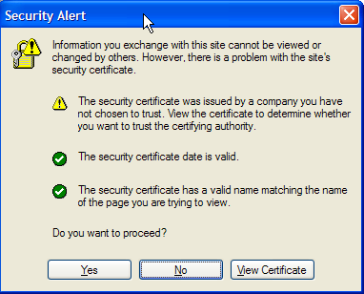

- Select ‘Yes’ to continue, the next screen that will be displayed will be the Liquidlogic Log in as below

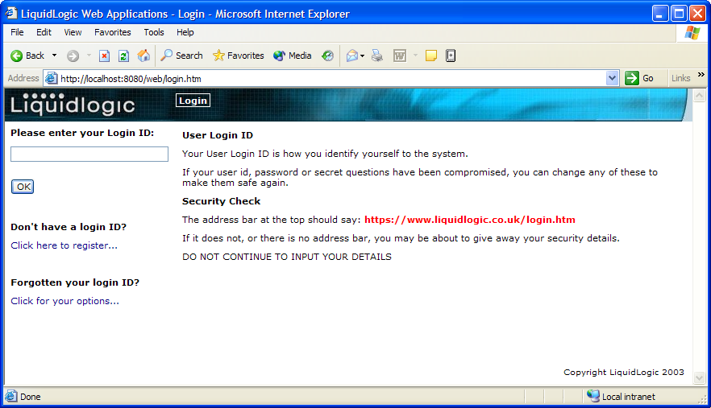

Logging In

Stage 1
Enter your User Id in the field provided and click OK

Stage 2
You will then be prompted to enter selected characters from your password (as below)

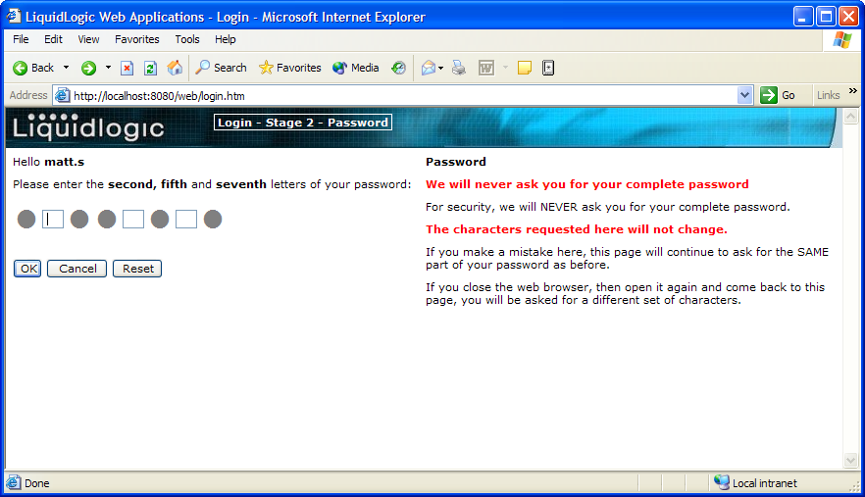

Enter the relevant characters and click OK to continue.

If you have entered your password incorrectly, a message will be displayed (as below) requiring you to input your password again

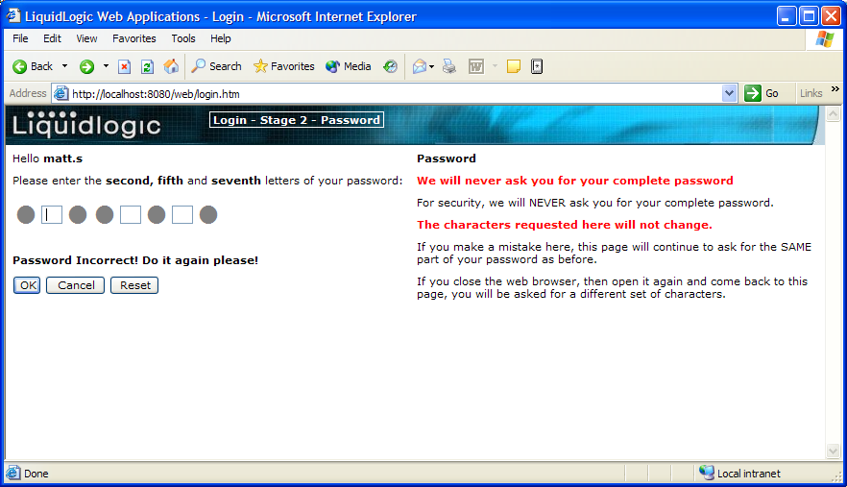

You will have 3 attempts to log in before being locked out of the system. If you get locked out, you will need to contact your Systems Administrator to be released before attempting again.

Stage 3
Next you will be asked at random one of your security questions (see example below)

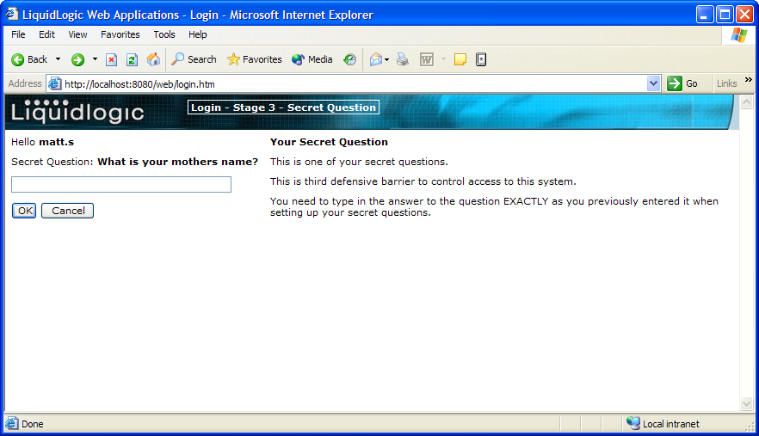

Input the response to the security question and then click OK to continue – this will open your work area within the application (see example below)

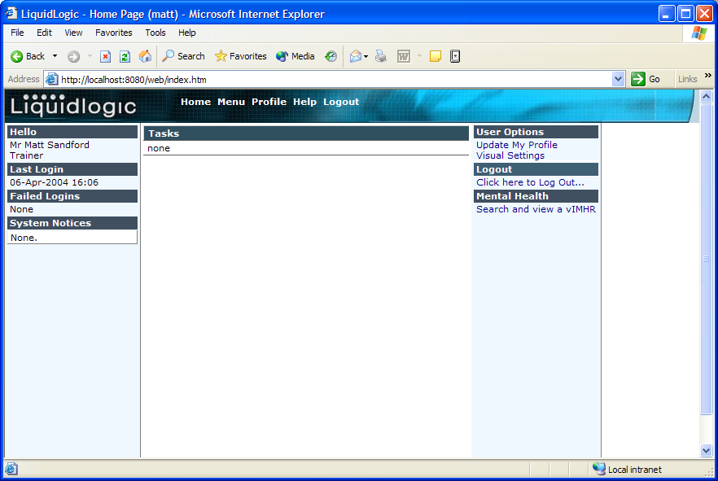

Updating Profile

The ‘Update My Profile’ option allows you to view and update your personal details on the vIMHR application. It is possible to update name, contact, password, security question and any additional information at any time whilst using the system. A lot of this information will remain the same, but it is possible to update these details at any time when required; for example, if your telephone extension number changes or you wish to update your password. Alongside each section there is a Help section which contains text to explain what information is required and how it should be entered. Any changes to your profile will require you to confirm your password on the password tab before you can update the information.

From your work tray select ‘Update my Profile’ and you will see the screen below.

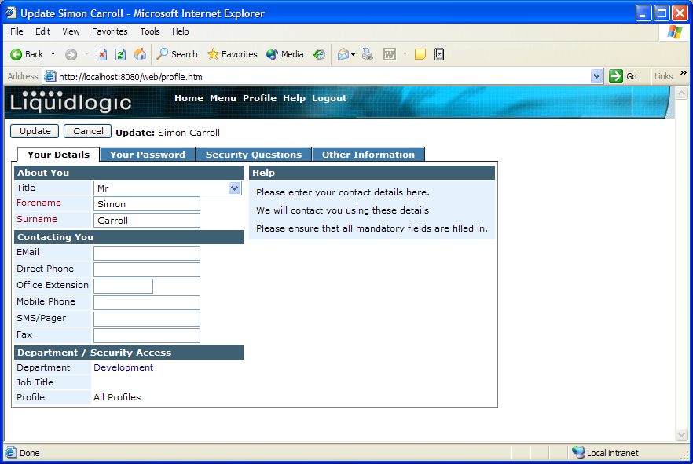

Your Details

This tab contains your basic details e.g. Title, Forename, Surname, Direct Phone number, Office extension etc.

Enter your details, confirm your password, then click on update, this will take you back to the work tray.

Once you have updated the details you can either move on to another tab, or click update to save your changes.
Your Password

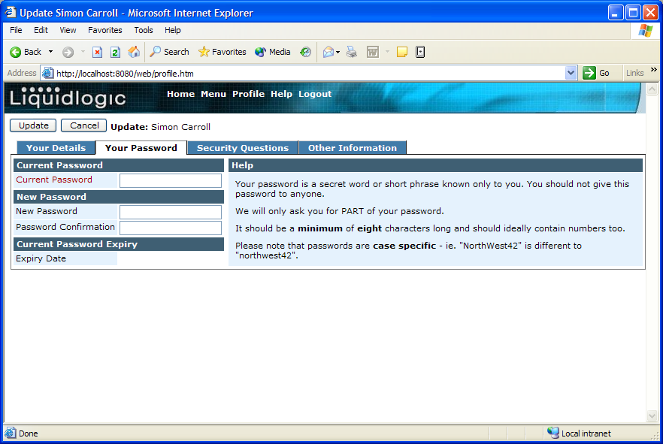

From here you are able to change/confirm your password.

Enter your existing password in the “Current Password” field, then enter your new password in the “New Password” and “Password Confirmation”.

Your password must be at least 8 characters long and contain at least 2 numbers (e.g. Winter04).

Your password is case sensitive, if you have added any capital letters into the password, you must always use them when logging into the system.

The system will use this new password for a defined period of time usually 90 days.

Once you have updated the details you can either move on to another tab, or click update to save your changes.

Security Questions

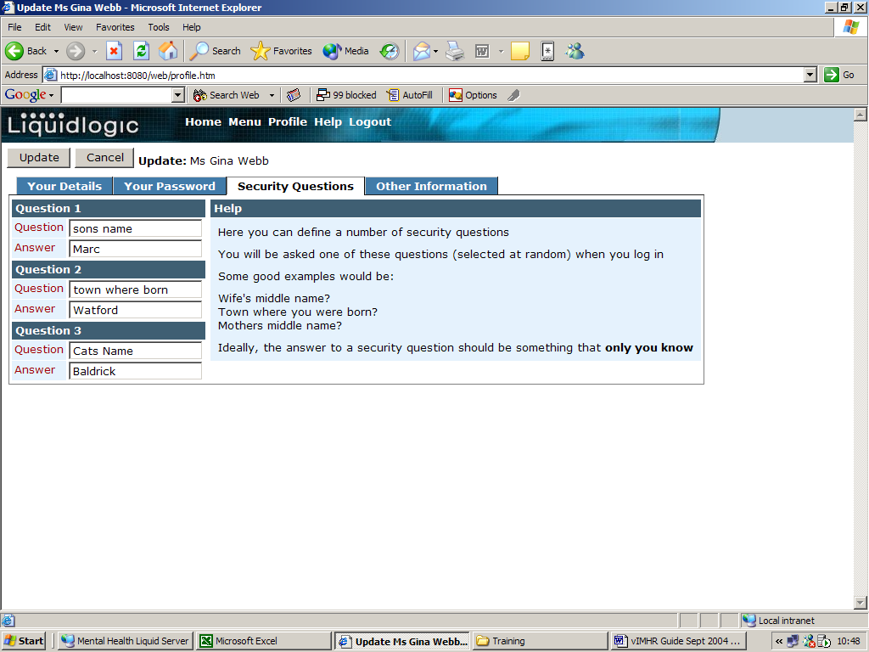

From here you are able to change your unique questions and answers that are part of your log in process. (e.g. son’s name)

Once you have updated the details you can either move on to another tab, confirm your password and click update to save your changes.
Other Information

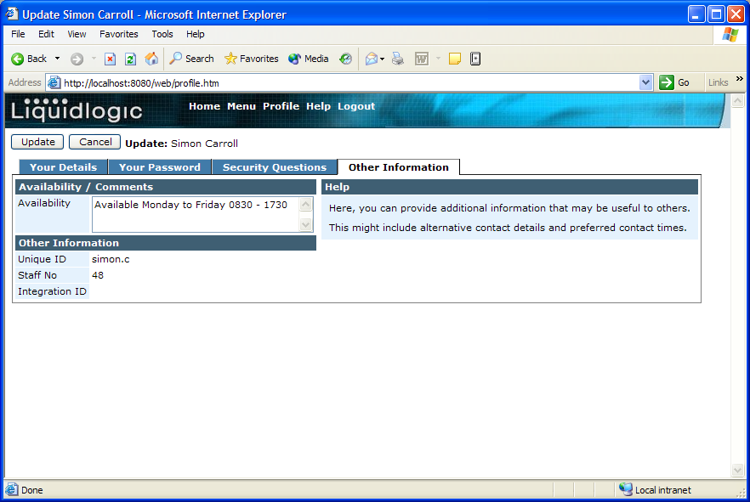

This is a free text box allowing you to enter any additional information that you feel may be useful for other users to know about your details. This could include alternative contact details, contact times or your availability (i.e. on emergency duty this current week).

Once you have updated the details you can either move on to another tab, confirm your password and click update to save your changes.

Search and View a vIMHR

Guidelines for Searching

Within the Search screen there are a number of different search fields that can be used. You do not have to input data into every field, invariably, less is best however; search results will differ depending upon how data is entered into the search fields.

The fields that are available to you are shown below and suggestions on searching are also included within these Guidance Notes.

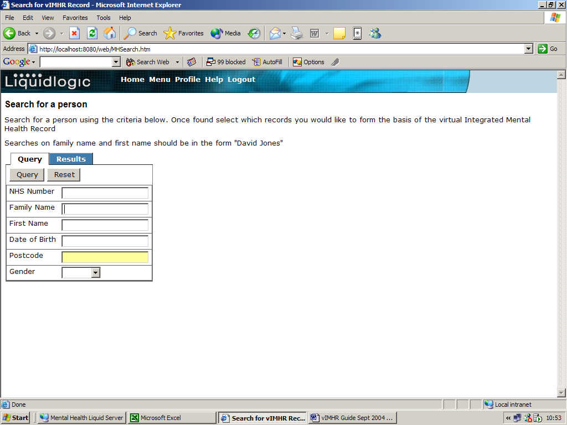

Entering exact information can sometimes result in no records being found. This is normally due to a number of factors:-

- Differences in spelling
- Differences in the data being supplied for the field and what’s been input into the core system originally – with the most common problem being encountered with the Forename
- Incorrect information held in original record i.e. wrong date of birth.
- Data held in different formats

Therefore, it is recommended that ‘wildcards’ always be used to improve the success of a search.

Wildcards

A ‘wildcard’ is a character % or * that is used to represent a character or series of characters. It can be added to the beginning, end or in the middle of data being entered into the search field.

Examples

- Searching for a Person whose surname is Brendan – this could have been entered into the database as Brendan, Brenden, Brendon, etc.,

To make searching for this person easier, you could enter the first 5 characters of the surname followed by the * into the Family Name field e.g.

Family Name = Brend%

Clicking on Search will then find you all records in the database for those people whose surnames begin with Brend. You would then use the data presented to match the person you are looking for.

- Searching for a Person whose surname is Daniel Smith – this is a very common surname and entering just the surname in the search criteria will present you with a very large list of results. Narrow this down by providing information in other fields available i.e. Forename

Enter the whole Surname in the Family Name field and then enter the Forename followed by the % into the Forename field e.g.

Family Name = Smith
Forename = Daniel%

Clicking on Search will then find you all records in the database for those people whose surnames are Smith but only if their first names start with Daniel

Service Users
In order to be find a service user on the FAME system you need to be aware that a service user must be aged 18-65 and be classified as a current Primary or Secondary Client Grouping of Mental Health recorded on the CareFirst system.

The Service User must also have one of the following recorded on CareFirst:-

- A Mental Health Act Section or informal admittance.

or

- A positive outcome to a CareFirst event carried out by a Mental Health team, or a positive outcome to an ASW event carried out by any team

or

- A positive outcome to a migrated assessment activity carried out by a Mental Health team, or a positive outcome to an ASW Activity carried out by any team

or

- A review activity, assigned to a Mental Health team or worker. (This uses the logic that if the service user has a review recorded, they must currently or in the past have been receiving services.)

Performing a Search

- Enter what information you have into the fields provided – if you enter your search criteria into only the Forename and/or Surname fields, the search is case sensitive. You must use capitals for the first letter of each name, i.e. John Smith. If you include other search criteria ie DOB, it does not have to be case sensitive. This is very important to remember because a search on lower case surname only, may not find results in the PCT system where an upper case search would have found results in the same PCT system.
- Click on the ‘Query’ button
- The system will query the information available and provide you with either a list of options or exact records from the various Mental Health Records.

Example - List of options
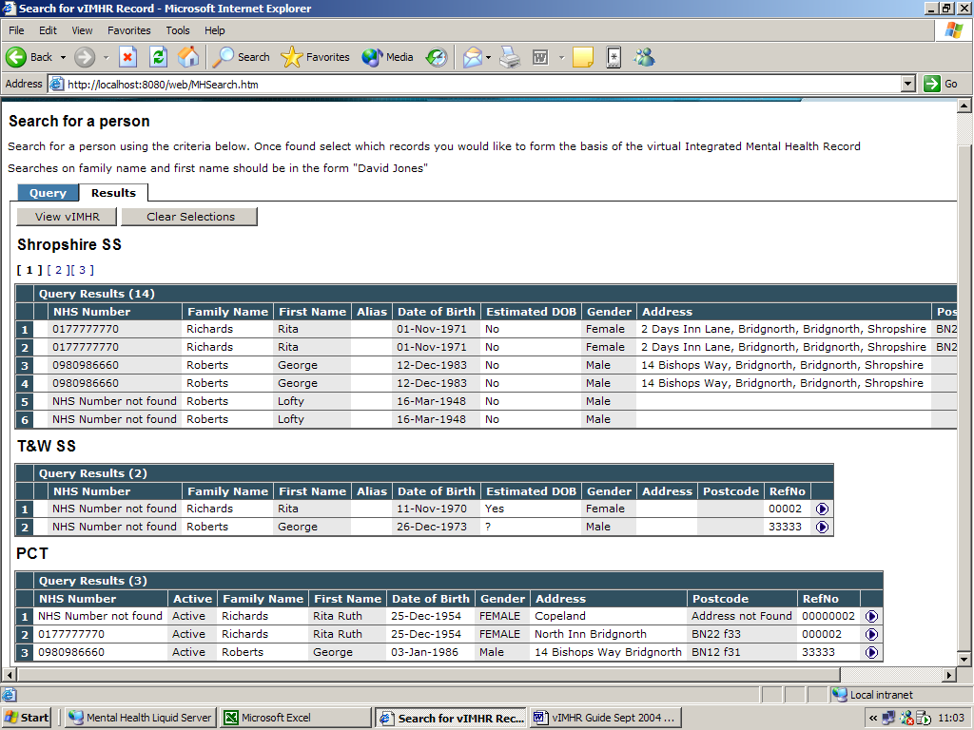

- The system will search across the databases to match the search criteria, in the example above the query found similar results from the Shropshire Social Services, Telford and Wrekin Social Services and the PCT.
- You may find some results appear that do not match the search that you entered; this may be because the Person found may have an alias that matches the query. If this is the case, you will find a tick (✓) in the Alias column.
- If you are presented with a number of different results, the maximum number that will be shown is 6, therefore, if more than 6 names were found from any of the databases, the results will be presented on different pages – see below:

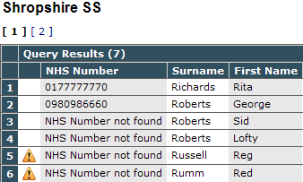

- The number in the brackets (7) tells you that 7 matching results were found but these have been presented over two pages . To view the second page, click on the [2].

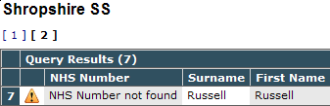

- Some records may show the indicator, this is to alert you to there being a warning indicator on the relevant system – you cannot access this information via the Liquidlogic application, you will need to access your core system or contact a key user for more information.
- If presented with a list of results (as above), it is possible to check the Persons basic details before you open those details fully. To do this, click on the button alongside the required entry.
- You will then be presented with a window displaying the Persons basic details (as below)

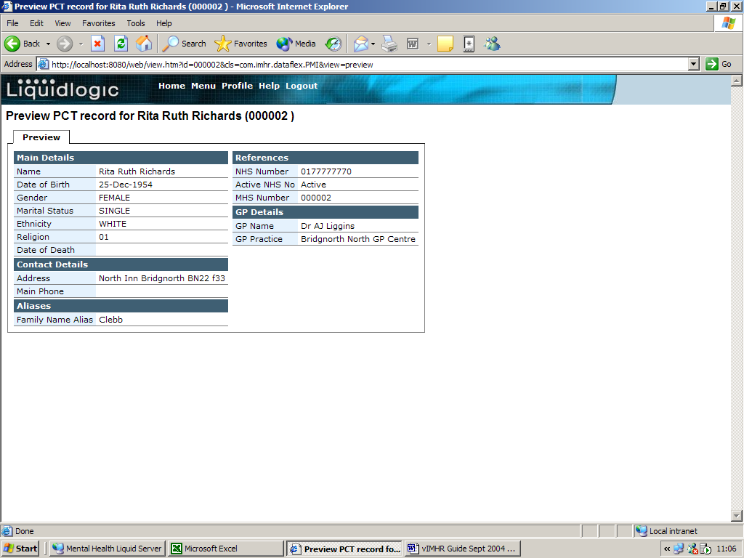

- Click on the ‘Back’ 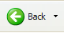 button to take you back to the search results screen.
- If the required entry is not listed, you will need to amend the search criteria. To do this click on the ‘Back’ button to take you back to the search screen, amend the original data entered and search again.
- If the search has found the correct Person, you will need to select that Persons’ details (by clicking once on their details), see below. NB From the 3 databases, in order to select and open the Persons vIMHR you MUST select at least one record from one of the first two databases (in this example, you must select at least one matching result from either the Shropshire SS or T&W SS database). It is possible to select only one results record (from the first two databases) or if a matching record has been found in all three databases, it is possible to select all three. Selecting a record from ONLY the PCT will NOT allow you to view the vIMHR.

- Once you have selected the Persons records, click on the button, this will open the Persons full vIMHR.

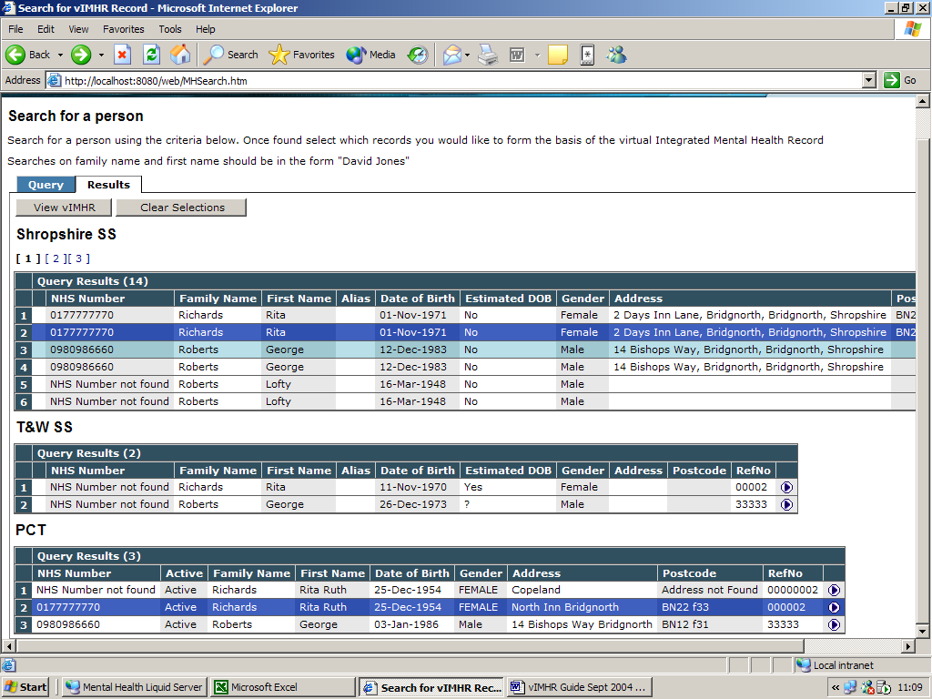

Viewing the vIMHR Details

The vIMHR details screen will initially present the combined database information at the Personal details screen. It is possible to open further information as and when required. This reference guide will show you how to open each section of the details screen to view all the patient information held against a vIMHR file.

If the vIMHR system is left inactive for 20 minutes, the system will automatically log you out of the system but will remember which screen you were in prior to logging you out. If you are logged out, you will be prompted to re-enter your login details to reactivate the system. For more details on logging into the vIMHR system please see the Electronic vIMHR Reference Guide Logging In.

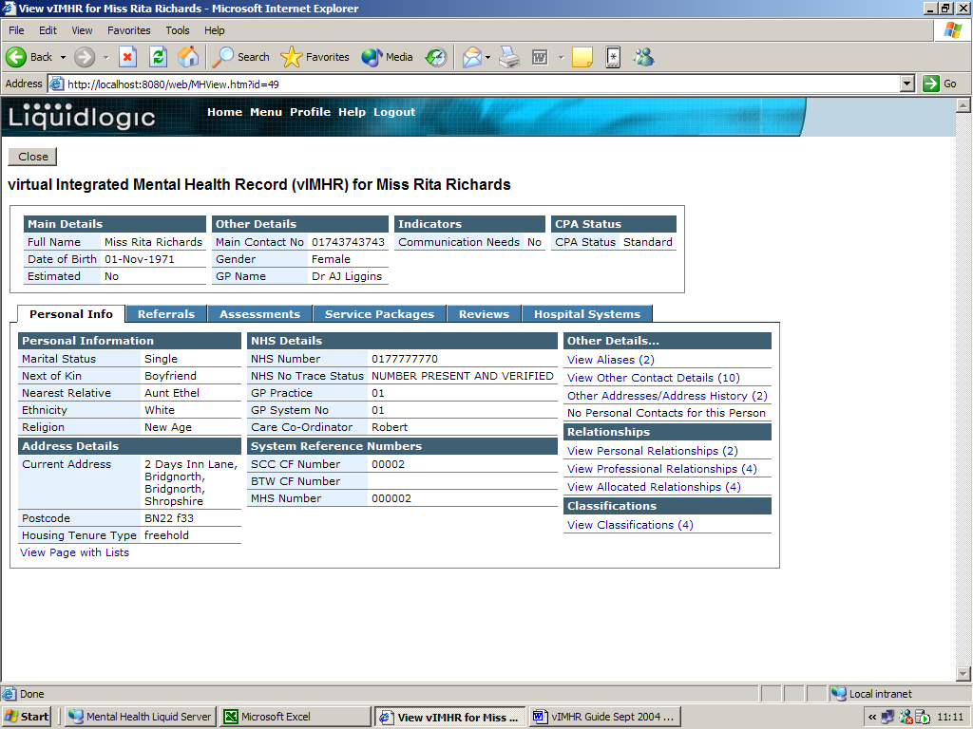

The details screen is split into 3 sections; Person Name; Persons Basic Details; Persons Detailed Information.

Person Name Details:

Persons Basic Details:
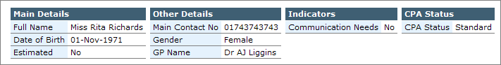

Persons Detailed Information:

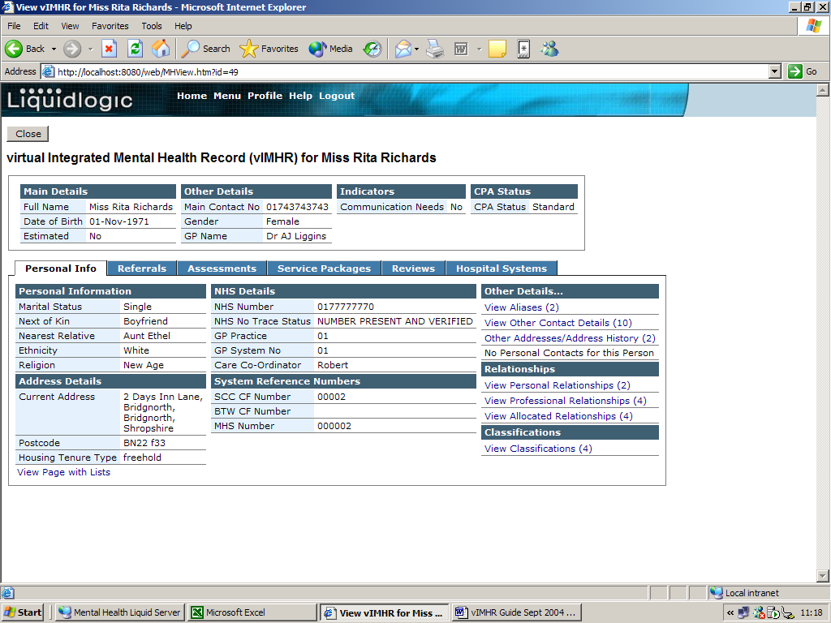

Viewing the Personal Info & Additional Information Tabs

The detailed information tabs present all the details held across the various databases that make up the vIMHR.

Within the Person Details window there are six tabs showing different types of information as below:

Personal Information | Provides personal details:  Personal details: Marital Status, Next of Kin, Ethnicity, Religion.  Address Details: Current Address, Post Code, Tenure Type.  NHS Details: NHS Number, NHS Trace Status, GP Practice (GP Name is shown on the Persons Basic Details in the Other Details section), Care Co-Ordinator.  System Keys: The database unique key identifiers  Other Details: Aliases, Contact Details, Address History  Relationships: Personal, Professional and Allocated Relationships.  Classifications: Religion
Referrals | Provides a summary of all the referrals that have been recorded for the service user.
Assessments | This tab provides summary information about assessments that have taken place for the service user. It also gives details of assessment activities and CPA Status History.
Service Packages | Shows previous and current service packages and Care First Care Plan Information.
Reviews | Shows a list of all the reviews and who carried them out, for that service user.
Hospital Systems | This tab shows the Inpatient and Outpatient information as part of the Hospitals Systems summary.

Viewing the Personal Info Tab

To view the personal information for the Person, select the ‘Personal Info’ tab, the screen will appear as below:

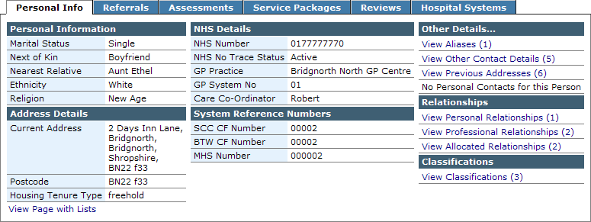

Any fields of information that appear in blue text means that it is possible to click on the text to either change the way the information is displayed, or allows you to ‘drill down’ to view more information relating to the blue text heading.

In order to display the information in a clear and concise way, the screen information has been summarised. The summary information is shown on the right of the screen under the headings of ‘Other Details’, ‘Relationships’ and ‘Classifications’.

If you wish to view all of the information in one go, click once on the blue text at the bottom of the Personal Info screen called ‘’. The screen will look similar to the following examples (the examples are split over two images as they are there is too much information to fit onto one screen):

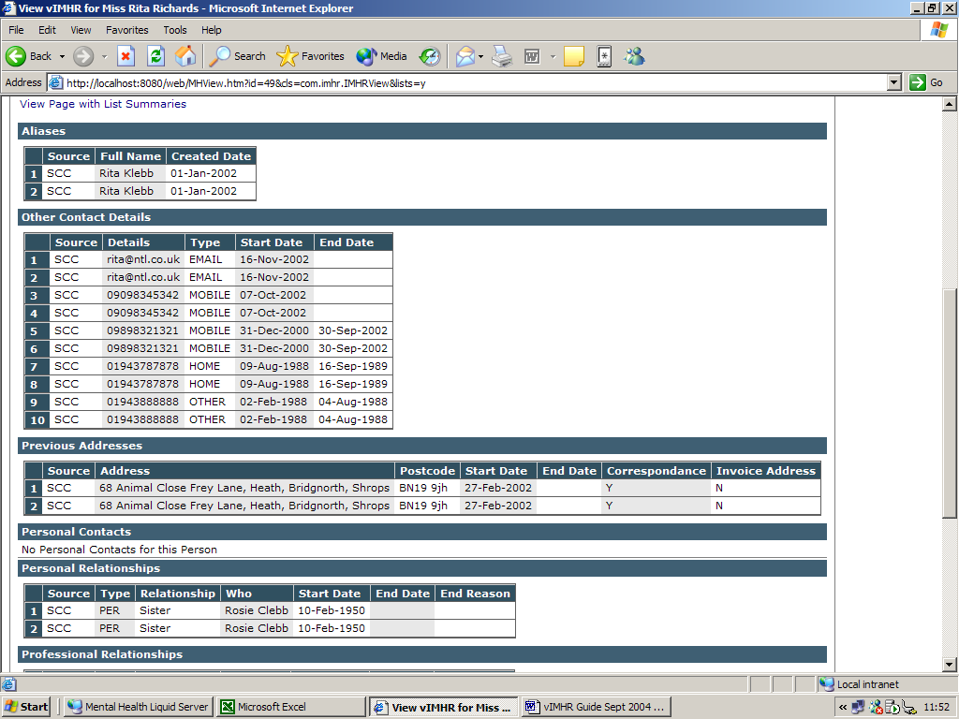

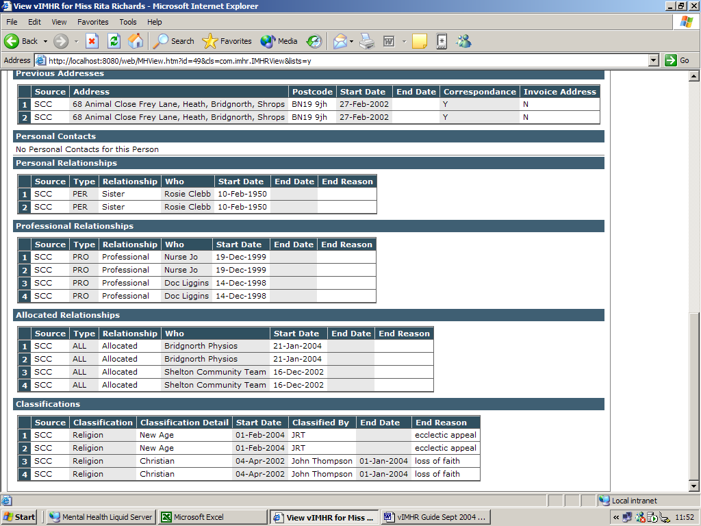

You will notice that the summary lists (on the right hand side of the screen) have disappeared and that the blue text has changed to ‘’. This is to allow you to return to the List Summary view and toggle back to view all the details whenever you want to.

If you view the information with the Summary Lists, it is still possible to view all the information; however, you view the information section by section, making it a lot clearer to view all the information you wish to look at.

To do this, simply click on the blue text from the following sections:

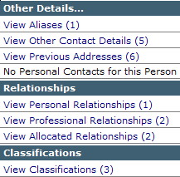

Other Details…

View Aliases
If there are any aliases available to view, the text will be shown blue (allowing you to click and open the details) and the number in brackets will represent how many aliases are recorded for this person. If you click on the View Aliases text, the following screen will appear:

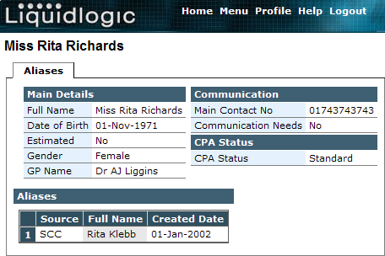

To return to the main details screen, click once on the Back button.

View Other Contact Details
If there are any other contact details available to view, the text will be shown blue (allowing you to click and open the details) and the number in brackets will represent how many other contacts are recorded for this person. If you click on the View Other Contact Details text, the following screen will appear:

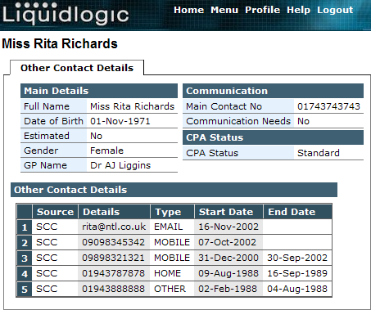

To return to the main details screen, click once on the Back button.

View Address History
If there are any previous addresses available to view, the text will be shown blue (allowing you to click and open the details) and the number in brackets will represent how many other addresses are recorded for this person. If you click on the View Previous Addresses text, the following screen will appear:

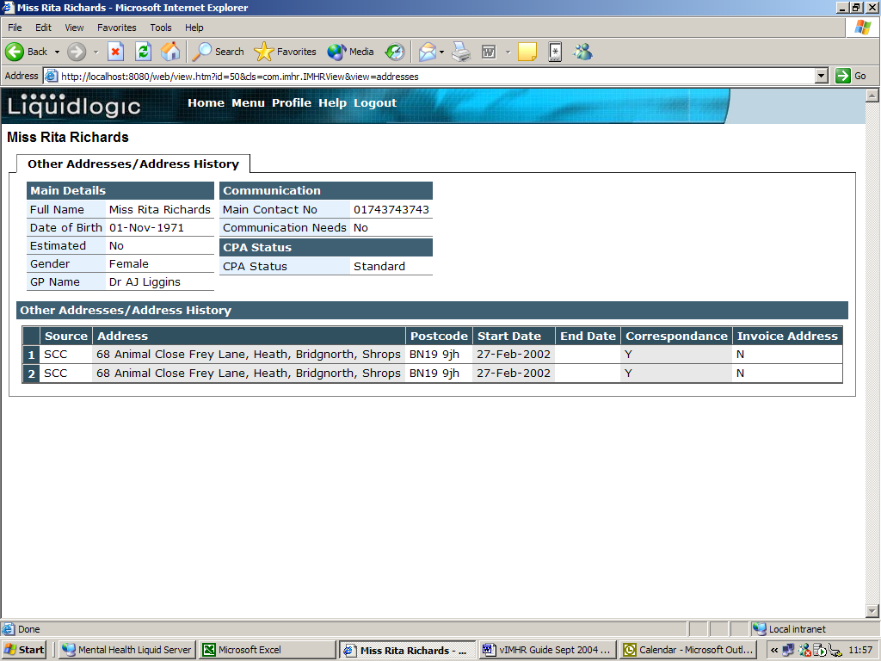
To return to the main details screen, click once on the Back button.

Personal Contacts for this Person
If there are any previous addresses available to view, the text will be shown blue (allowing you to click and open the details) and the number in brackets will represent how many other addresses are recorded for this person. If you click on the View Previous Addresses text, the following screen will appear:

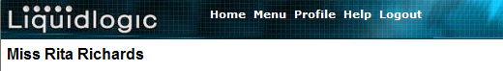
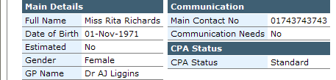
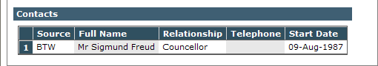

To return to the main details screen, click once on the Back button.

Relationships

View Personal Relationships
If there are any personal relationship details available to view, the text will be shown blue (allowing you to click and open the details) and the number in brackets will represent how many relationships are recorded for this person. If you click on the View Personal Relationships text, the following screen will appear:

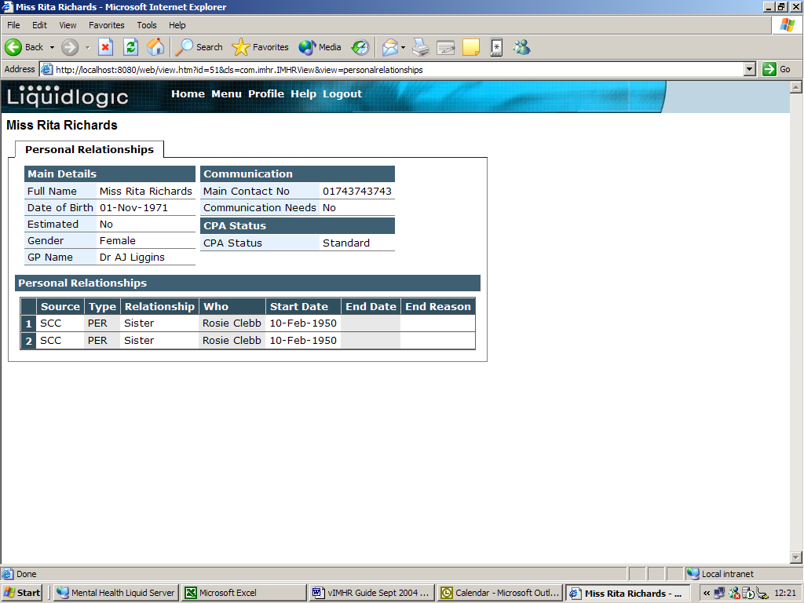

To return to the main details screen, click once on the Back button.

View Professional Relationships
If there are any professional relationship details available to view, the text will be shown blue (allowing you to click and open the details) and the number in brackets will represent how many relationships are recorded for this person. If you click on the View Professional Relationships text, the following screen will appear:

T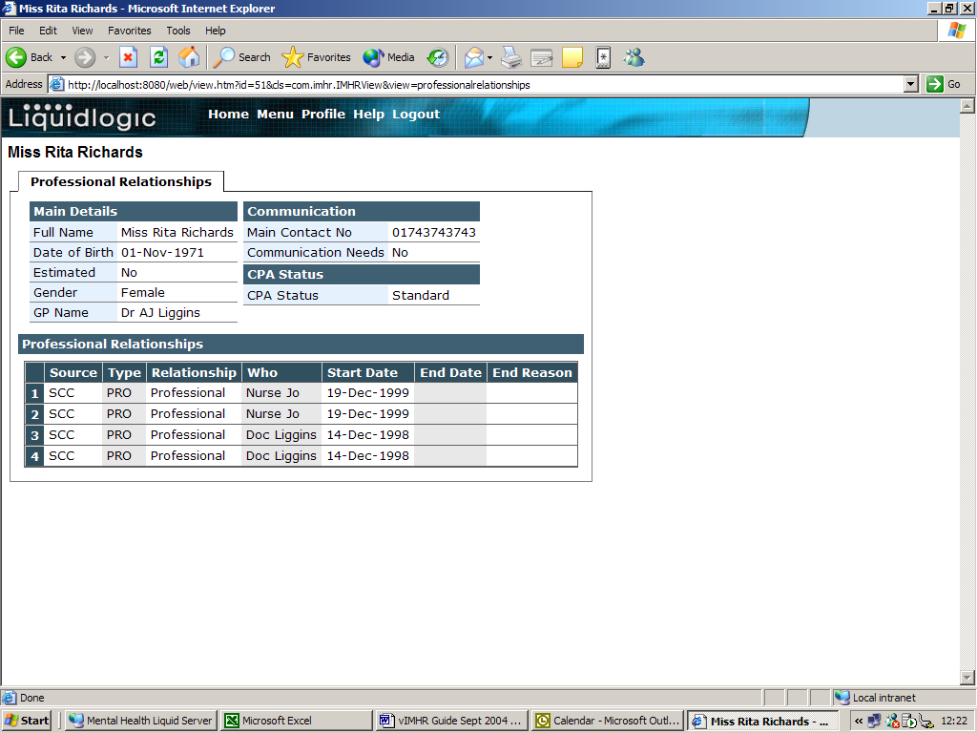To return to the main details screen, click once on the Back button.

View Allocated Relationships
If there are any allocated relationship details available to view, the text will be shown blue (allowing you to click and open the details) and the number in brackets will represent how many relationships are recorded for this person. If you click on the View Allocated Relationships text, the following screen will appear:

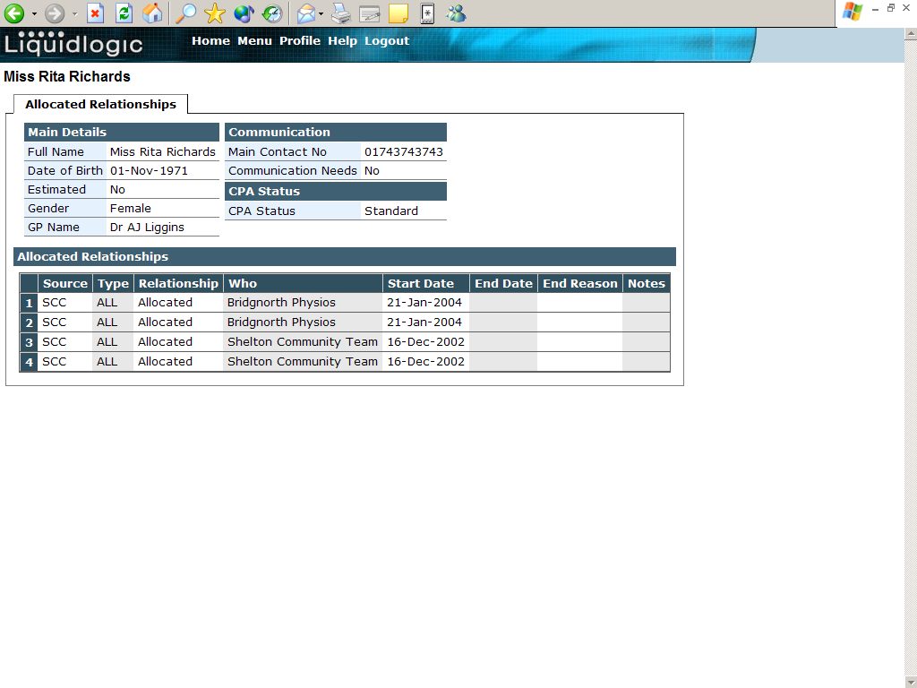

To return to the main details screen, click once on the Back button.

Classifications

View Classifications
If there are any classification details available to view, the text will be shown blue (allowing you to click and open the details) and the number in brackets will represent how many classifications are recorded for this person. If you click on the View Classifications text, the following screen will appear:

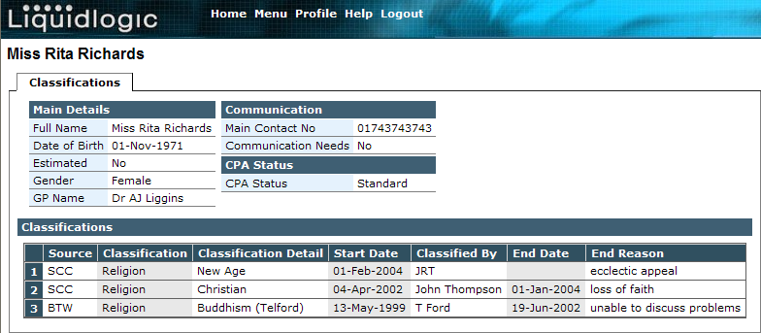

To return to the main details screen, click once on the Back button.

Viewing the Referrals Tab

To view the referrals information for the Person, select the ‘Referrals’ tab, the screen will appear as below:

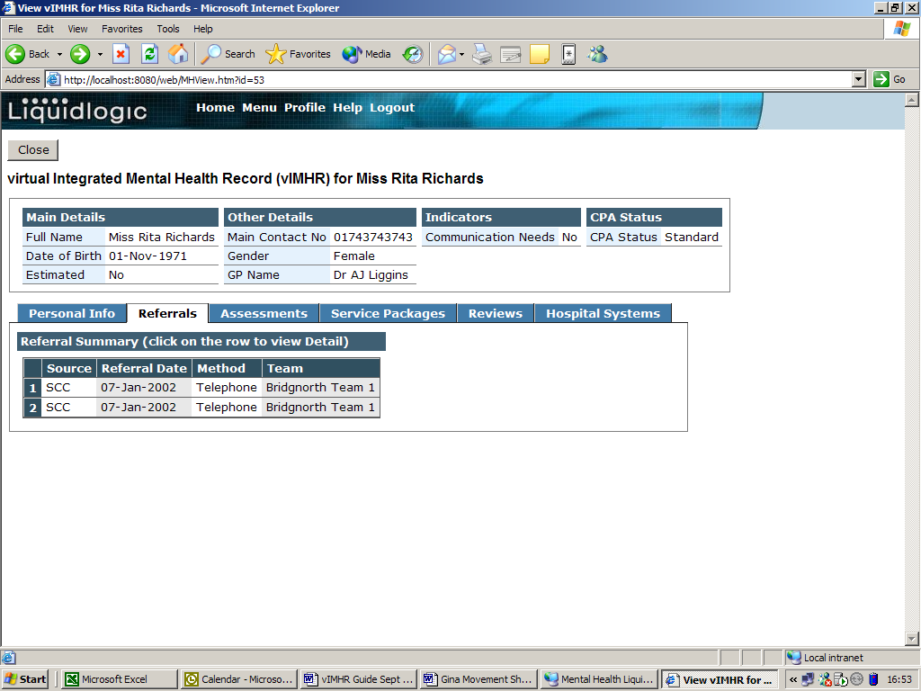

If there is any information recorded regarding the referrals that have been made for this person, they will be listed in the Referral Summary section – the most recent referrals will automatically be shown at the top of the list.

It is possible to ‘drill down’ to view the detail of specific referrals if required. To do this, move your mouse over the required line of information and it will be highlighted in blue:

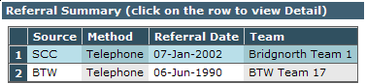

Once the line is highlighted, click once with your left mouse button and it will open the details.

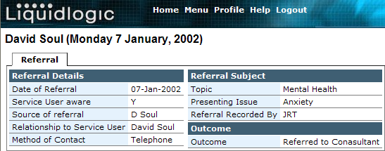

To return to the main details screen, click once on the Back button.

Viewing the Assessments Tab

To view the assessments information for the Person, select the ‘Assessments’ tab, the screen will appear as below:

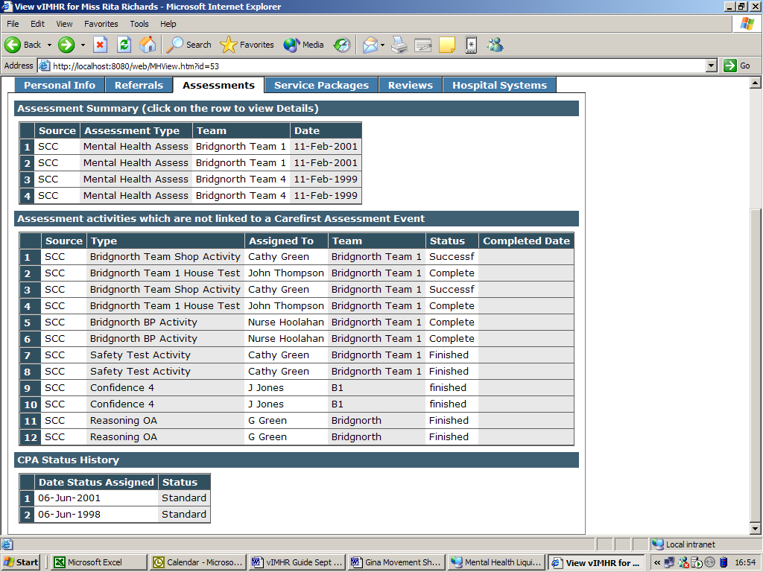

If there is any information recorded regarding the assessments that have been made for this person, they will be listed in the Assessment Summary section – the most recent assessments will automatically be shown at the top of the list.

The Assessment Activities section records assessment information from previous Social Services systems that are no longer in use. When this historical information was migrated (ie transferred from the older system to the current CareFirst system) into CareFirst, some of the information could not be matched up with the current assessment categories. It is therefore stored in this separate area so you are able to view all of the historical assessment information.

The CPA Status History provides information about any changes of Care Programme Approach status for the service user levels of over time. The list will always show the most recent status at the top of the list.

From this section, the only additional information is available from the Assessment Summary section.

It is possible to ‘drill down’ to view the details of the assessments if required. To do this, move your mouse over the required line of information and it will be highlighted in blue:

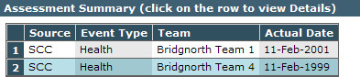

Once the line is highlighted, click once with your left mouse button and it will open the details.
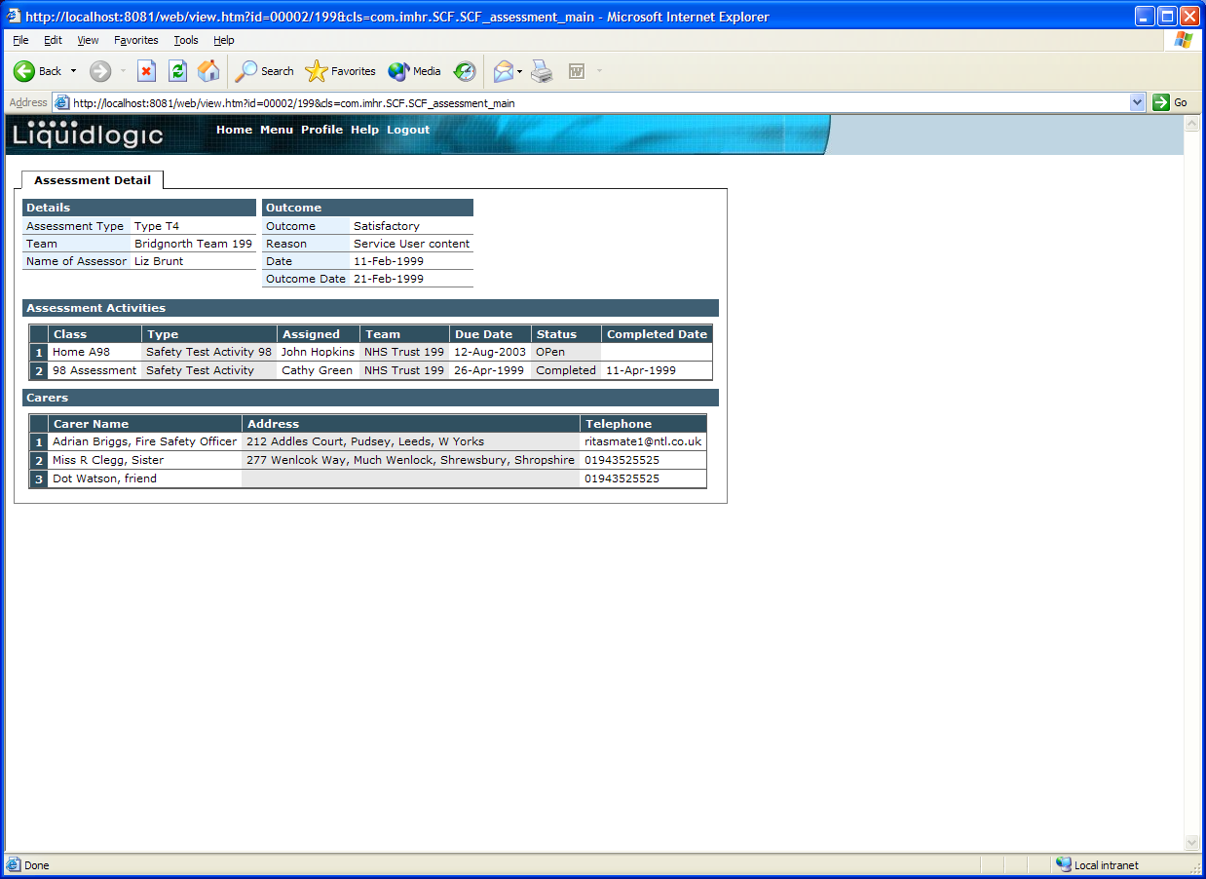

To return to the main details screen, click once on the Back button.

Viewing the Service Packages Tab

The Service Packages tab shows the services that have actually been delivered.

To view the services information for the Person, select the ‘Service Packages’ tab, the screen will appear as below:

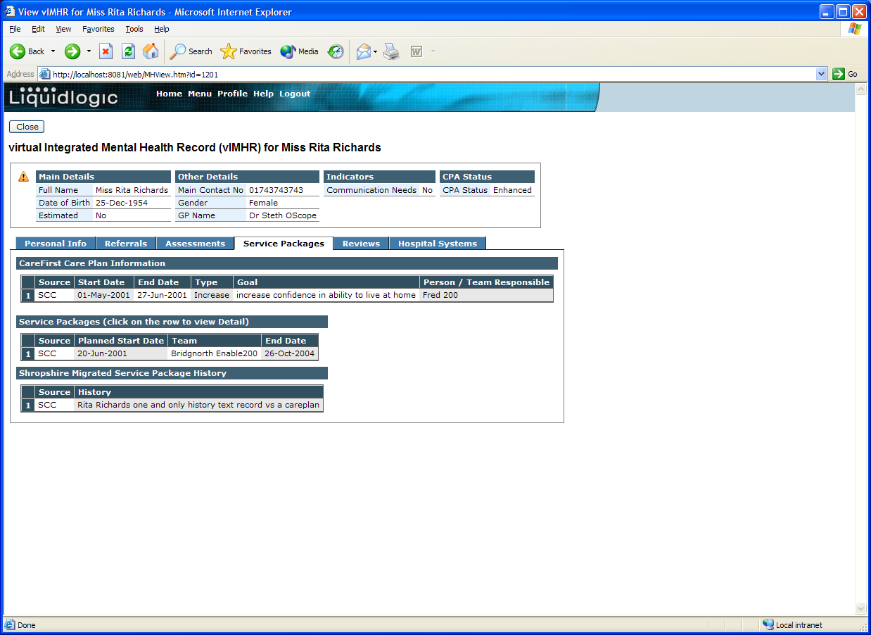

If there is any information recorded regarding the service packages that have been made for this person, they will be listed in the three sections: CareFirst Care Plan Information (provides information regarding what the person wishes to achieve with an overview of the objectives); Service Packages (packages provided and recorded within the CareFirst system) and the Shropshire Migrated Service Package History section (records service package information from previous Social Services systems that are no longer in use. When this historical information was migrated (ie transferred from the older system to the current CareFirst system) into CareFirst, some of the information could not be matched up with the current package categories. It is therefore stored in this separate area so you are able to view all of the historical information) – the most recent items will automatically be shown at the top of the lists.
From the Service Packages tab, the only additional information is available from the Service Packages section.

It is possible to ‘drill down’ to view the details of the services if required. To do this, move your mouse over the required line of information and it will be highlighted in blue:

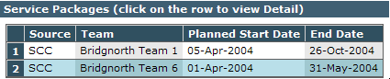

Once the line is highlighted, click once with your left mouse button and it will open the details.

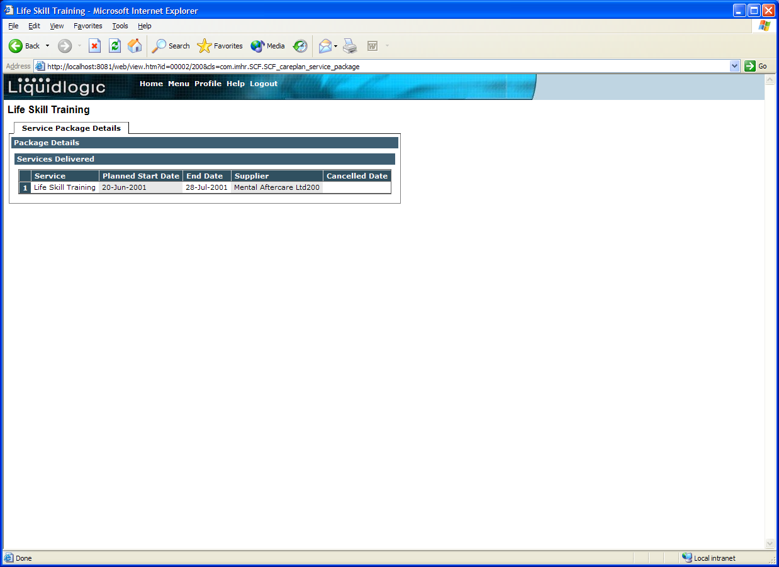

To return to the main details screen, click once on the Back button.

Viewing the Reviews Tab

To view the reviews information for the Person, select the ‘Reviews’ tab, the screen will appear as below:

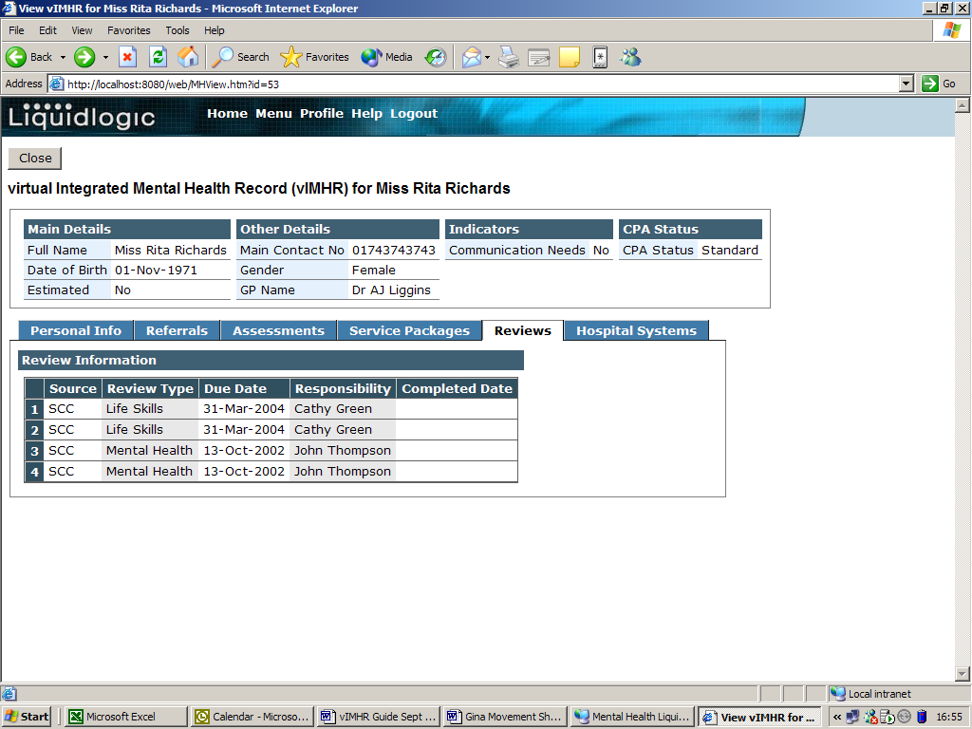

If there is any information recorded regarding the reviews that have been made for this person, they will be listed in the Review Information section – the most recent reviews will automatically be shown at the top of the list.

Viewing the Hospital Systems Tab

The Hospital Systems tab shows the In Patient and Out Patient details for the Person.

To view the In/ Out Patient information for the Person, select the ‘Hospital Systems tab, the screen will appear as below:

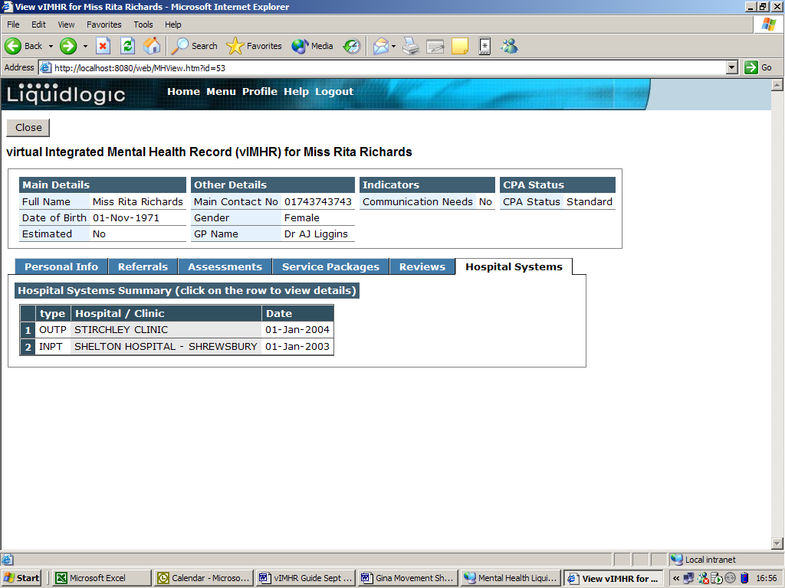

Within the ‘Type’ column, the codes INPT and OUTP relate to an In Patient and Out Patient record respectively.

It is possible to ‘drill down’ to view the details of the Hospital Systems Summary if required.

To do this, move your mouse over the required line of information and it will be highlighted in blue:

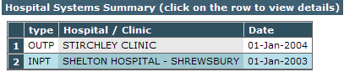

Once the line is highlighted, click once with your left mouse button and it will open the details.

In Patient Details:

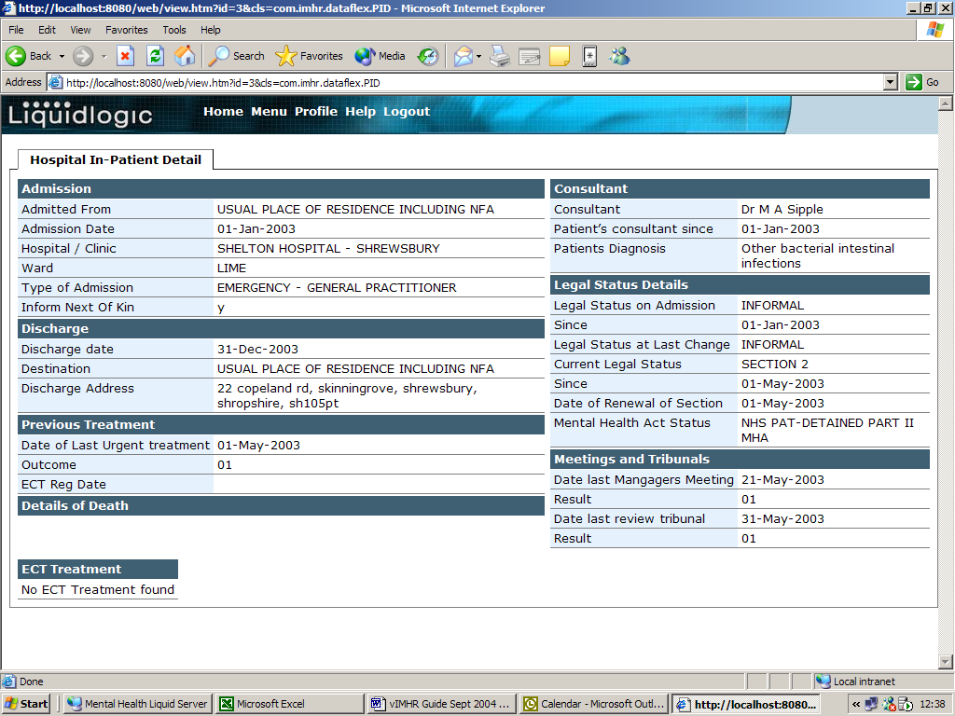

Out Patient Details:

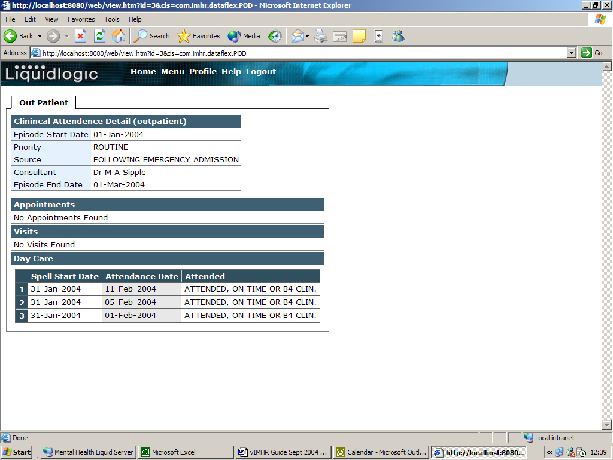

To return to the main details screen, click once on the Back button.

Logging Off

When logging off the system, you must log out by clicking on ‘Click here to log out’ and not just X out.

