Document Purpose

This document was produced by the FAME Programme to provide guidance and practical examples to all Local Authorities/Partner Agencies for an implementation of Multi-Agency working. All documents are the property of FAME National Project, and to access these documents you have agreed to the terms and conditions set out in the accessing of these products from the FAME website.

For a further description of this document please see the Product Definition below stating exactly what the product is. For more in depth explanation and guidance please see the FAME "How to Implement and Sustain a Multi-Agency Environment".

User documentation:
this is documentation that forms the basic user instructions for piece of software, it will consist of content and screen shots of the system. It will take a user of a technical system through the different steps and workflow to be able to use that system. It will be based on agreed upon processes from the business requirements, technical statement of requirements and information sharing protocols

Table of Contents

Introduction 3
Logging In 3
From Internet Explorer 3
Logging In 5
Setting up the System 6
Profile Maintenance 7
Adding a Profile Error! Bookmark not defined.
Deleting a Profile 8
Amending a Profile 9
User/Department Maintenance 11
Adding a Main Level Department 11
Adding a ‘Sub-Department’ 13
Updating a Department 14
Deleting a Department 14
Open Dept Details 15
Adding a User 16
Updating User Details 18
Deleting a User (Staff Member) 19
Moving a User between Departments 19
Changing User Passwords / Secret Questions 20

Introduction

Logging In

To be able to access the application you will need to know your user id, password and responses to 3 pre-defined security questions.

From Internet Explorer
To Log in via the Internet Explorer

- Double click the 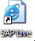 icon (you may also have an icon called “SAP Test”; this is the test area of the system for you to practice in) located on your desktop and a window similar to the one below will be displayed:

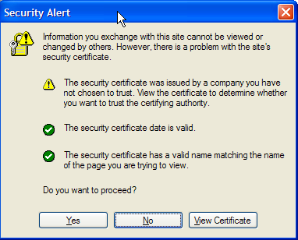

- Select ‘Yes’ to continue, the next screen that will be displayed will be the Liquidlogic Log in as below

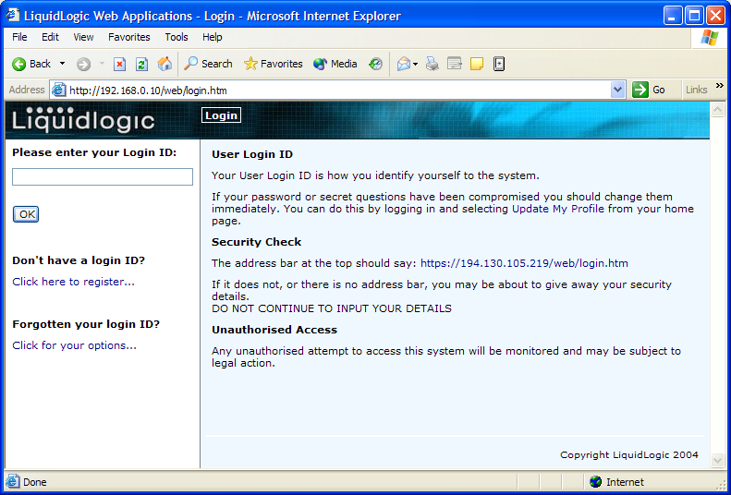

Logging In

Stage 1
Enter your User Id in the field provided and click OK

Stage 2
You will then be prompted to enter selected characters from your password (as below). You will never be asked to enter your full password, only 3 letters from the password, selected at random.

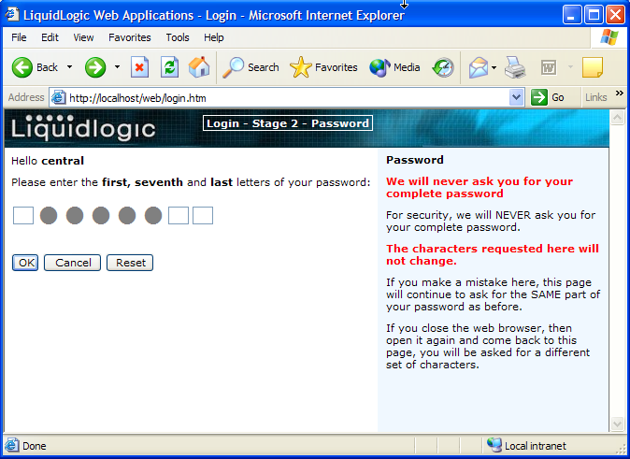

Enter the relevant characters and click OK to continue.

If you have entered your password incorrectly, a message will be displayed (as below) requiring you to input your password again

Stage 3
Next you will be asked at random one of your security questions (see example below)

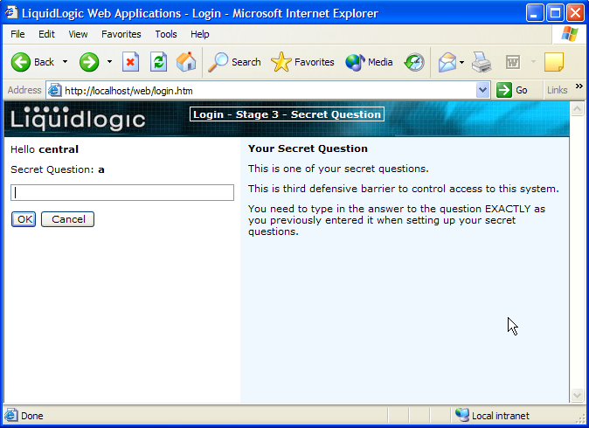

Input the response to the security question and then click OK to continue – this will open your work area within the application (see example below)

Setting up the System

The recommended order for the initial set-up of the Protocol application is as follows:-

- Profiles
- Departments
- Users

Maintain Departments and users from within ‘User/Dept Maintenance’

Profile Maintenance

Profiles determine the access users have to the system and are generally set-up to reflect ‘job’ types. Select the option ‘Profile Maintenance’ to view and update.

NB The main profiles will be created by Liquidlogic at implementation time. You are advised to consult the Help Desk before making changes to the hierarchy and to limit changes to adding sub-profiles.

‘Sub-Profiles’

When a profile is added from the highest level (All Profiles) all available access rights within the system are displayed.

You can add a profile within an existing profile (sub-profile) and at creation you will only be presented with those access rights currently associated with the higher level profile

In the example below, the profile of ‘Social Services Care Staff’ has been assigned access rights as displayed in the left side of the window

To Add a ‘Sub’ Profile

- Select the main profile from the list available, enter the name of the new profile and select ‘Add Profile’

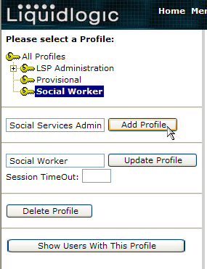

- Follow the steps as previous for setting up a profile being aware of the limited ‘access rights’ that will be available.

Deleting a Profile

You have the ability to delete profiles in instances where profiles have been created in error or you want to remove profiles that are no longer in use.

- Select the profile from the displayed list
- Select ‘Delete Profile’ option
- The profile will be removed immediately

It is important to ensure prior to deletion, that the profile is not in use by checking the staff that currently have the selected profile assigned to them (see instructions below).

Checking if a Profile is in use

- Select the profile you wish to check.
- Select the option ‘Show Users With This Profile’

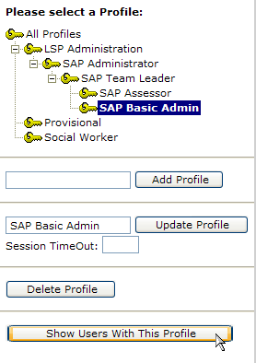
- A window similar to the one below will be displayed identifying those users that have the profile assigned to them.

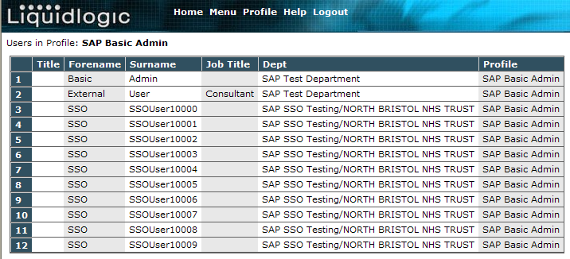

Warning – the system will allow you to delete a profile even if there are staff currently assigned to it!

Amending a Profile

If you wish to amend a name of the profile, select the profile to be renamed, enter the new name in the field to the left of ‘Update Profile’. See below.

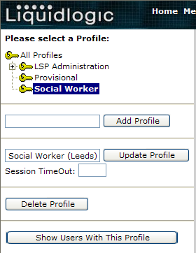

Select ‘Update Profile’ and the name will be updated.

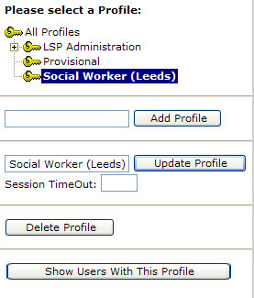

Shropshire special Profile settings

Messaging privileges

Extract Files

User/Department Maintenance

Departments are used to define the set-up/structure of an organisation within the Protocol application.

They identify which users are members of which team(s) which can if required, be associated to internal departments located within an organisation/office location, etc.,

e.g.
    - Organisation ‘Shropshire’ (main level Department)
    - Shelton Hospital (sub-department)
    - Central Team (further sub-department)
    - User 1 (OT)
    - User 2 (District Nurse)
    - User 3 (Social Worker)
    - Ward 1 Team
    - User 1
    - User 2
    - User 3
    - W2 Team
    - W3 Team
    - BTW
    - Civic Offices
    - Darby House
    - Madeley
    - User 1
    - User 2

The higher up the departmental hierarchy a user is placed (i.e. Main level), the more access they will have. In the example above, if a user is placed within the Organisation ‘Shropshire’, they would have access to every department below. If a user is a member of the General Hospital department, they would have access to General Hospital and all the associated ‘teams’ within. A user assigned to a specific team (in this example) would be able to access that team only.

Adding a Main Level Department

From the General Maintenance menu select the option ‘User/Dept Maintenance’ and a window like the example below will be displayed

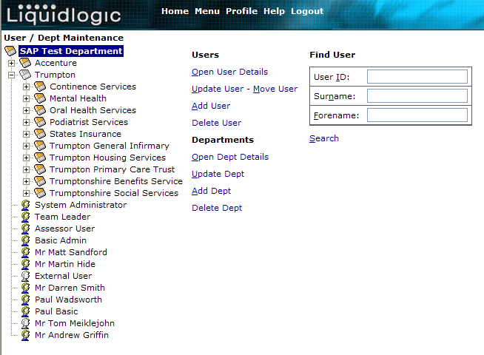

From here you can add, update and delete departments and users.

- From the General Maintenance Menu select the ‘User/Dept Maintenance’ link.
- Select ‘Add Dept’, from under Departments
- The following window will be displayed allowing you to enter the details for the Department.

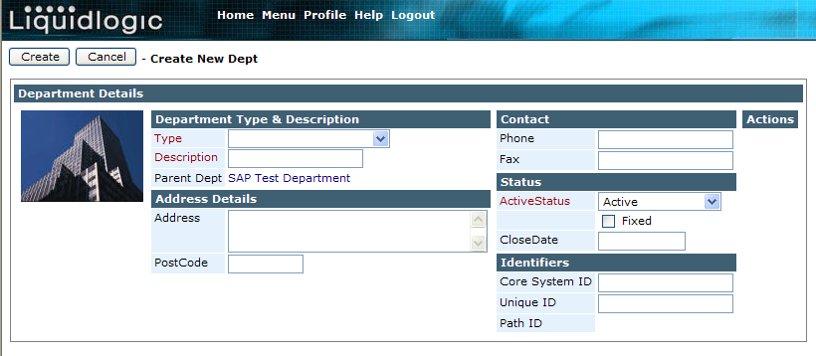

- You will notice that some of the ‘field’ descriptions are printed in RED – this denotes that these fields are mandatory and must be completed in order to set-up a department.
- The ‘Type’ option will present you with a list of options to choose from these can be added locally – see later section ‘Picklist Maintenance’
- Select the relevant ‘type’
- Enter the name (description) for the department to be added
- The Address, Postcode, Phone and Fax fields do not need to be entered but are useful as this information can be used to automatically populate letter templates, faxes, etc., from within Processes used within the Protocol system
- The ‘ActiveStatus’ option again will present you with a list of choices shown below and these are as depicted by the system

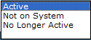

Active – Indicates that the Department is currently in use by the system
Not on System – Allows the Department to be used/displayed within the application but indicates that they will not be able to receive information electronically
No Longer Active – Indicates a Department that is electronic but is currently not receiving work via the system
- Select ‘Create’ to accept the details and the Department will be added automatically
- Cancel will close down the window without actioning anything

Adding a ‘Sub-Department’

Departments are set up in hierarchical format in the system so you can replicate existing department / team structures as required (see example below)

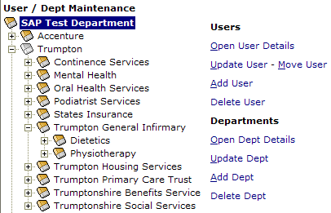

- To add a ‘sub-department’ select the Department that the ‘new department’ is to be a part of
- Select ‘Add Dept’
- Follow steps as previous for adding a new department

N.B. A user will have access only to the Department they are in and to any ‘sub-departments’ located within

Viewing Departments

If a department contains ‘sub-departments’, a plus (+) indicator will appear to the left of the department.

Clicking on the + will expand to show the departments contained within. This indictor will continue to appear against the ‘sub-departments’ if further departments are contained within. Once a department has been expanded the + switches to a -. To close a department select the – and the department will contract and the – will switch back to +.

Clicking on each + in turn will continue to expand the departments.

If there is no + to the left of the department then it contains no ‘sub-departments’!

Updating a Department

If the details of a department change e.g. the name, the electronic availability, etc., then it is important to update the department details.

- From the General Maintenance Menu select the ‘User/Dept maintenance’ option
- Next, select the department that needs to be updated
- Select the ‘Update Dept’ and the following window will be displayed

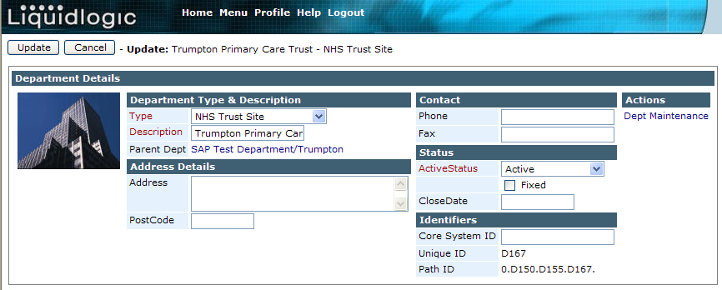

- If you want to add to the description, click once in the field to deselect the text first before typing.
- Continue to make the relevant changes following the steps as previous for adding a new department.
- Clicking OK automatically saves the changes that have been made.

Deleting a Department

You have the ability to delete Departments in instances where they have been created in error.

- Select the relevant Department / ‘sub-department’.
- Select ‘Delete Dept’ option
- The department will be removed immediately

N.B. If a department is no longer in use you should not delete the department. Instead, you should ‘Update’ the department changing the ‘active status’ accordingly.

Also, the system will not allow you delete a department that contains staff (users). When you select a department staff members will be displayed in the right of the window.

Should you choose the option to delete at this point the following message will be displayed.

N.B. In order to delete this department, you would firstly need to move or delete the staff within it (see later sections Moving Users and Deleting Users).

Open Dept Details

If you just wish to view the department’s details, select ‘Open Dept Details’

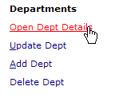
A window like below will be displayed.

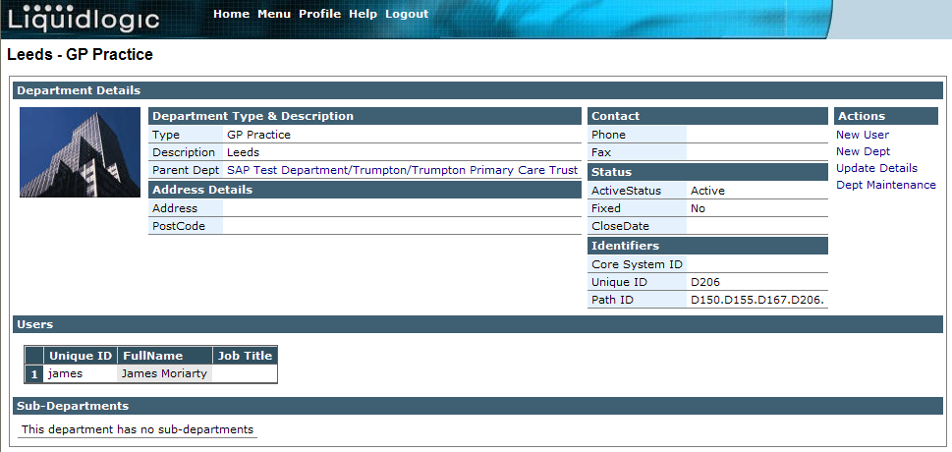

From this window you are able to –

New User | Allows you to create a new user for this department
New Dept | Allows you to create a sub department
Update Details | Allows you to update/change details of this department
Dept Maintenance | Takes you back to User/Department Maintenance.

You are also able to view the users within this department, and by selecting a user, the details of that user will be displayed. See below.

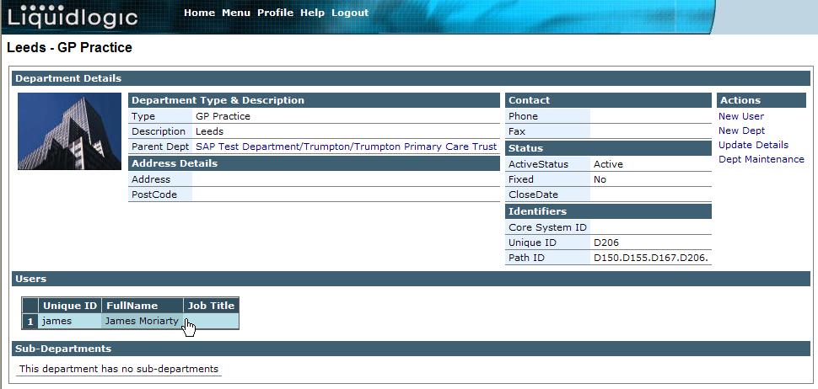

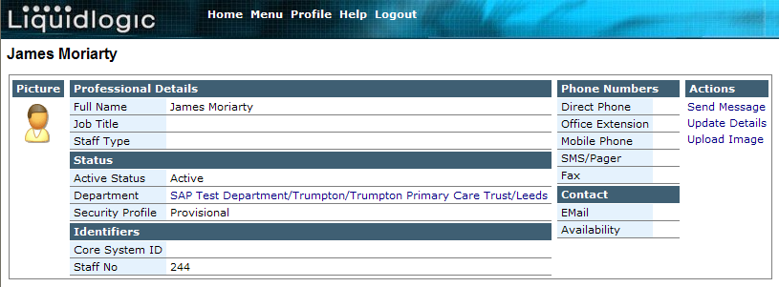

And form here you would be able to update the user’s details (See User/Department maintenance).

Adding a User

In the right side of the ‘User/Department maintenance’ window you will find ‘action buttons’ (as below) that are used for adding, updating, moving and deleting users.

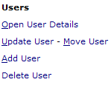

- From the General Maintenance menu select the option ‘User/Dept Maintenance’.
- Select the relevant Department that the user is to be a member of
N.B. Users have to be members of a Department so it is necessary to select the relevant Department from the hierarchy before you can add a user. A user can only belong to one department.
- Select ‘Add User’ button and the following window will be displayed

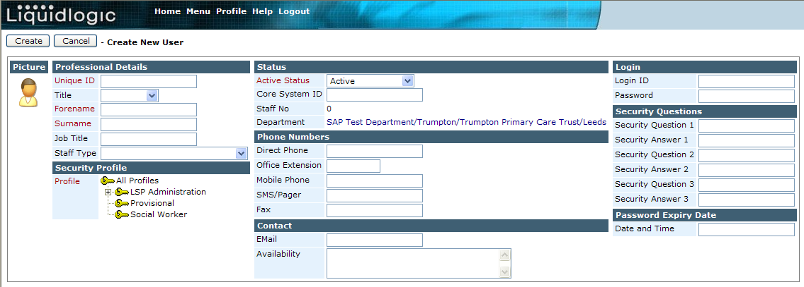

- You will notice that some of the ‘field’ descriptions are printed in RED – this denotes that these fields are mandatory and must be completed in order to set-up a user (the Staff No will be provided automatically by the system).
- Input the details for the user

Unique ID | This will provide the ‘Log In’ for the User. It should be a maximum of 40 characters. Avoid spaces and combining upper and lower case characters – use either all l/case or all caps.
Title | Choose as appropriate from the list provided
Forename (mandatory) | The Forename field is highlighted in red, this indicates that the information is mandatory and must be entered before the details can be saved or updated. It should contain only the user’s first name.
Surname (mandatory) | The surname field is highlighted in red, this indicates that the information is mandatory and must be entered before the details can be saved or updated.
Job Title | This is a free text field where the users job title can be entered
Staff Type | Choose from the drop down.
Profile | Choose the relevant profile for the user by clicking in this field and selecting from the list of profiles available
ActiveStatus | Active – Indicates that the User is currently in use by the system  Not on System – Allows the user to be used/displayed within the application but indicates that they will not be able to receive information electronically  No Longer Active – Indicates a user that is electronic but is currently not receiving work via the system
Department | Details which department the user belongs to
Direct Phone | Enter the user’s telephone number in this field.
Office Extension | If the user has an extension number, enter it in this field.
Mobile Phone | If the user has a mobile telephone number, enter it in this field.
SMS Pager | If the user has an SMS or Pager, enter it in this field.
Fax | If the user has a fax number, enter it in this field.
Email | If the user has an Email address, enter in this field
Availability | This is a free text box allowing you to enter any additional information that you feel may be useful for other users to know about the user. This could include alternative contact details, contact times or your availability (ie on emergency duty this current week).
Login | This will provide the ‘Log In’ for the User. It should be a maximum of 40 characters. Avoid spaces and combining upper and lower case characters – use either all l/case or all caps.
Password | The password should be at least 8 characters long, it is case sensitive and should contain at least 2 numbers. Example – ‘Password11’
Security questions | Enter a selection of unique questions and answers (that is known only to the user). These are the answers that the user will enter when the system randomly selects a question when logging into the application.
Password Expiry Date | This specified the date when the password will expire.

N.B. If you don’t have all the user info available at initial set-up, this can be added later by updating the user details. Alternatively, the user can add/change their personal information themselves from within the work tray.
- Selecting ‘Create’ will add the user to the selected department.
- If you have omitted to complete any of the mandatory fields you will not be able to add the user. The following message will be displayed identifying which fields need to be completed.

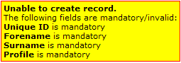

Updating User Details

If the details of a user change e.g. their name, electronic availability, etc., then it is important to update the user details.

- From the General Maintenance Menu select the ‘User/Dept maintenance’ option
- Next, you will need to locate the user that needs to be updated within the relevant department
- Select the relevant user, select ‘Update User’ and the following window will be displayed

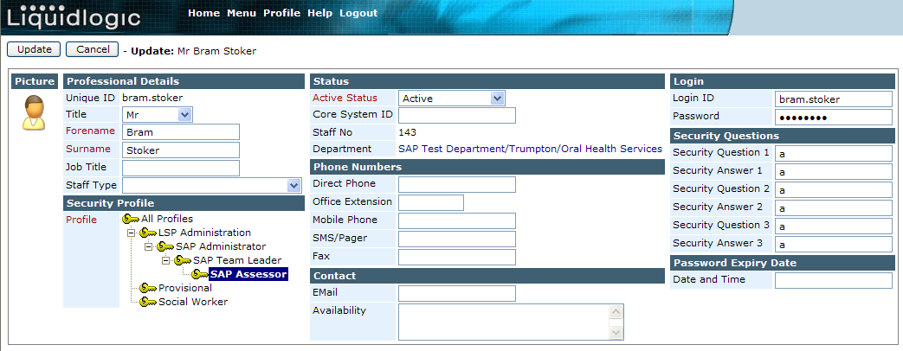

- Make any relevant changes following the steps as previous for adding a new user.
- Selecting ‘Update’ automatically saves the changes that have been made.

N.B. You cannot update the Users ‘Unique ID’ (log in) once it has been added – the field is not available. If you need to change the ‘Unique ID’ (log in) for a user, you will need to delete the original staff record and add the user again with the new ‘Unique ID’ (log in).

Deleting a User (Staff Member)

You have the ability to delete Users in instances where they have been created in error.

If a User is no longer ‘using’ the system you should not delete them. Instead, you should ‘Update’ the users details changing the ‘active status’ accordingly.

- Select the relevant User
- Select ‘Delete User’ and the following message will be displayed

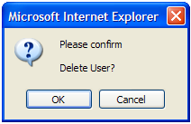

- The User will be removed immediately

Moving a User between Departments

Users can only belong to one department and sometimes it will be necessary to move users to different departments

- To move a user from a department, firstly select the user
- Then, select ‘Move User’ and the following window will be displayed

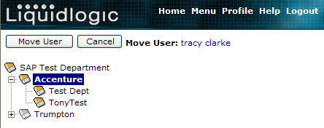

- From the displayed window, select the department to move the user to
N.B. It may be necessary to expand the departmental hierarchy to find the relevant department.
- Selecting Cancel will close the window without moving the selected user
- Selecting ‘Move User’ will move the user immediately to the selected department.

Changing User Passwords / Secret Questions

If a user has forgotten their password or secret questions, it will be necessary to reset the details before the user can attempt to log in again.

To re-set a user password or security questions, firstly select the user

Select ‘Update User’ and the following window will be displayed

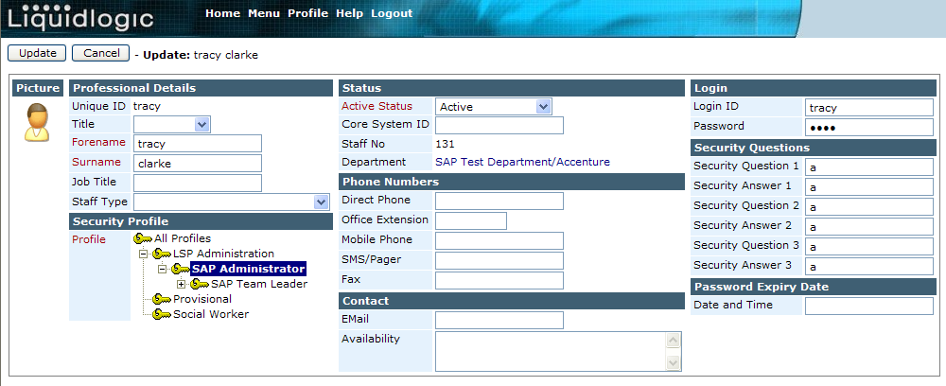

Changing a Password/Questions

- Enter a ‘new’ password into the Password field
- Change the Expiry date accordingly i.e. 30 days and select ‘Update’
- The user should be informed of their new password and should be reminded to change their password immediately to make it secure

Appendix 1 – Profile hierarchy for rollout

A System Admin ‘hierarchy’ seemingly works fine. The only practical set up I can envisage is:
1. All Profiles – all options
2. System Admin – extracts, passwords, messaging admin if used
3. Local Admin - passwords

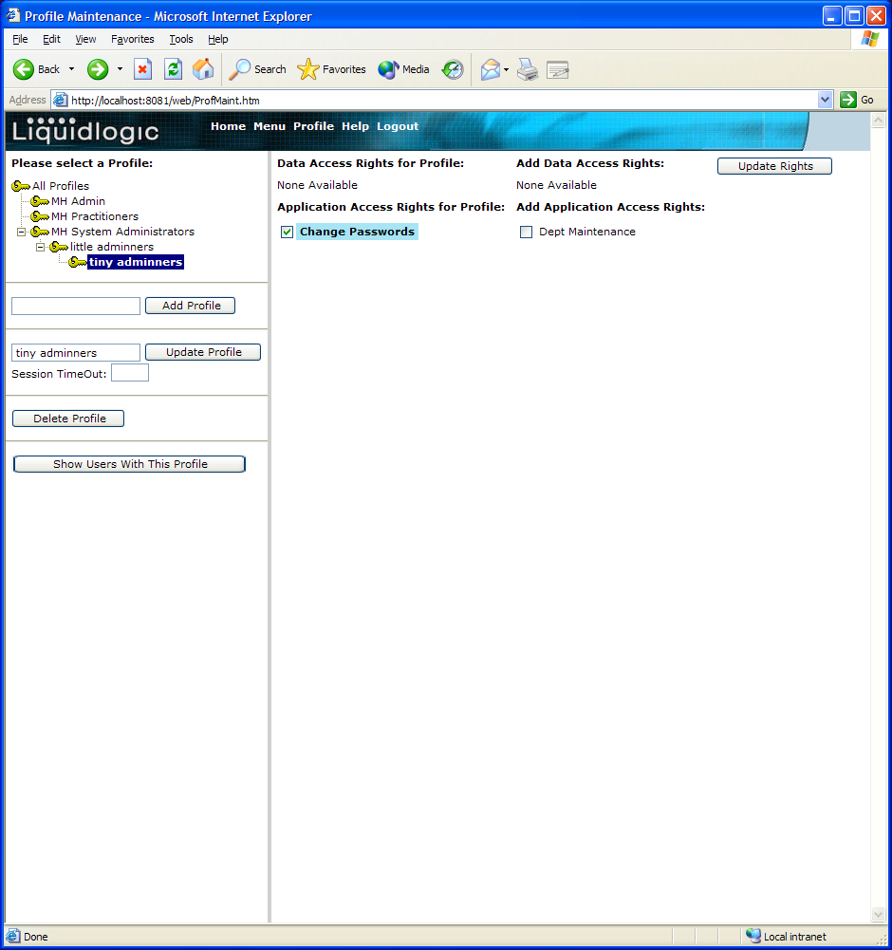

Amend current users’ profile individually via Open User – Update Details

