Document Purpose

This document was produced by the FAME Programme to provide guidance and practical examples to all Local Authorities/Partner Agencies for an implementation of Multi-Agency working. All documents are the property of FAME National Project, and to access these documents you have agreed to the terms and conditions set out in the accessing of these products from the FAME website.

For a further description of this document please see the Product Definition below stating exactly what the product is. For more in depth explanation and guidance please see the FAME "How to Implement and Sustain a Multi-Agency Environment".

Specification of Requirements:
the technical and process specifications to support the development and implementation of a working solution.

Table of Contents

Chapter1. Purpose & Functional Scope of Project 4
1 Project Summary 4
2 Purpose of Project 5
3 Scope of Project 5
4 Proposed Approach 6
5 Stakeholders and Actors 7
6 Business Rules Catalogue 8
7 Acceptance of Client Requirements Specification 9
Chapter2. Glossary 10
1 Glossary of Terms Used 10
Chapter3. The Use Cases 10
1 What Are Use Cases? 10
2 The Use Cases 13
Chapter4. Technology Requirements 27
1 Data Requirements 27
2 Hardware Requirements 29
3 Integration Requirements 29
3.1 Data Integration 30
3.2 System Integration 30
Chapter5. Other Technical Requirements 32
1 Development Process 32
2 Project Constraints 32
3 Operations and Security 33
4 Documentation 33
5 Usability Requirements 33
6 Performance Requirements 34
7 Reporting Requirements 34
8 Maintenance and Portability 34
9 Deferred Issues 34
10 Unresolved Issues 35
Chapter6. Soft Systems Issues 36
1 Human Backup to System Operation 36
2 Legal and Political Requirements 36
3 Human Consequences of Completing the System 36
4 Training Requirements 36
5 Assumptions and Dependencies 36
Chapter7. Appendices 38
Appendix 1 Data Requirements 38
Appendix 2 Prototype 41
Appendix 3 – Mental Health Use Case information 50

- Purpose & Functional Scope of Project

Project Summary

This project aims to deliver a multi-agency software system to allow Health and Social Services professionals to have a complete picture of a Service User’s mental health record including all operating care processes. As it is part of the ODPM’s FAME Project it will also make recommendations that help the FAME Project Board define a framework for multi-agency working.

The system will be developed in ‘Protocol ‘and deliver the following key functions:

- a shared electronic mental health record accessible by all participating agencies.
- a safe and secure means of sharing information within the Authority’s agreed information sharing protocols.
- ‘messaging’ - the processes to allow professionals to flag, monitor and pass information and action requests between colleagues from different agencies.

The system will integrate information from the County’s core PCT and Social Services applications and will enable security access to information to be controlled in line with Information Sharing Protocols.

The project team will deliver a ‘pilot’ implementation in two CMHTs during February and March 2004 and a ‘full’ implementation by the end of September 2004.

The proposed phase 1 deliverables are:
- agreed security and information sharing protocol
- integration to trace “the right person”
- presentation of the vIMHR, including a CPA ‘Summary’ (comprised of CPA information currently available electronically)

The proposal is realistic if we see swift resolution of key unresolved issues – provision of Stakeholder data and functionality requirements, user security roles - and the assumptions and dependencies listed in the PID, plus delivery of OLM’s ‘CareXchange’ software. It is important we now adopt the planned ‘pilot’ approach to maximise Stakeholder involvement.

The communications infrastructure and system operating platform are now confirmed. Telford and Wrekin PCT are hosting servers on the NHSNet.

By the end of September 2004 the application will integrate information from PCT and Social Service areas, including GP systems and be rolled out across all Mental Health service settings as agreed. There will be ‘messaging’ facilities. Also, we anticipate building system integration that allows users in main core applications like Graphnet and CareFirst calling the vIMHR automatically and passing it details of the service user to query.

The collection and display of extra CPA information, notably that relating to signs of relapse, crisis plans and assessment forms, will not be pursued in this phase.

Purpose of Project

The project purpose and scope is defined in Shropshire’s own PID by Debbie Bywater, dated 13-May-2003. The problem to be addressed through this project is that Health and Social Services professionals do not always have access to a complete picture of a Service User’s mental health record. A system showing information collated by Social Services, hospital, community and GP’s information would be of vital importance to most staff, but notably Community and Out of Hours teams. A fuller picture of the service user’s CPA would improve the effectiveness of mental health services throughout Shropshire.

Scope of Project

The project is part of the ODPM’s FAME project, working to ‘join up’ systems to support multi-agency processes. Liquidlogic will deliver a full project specification now, but phase delivery in line with FAME milestones and budgetary decisions. The key deliverable is to have a working application piloted by 2 CMH teams during February and March 2004 (phase 1) and the full implementation complete (phase 2) by 30 September 2004.

The ‘Proposed Approach’ below and Section 5.1, Development Process, looks at the options for splitting down phases 1 and 2 in more detail.

Liquidlogic’s current outline proposal follows:

 | Timescale | Scope
Phase 1 scope | Feb and March, 2004 | Integration software to identify service user (‘the right person’)  System security and administration  Build vIMHR from core applications  Pilot implementation in Madeley and Bridgnorth
Phase 2 | 30 September 2004 | ‘Messaging’ across Agencies  Improve vIMHR, based on pilot evaluations  Provide integration with GP systems in Madeley and Bridgnorth  Rollout integrated record across all MH service settings
Ensuing phases | Ideas to consider: | PDA or tablet access to integrated record  Link ‘messaging’ (eg assessment requests, reminder type message pre reviews) and electronic calendars  Integrate vIMHR with CPA systems  Further support tools for specialist assessments

Liquidlogic costs and associated technical costs quoted cover phases 1 and 2 only. Future development phases will depend on the successful evaluation of phases 1 and 2 plus the availability of funding.

Which potential activities are in or out of this project’s scope? | In | Out
Wholesale review of working procedures |  | x
Standardisation across areas reviewed | x
Introduction of virtual, integrated, electronic record for mental health | x
Piloting of electronic communication processes across Authorities | x
Piloting electronic aids to assessment, referral, review processes in pilot sites |  | x
Piloting CPA forms |  | x
Integration of electronic service user related information stored across Authorities | x
Recoding or extensive update of information in current core systems |  | x

Number of named users

Area | Phase 1 | Phase 2 (awaiting confirmation)
CMHTs | 35 | 90
GP practices | 6 | 50?
Hospital clinicians | 33 | 150
PCT admin (+ IT) | 5 | 150
SS Shropshire | 4 | 150
SS T & W | 8 | 150

Numbers needs to be clearly defined to allow realistic assessment of ongoing support levels.

In phase 1 a small number of GP staff will have access to read the vIMHR. In phase 2 two practices’ databases will be integrated to the vIMHR and we anticipate other practices having read access.

Proposed Approach

The project name rightly portrays our main goal as reading information from existing core operational systems about service users and displaying this in a way that makes it accessible and understandable to a wide range of people across multiple agencies. Our analysis confirmed the anticipated benefits, detailed in the PID, of the integrated record, notably:

- increased access to information
- access to up-to-date information
- ability to share information and encourage close co-working between professionals

Analysis has also identified two important, linked issues:

- ‘messaging’ - processes that allow professionals to flag events to colleagues
- the collection and display of CPA information, notably that relating to signs of relapse and crisis plans; CPA assessment forms.

CPA developments will not be covered by the FAME project.

The system requires an Administrator to: register users; give them system privileges; coordinate training and access to other systems; report problems and requests to Liquidlogic; assess performance; audit system usage. A project team member will fill the role during phases 1 and 2. The work level will be low after that. The system must therefore include the functionality to record service user requests to restrict information access and the Project Team must ensure work processes cater for this important step.

Stakeholders and Actors

This is a list of all people affected by the project and involved in the decision making and implementation processes.

Ref. | Actor | Task/Goal
1 | Service User | A member of the public requiring health and social services support
2 | Carer | Supports service users who have mental health problems
3 | South Wrekin CMH Team Manager | Manages the CMH Team
4 | South Shropshire CMH Team Manager | Manages the CMH Team
5 | CPA Manager | A professional responsible for effective implementation, management and development of the Care Programme Approach
6 | Senior Social Worker  Social Worker | Social Services professionals responsible for Care Management Services
7 | Community Care Worker | Helps service users to maintain independence
8 | General Practitioner | Provides on-going care to service users and refers them to health and social services professionals for specific needs
9 | Care Co-Coordinator | Provides a co-ordination role for service users who have mental health problems and multi-disciplinary services
10 | Community Mental Health Nurse | Provides mental health services in the community
11 | Clinical Psychologist | Provides services as part of the CMHTs
12 | Consultant Psychiatrist | Provides inpatient and out-patient mental health services
13 | Admin Staff, Secretary | Provides administrative service for operational team business
14 | Hospital Practitioner | Provides health/medical care
15 | Occupational Therapist | Provides occupational therapy services
16 | G Grade Nurse  Charge Nurse | A Professional employed to provide health care services
17 | Staff Grade Doctor | A Doctor employed in hospital and community care
18 | Senior House Officer | A Doctor employed in all areas of medical care to complete his medical training
19 | Out of Hours Team, EDT | Provides an out of hours emergency service for Social Services
20 | Commissioners | Commissions Mental Health services for Shropshire County
21 | DOH | Provides frameworks and guidance for delivery of health and social care
22 | Shropshire & Staffordshire Strategic Health Authority | Supports PCTs and Trusts through the provision of expert services
23 | Shropshire Social Services | Provides Community Care Services to the people of Shropshire
24 | Telford & Wrekin Social Services | Provides Community Care Services to the people of Telford & Wrekin
25 | Shelton Hospital | Provides inpatient and mental health services
26 | Shropshire County PCT | Provides health services
27 | Telford & Wrekin PCT | Provides health services

Business Rules Catalogue

The Business Rules Catalogue defines rules that project procedures and applications must adhere to. Acceptance testing must review conformance in detail.

No. | Rule Definition | Type | Source
1 | Information Sharing protocols | Structural Fact | Stakeholder Group
2 | Comply with Community Care Act | Structural Fact | Community Care Act
3 | Comply with MH Act |  | MH Act
4 | SS info for new and existing service users must be maintained by the CareFirst system | Structural Fact | SS Policy
5 | Health info for new and existing service users must be maintained by the Dataflex (soon to be Graphnet + CareFirst) system | Structural Fact | Health Policy
6 | All staff in CMHT must use CPA process | Structural Fact | H&SS Policy
7 | Service user must be referred to team | Action triggering | H&SS Policy
8 | Agreed local protocols between primary care and specialist MH services | Structural Fact
9 | Appointment must be made for assessment | Action triggering | H & SS Policy
10 | Team must use agreed CPA process | Action triggering | H & SS Policy
11 | CMHTs must assess Service Users within agreed timescales:  1 day MH Act Ass; 3 day; 7 day or  14 days  Hospital Outpatients must be assessed within 13 weeks | Action triggering
12 | Service user needs must be reviewed within 12 months | Action triggering | CPA

Acceptance of Client Requirements Specification

This document has been issued by Liquidlogic in December 2003. It will form the basis of the development of the FAME vIMHR application.

The document is a comprehensive definition of the system’s framework and functionality.

Your agreement to this document will allow Liquidlogic to start development and conduct the final analysis iterations.

Acceptance by Client Representative ______________________________________

Role on Project Board ______________________________________

Date ______________________________________

Acceptance by Technology Provider ______________________________________

Role at Liquidlogic ______________________________________

Date ______________________________________

- Glossary

Glossary of Terms Used

This chapter contains a glossary of all technical and specialist terms used within the document. It will normally be the last chapter to be completed.

Professional – a member of the Health Services or Social Services departments who provides assessment or care to a Service User. The abbreviation ‘hcp’ is sometimes used within the Use Cases.

- The Use Cases

What Are Use Cases?

Liquidlogic uses a development methodology based on ‘Use Cases’, as a way of defining processes.

Use Cases are written in ‘real’ English, so analysts and customers can work through and agree detail together using a document that will be the key source of developers’ work. These Use Cases’ are converted to ‘State Charts’, the direct input to ‘Protocol’, Liquidlogic’s own software development environment.

This section contains a table which summarises all processes that the project team believes are key to the new system and presents an idea of how they interrelate.

Section 2 holds our current definition of each Use Case. The final analysis iteration will lead to refinement of the main processes and may see minor changes round service levels and look and feel requirements.

Use Case Matrix

Project: vIMHR
Client: Shropshire

No. | Use Case Title | Level | Summary | Conc | Dep | Link | CPA form
VR01 | View vIMHR | Sum | Protocol validates the professional’s user name and password. The Professional selects an individual and then requests a picture of his health record. The system queries the authorities’ databases, returns all located information and audits the request.
VR02 | Identify ‘the right person’ | User | Protocol aids the search for the correct service user by displaying key personal detail. |  | VR01 or external app.
VR03 | Build the vIMHR | user | Protocol creates and displays information from core application databases. based on the records identified in VR02 |  | VR02
VR10 | Log read of the vIMHR | Sub | Protocol records detail of who has read a record, when and whose (service user) record it was |  | VR01 | VR02
VR12 | Produce reports | User | Produce reports for management users – audit trails, extract for Crystal/BO (subject to security) |  | VR01 | VR02
VR20 | Recommend Service User Personal Details update | User | A professional may have some difficulty locating ‘the right person’ due to conflicting information across the integrated record. He/she can flag discrepancies to administration staff, advising changes. |  | VR02 | VR02
VR21 | Flag service user event to another professional | User | A professional sends a picture of the vIMHR to a colleague (must be Protocol user), using a comment or indicator to highlight an event |  | VR03 | VR03
VR13 | Identify service user restriction rules | sub | Protocol reads restrictions given by a service user and applies restrictions across records and fields |  | VR03
VR14 | Record service user restriction rules | User | During assessment the professional asks the service user for restrictions to availability |  | VR02 | VR02

Use Case Diagram – vIMHR phase 1

provide integrated info about a service user
view the vIMHR***
identify the service user
- view personal info
- view CPA Summary

*** reads core systems (SS, PCT)

audit read of the vIMHR

create reports

Use Case Diagram – vIMHR phase 2

provide integrated info about a service user
view the vIMHR***
identify the service user
view personal info
send messages re service user
view CPA Summary

***read core systems
(SS, GP, PCT)
send different types of message
audit read of the vIMHR

create reports

The Use Cases

The Use Cases are grouped by type of function:
VR0n - creation and view of the electronic record
VR1n - audit trails, security, reasons
VR2n - ‘messaging’ functions

IRnn - Mental Health processes

VR01  Specification of Client Requirements +

Scope: |  | FAME project IMHR systems
Level: |  | Summary
Summary: |  | A professional enters name and password and then requests a view of a service user’s mental health record. Protocol performs security checks and confirms identity of the service user, then creates and displays a virtual integrated mental health record, containing personal and CPA summary information.
Primary Actor: |  | professional responsible for the service user’s care
Other Actors: |  | Service user
Preconditions: |  | No conditions
Trigger: |  | Pending appointment or actual contact with the service user
Linking use case: |  | The professional could be processing the service user’s records in another part of this application (eg messaging options) or in another application (eg CareFirst) and want to view the integrated record
Concurrency
Success Guarantee: |  | Protocol needs to identify & find details for the service user on at least one social service and one PCT database – hospital and or GP
Minimal Guarantee: |  | Protocol needs to identify the ‘right person’ or convince the professional that he/she is not on any local systems
Frequency:
Basic Course of Events
1  2  3  4.  5  6  7  8 | The professional (hcp) enters a user name and password for validation and security checks  The hcp keys one or more of the service user ref. number, surname, forename, dob and postcode  Protocol reads system(s) to identify matches (VR02) and returns a list of matches with address, age, gender, GP detail, family  The hcp chooses ‘the right person’, one of the returned service users  Protocol builds the vIMHR from other application databases (VR03)  Protocol logs the request on a database table (notably hcp, service user, when)  The hcp looks at the various parts of the record  The hcp exits or starts another search
Alternative paths
3a,  5a | The hcp exits or starts another search
Exceptions
Business rules and non-functional requirements
All reads of the vIMHR must be auditable.
Owner |  | Shropshire Project Manager
Iteration Dates and person(s) completing iterations:
1 | 29 September 2003 |  | AWR
2 | 28 November 2003 |  | AWR
3 | 04 December 2003
4

VR02 Specification of Client Requirements

Scope: |  | FAME project IMHR systems
Level: |  | summary
Summary: |  | A professional requests a view of a service user’s mental health record. Protocol confirms identity of the service user, that is ‘the right person’, based on key personal information
Primary Actor: |  | professional responsible for the service user’s care
Other Actors: |  | Service user
Preconditions: |  | No conditions
Trigger: |  | Called from VR01 (direct request from vIMHR entry screen)
Linking use case: |  | The professional could be processing the service user’s records in another part of this application (eg messaging options) or in another application (eg CareFirst) and want to view the integrated record
Concurrency
Success Guarantee: |  | Protocol needs to find details for the service user on one social service and one PCT database – hospital or GP
Minimal Guarantee: |  | Protocol needs to identify the ‘right person’ or convince the health professional that he/she is not on any local systems
Frequency:
Basic Course of Events
1  2  3  4  5  6 | Protocol takes the combination of the service user ref number, surname, forename, dob and postcode received from VR01, an API or other IMHR module  Protocol reads system(s) to identify matches:  - Protocol reads Shropshire CC Social Services information for matching people records  - Protocol reads T&W CC Social Services information for matching people records  - Protocol reads Shropshire County PCT hospital information for matching people records  - Protocol reads Shropshire County PCT community information for matching records  - Protocol reads GP information for matching people records  Protocol returns a list of matches with address, age, sex, GP detail  The hcp chooses ‘the right person’ - one of the returned service users is selected from each section on the screen  Protocol logs the read on an audit table  Protocol reads system administration tables to identify service user restriction rules
Alternative paths
2a  3a  4a  4a | If no matches are found Protocol should continue to read the next application database  Display a ‘no suitable matches found’ message if no matches  the hcp can exit from the application here if the hcp is convinced a match cannot be found  the hcp can conduct another search (loop back to step 1)
Exceptions
Business rules and non-functional requirements
All reads of the vIMHR must be auditable.
Owner |  | Shropshire Project Manager
Iteration Dates and person(s) completing iterations:
1 | 22 October 2003 |  | AWR
2 | 28 November 2003 |  | AWR – update person selection step
3 | 04 December 2003
4

VR03 Specification of Client Requirements

Scope: |  | FAME project IMHR systems
Level: |  | user
Summary: |  | Once a professional confirms identity of the service user, Protocol then creates and displays a virtual integrated mental health record, from medical and social services databases.
Primary Actor: |  | professional responsible for the service user’s care
Other Actors: |  | Service user, Protocol
Preconditions: |  | No conditions
Trigger: |  | VR02
Linking use case: |  | VR02
Concurrency |  | The professional could be processing the service user’s records in another part of this application (eg messaging options) or in another application (eg CareFirst) and want to view the integrated record
Success Guarantee: |  | The user needs to choose details for the service user on one social service and one PCT database – hospital or GP
Minimal Guarantee: |  | If no records are found Protocol must allow the hcp to conduct another search
Frequency:
Basic Course of Events
1  2  3  4.  5  6  7 | Protocol uses the service user id number to read out to other application databases  Protocol reads Shropshire CC Social Services information for the chosen person  Protocol reads T&W CC Social Services information for the chosen person  Protocol reads Shropshire County PCT hospital information for the chosen person  Protocol reads Shropshire County PCT community information for the chosen person  Protocol reads GP information for the chosen person  Protocol displays all information found on the vIMHR
Alternative paths
2a to 7a  8 | If no matches are found Protocol should continue to read the next application database  If no records are found return to VR01 (to display a ‘No records found’ message. The professional can then exit or try another query)
Exceptions
Business rules and non-functional requirements
Owner |  | Shropshire Project Manager
Iteration Dates and person(s) completing iterations:
1 | 21 October 2003 |  | AWR
2 | 03 December 2003
3 | 04 December 2003 |  | AWR
4

VR10  Auditing – log read of vIMHR
Scope: |  | Shropshire
Level: |  | Sub-function
Summary: |  | Protocol professional
Primary Actor:
Other Actors: |  | Service user, Protocol, hcp
Preconditions:
Trigger: |  | System user has viewed the vIMHR
Linking use case: |  | VR02
Concurrency
Success Guarantee: |  | Record added to audit table
Minimal Guarantee: |  | Record added to audit table
Frequency:
Basic Course of Events
1  2 | Protocol creates a record on the audit table (type IMHR) and populates:  Date – time logged on (+ off, is it possible?) – system user – service user  Protocol returns control to VR02
Alternative paths
Exceptions
Business rules and non-functional requirements
All access of the vIMHR must be auditable
Owner |  | Shropshire Project Manager
Iteration Dates and person(s) completing iterations:
1 | 07 October 2003 |  | AWR
2 | 02 December 2003
3 | 04 December 2003 |  | AWR
4

VR12 Management Reporting – create reports
Scope: |  | Shropshire
Level: |  | Sub function
Summary: |  | Produce reports for management users
Primary Actor: |  | Protocol
Other Actors:
Preconditions: |  | System Administrator logged on
Trigger: |  | System user hits reporting button off any Protocol screen  Protocol has validated they are System Administrator
Linking use case:
Concurrency
Success Guarantee: |  | Report / report extract produced
Minimal Guarantee: |  | Record added to audit table
Frequency:
Basic Course of Events
1  2  3  4 | HCP hits the ‘reports’ button  Protocol returns a menu screen  The HCP chooses ‘Audit trail’ and enters a combination of :  Start Date – End Date – system user – service user - location  Protocol retrieves all audit records from the audit log for the chosen people between the dates given
Alternative paths
3a  4a | The HCP chooses ‘Business Objects/Crystal’ extract file and enters a combination of :  Start Date – End Date – system user – service user - location  Protocol prompts the user for a file location and format and creates the file
Exceptions
4a | If the create fails or the file is empty pass back a message to screen ‘Extract Failed’ / ‘No records selected’
Business rules and non-functional requirements
All access of the vIMHR must be auditable
Owner |  | Shropshire Project Manager
Iteration Dates and person(s) completing iterations:
1 | 10 October 2003 |  | AWR
2 | 02 December 2003 |  | AWR
3 | 04 December 2003 |  | AWR
4

VR20 Specification of Client Requirements
Scope: |  | Shropshire
Level: |  | User goal
Summary: |  | A professional (hcp) who finds discrepancies in personal details gathered by Protocol can use Protocol to send a message to a system administrator of the record in question, recommending amendment
Primary Actor: |  | hcp
Other Actors: |  | Service user, Protocol, administrators
Preconditions: |  | Hcp has located a service user via the ‘right person’ search
Trigger: |  | VR02 has been run, is running
Linking use case: |  | VR02
Concurrency |  | VR02
Success Guarantee: |  | Message despatched to known application user
Minimal Guarantee: |  | Successful exit from module
Frequency:
Basic Course of Events
1  2  3  4 | The hcp clicks the ‘messages’ icon on Protocol and accesses the Messaging window  The hcp chooses the ‘personal details discrepancy’ option  A window pops up. Protocol passes it the personal details highlighted on VR02. The hcp fills in a comment and chooses a system user from a pick list to be recipient of the message. This must be an administrator.  The hcp clicks OK and Protocol sends a message to the chosen user
Alternative paths
3a  4a | The hcp can exit the window by clicking a Quit button
Exceptions
Business rules and non-functional requirements
All access of the vIMHR must be auditable
Owner |  | Shropshire Project Manager
Iteration Dates and person(s) completing iterations:
1 | 22 October 2003 |  | AWR
2 | 03 December 2003 |  | AWR
3 | 04 December 2003 |  | AWR
4

VR21 Specification of Client Requirements
Scope: |  | Shropshire
Level: |  | User goal
Summary: |  | A professional can use Protocol to send a message to a system user that highlights an event concerning the service user whose vIMHR is in view
Primary Actor: |  | hcp
Other Actors: |  | Service User, Protocol
Preconditions: |  | The hcp has identified the service user in question
Trigger: |  | Can be accessed from any vIMHR module
Linking use case:
Concurrency
Success Guarantee: |  | Message despatched to known application user
Minimal Guarantee: |  | Successful exit from module
Frequency:
Basic Course of Events
1  2  3  4  5 | An hcp clicks the ‘messages’ icon on Protocol menu bar and accesses the Messaging window  The hcp chooses the ‘flag event to colleague’ option  A window pops up and the hcp fills in a comment and chooses a system user from a pick list to be recipient of the message  The hcp clicks OK and Protocol sends a message to the chosen user  Protocol returns control to the module that triggered this functionality
Alternative paths
3a  4a | The hcp can exit the window by clicking a Quit button
Exceptions
Business rules and non-functional requirements
All access of the vIMHR must be auditable
Owner |  | Shropshire Project Manager
Iteration Dates and person(s) completing iterations:
1 | 25 September 2003 |  | AWR
2 | 03 December 2003 |  | AWR
3 | 04 December 2003 |  | AWR
4

VR13 identify service user restriction rules
Scope: |  | Shropshire
Level: |  | Sub function
Summary: |  | Protocol identifies whether the service user has imposed any restrictions on access to his IMHR
Primary Actor: |  | Protocol
Other Actors: |  | Service user,
Preconditions: |  | The service user’s ref number has been identified via VR02
Trigger: |  | Called after identification of the user in VR02
Linking use case:
Concurrency
Success Guarantee: |  | Record accessed
Minimal Guarantee: |  | Record accessed
Frequency:
Basic Course of Events
1  2  3 | Protocol reads system admin tables for the service user’s record  Protocol looks for restrictions on the record and for the system user  Protocol passes access rules back to the application and the application imposes restrictions on fields, columns, screens
Alternative paths
2a | If all information is restricted to this system user display ‘You are not allowed to view this service user’s information’
Exceptions
2x | If no record is found display ‘There are no consent rules for this service user. Please contact your System Administrator’.
Business rules and non-functional requirements
Owner |  | Shropshire Project Manager
Iteration Dates and person(s) completing iterations:
1 | 22 October 2003 |  | AWR
2 | 25 November 2003 |  | AWR
3 | 04 December 2003 |  | AWR
4

VR14 record service user restriction rules
Scope: |  | Shropshire
Level: |  | Sub function
Summary: |  | Protocol identifies whether the service user has imposed any restrictions on access to his IMHR
Primary Actor: |  | Service User
Other Actors: |  | Professional, Protocol
Preconditions: |  | The service user’s referral is complete and a Professional has met the service user for the first time
Trigger: |  | Filling in Care Plan information
Linking use case: |  | IR05
Concurrency |  | IR05
Success Guarantee: |  | Record accessed
Minimal Guarantee: |  | Record accessed
Frequency:
Basic Course of Events
1  2  3  5 | The professional asks the service user if he is happy for all professionals to see his mental health record  If the service user is happy, no details are logged (as the application assumes consent is given if no details are found)  If the user is not happy the professional logs any restrictions on the record. Protocol date and time stamps the record  Protocol returns control to the module that called this function
Alternative paths
Exceptions
Business rules and non-functional requirements
Owner |  | Shropshire Project Manager
Iteration Dates and person(s) completing iterations:
1 | 22 October 2003 |  | AWR
2 | 25 November 2003 |  | AWR
3 | 04 December 2003 |  | AWR

IR17 Specification of Client Requirements

Scope: |  | FAME project IMHR systems
Level: |  | User goal
Summary: |  | If a service user passes on key changes of personal details these are recorded on the Core System.
Primary Actor: |  | professional
Other Actors: |  | Service user; the Care coordinator
Preconditions: |  | The service user must be registered on the local system first
Trigger: |  | Visit by service user; vIMHR search highlights discrepancy (VR02, VR20)
Linking use case: |  | VR02, VR20
Concurrency
Success Guarantee: |  | Care co-ordinator assesses information on their core application and decides to change personal details
Minimal Guarantee: |  | Care co-ordinator assesses information on their core application and declines to change personal details
Frequency:
Basic Course of Events
1  2  3 | The application user compares the request to their core application  The application user assesses information and decides to change personal details  The application logs the change on its audit tables
Alternative paths
Exceptions
Business rules and non-functional requirements
Owner |  | Shropshire Project Manager
Iteration Dates and person(s) completing iterations:
1 | 1 October 2003 |  | AWR
2 | 25 November 2003 |  | AWR
3 | 04 December 2003 |  | AWR
4

- Technology Requirements

Data Requirements

The Project Team will provide Liquidlogic with a data map (of the core systems, including sizing of each of the data fields) and a Data Dictionary that defines the requirements of the vIMHR. Liquidlogic will use this to define the system data categories (e.g. name, personal details etc.) and individual data fields in the vIMHR.

Liquidlogic will adapt and document these in line with ‘Protocol’ system needs and for specification of integration software with core system suppliers.

PCT information will initially be drawn from ‘DataFlex’ databases. DataFlex systems are due to be replaced before phase 2 is complete, probably by systems developed by Graphnet and OLM. Liquidlogic will develop interfaces to draw the equivalent data sets from the new systems.

The Project Team must also specify security level requirements: the types of restrictions required (eg field level, screen level) and system user groups (eg make unavailable to an individual, a job role, a region) and decide if and how user consent is obtained and logged.

Definition of main service user related information required

Service user
Assessments, Reviews

Family, Carers
Personal Information

CPA Summary
Audit dates and outcomes (records read, services , appointments,)

Episodes, Diagnoses

See Appendix 1 for a definition of data elements. This will expand after we receive full business and data requirements.

Hardware Requirements

All users need to have the minimum required specification of Windows 98 pcs with 64M of memory. We understand most users will be running Windows 2000 with 2 Mb memory. PCs need JVM (Java Virtual Machine) and IE 5 or above installed.

Liquidlogic’s recommendation for the pilot consists of 2 HP Compaq Proliant servers running Windows 2000. One acts as a database server, with Oracle 9i Standard software. The other is the Main Protocol server, controlling communication out with core application database servers.

The host, Telford and Wrekin PCT, will need to provide or co-ordinate backup and recovery services. They will set up two servers, including O/S, and set up and configure Oracle with guidance from Liquidlogic. Liquidlogic will visit the host to install Protocol and its database.

Integration Requirements

Diagram of Core Systems linking to vIMHR

integrated MH record – reads out to ….
T&W SS
(Dec 03) – CareFirst

Shropshire SS - CareFirst
New PCT systems (mid 04) – ?Graphnet and Carefirst?
Current PCT system - DataFlex
GP systems (EMIS, Inpractice)

Data Integration

Every vIMHR inquiry made on the system will initiate a read from the integrated core system databases. Ideally and subject to external supplier commitment, the number of systems read will be –

2 Social Services databases (Shropshire, and Telford and Wrekin systems)
2 PCT databases (Shropshire County– Community and Hospital)
2 GP systems

The type of information required from each source is:

Information type |  | Shropshire SS | T&W  SS | PCT  community | PCT  hospital | GPs
Name, ID (NHS/SS number?) |  | X | X | X | X | X
DoB, address, |  | X | X | X | X | X
Family, carer, professionals |  | X  X | X  X | X | X | X
assessments, reviews (outcomes + dates) |  | X | X | X
Hospital episodes |  |  |  |  | X
Referral across Agency |  | X | X | X | X | X
Appointment attendance  audit |  | X | X | X | X | X

Factors that influence the nature of data integration processing will be:
  - how the ‘Right Person’ is identified
  - whether the GP name and hence system can be identified

There are currently 66 independent GP systems in Shropshire. 63 use EMIS, including Madeley. Bridgnorth uses InPractice. We will seek to build links with one in both Bridgnorth and Madeley after the March pilot work, then assess further requirements.

Calls to these external databases are read-only in phases 1 and 2. Therefore Protocol processing will have no effect on core application performance. Protocol will log all reads of the virtual database on its own database tables.

System Integration

The Project Team has identified that users will often be processing a service user’s details in their core application (CareFirst or Graphnet) when they decide they want to access that person’s vIMHR.

It is therefore advantageous to be able to call ‘vIMHR’ direct from the core application. This, however, requires development of that system, which is outside the scope of FAME.

Phase 1 of the project will be launched without this type of integration. Users will have a desktop icon (and need to provide a user name and password) to take them straight into Protocol.

Liquidlogic will work with core system providers to specify and cost the development. There will only be one process required: start up Protocol, transfer CareFirst fields (eg personal id number, surname, first name, DOB and post code) over to the ‘right person’ search screen and submit the search query.

The anticipated process of viewing vIMHR when called from core applications

v
calls to integrated MH record –

automatically sets up the search criteria and runs search
Core system

(Graphnet or CareFirst)

processing record of

96969 JR Tobin

user decides to check hospital diagnoses vs. home care
the search reads other systems
you identify the person and view the vIMHR

- Other Technical Requirements

Development Process

A full project plan is to be maintained by the Shropshire Project Managers and Liquidlogic Project Manager. Our current projected workload and timetable is detailed in the plan sent to the Project Team. This will be adjusted in line with progress and resolution of points referred to in the Assumptions, Dependencies and Unresolved Issues sections.

Project development and implementation needs to be staged to ensure we meet our phase 1 targets. Critical path tasks include:

- agreement of business requirements
- signing of this specification
- confirmation of Information Sharing Protocols; definition of system security
- data integration software being developed by outside suppliers
- Liquidlogic development and integration software development and testing

Testing Plan stages:

- Liquidlogic in-house testing
- Proof of concept testing for data integration
- Implementation testing (DataFlex, EMIS, OLM, Integration) – ensure resilience if applications are unavailable, if records for selected service users are not found, validity of service user number approach agreed
- User controlled acceptance testing, to ensure adherence to security levels defined by Governance Group

Stages 3 and 4 require committed involvement from stakeholders and IT staff, stage 2 from Liquidlogic and third party suppliers.

Project Constraints

The FAME board require the first phase of the project to be complete by 31 March 2004 and to include:

- vIMHR operational in 2 pilot teams
- a development plan for phase 2

The vIMHR depends upon data integration software being developed by outside suppliers. The phase 1 timescale is tight and needs regular monitoring.

Information pertaining to mental health is deemed to be highly sensitive so system design, access, and links across servers must be secure and well tested. Implementation testing will need to be conducted on scrambled data but must be a thorough test of identifying people’s records across databases.

Operations and Security

Liquidlogic will release system updates to the nominated host’s IT staff after their testing, for user acceptance testing (when required) and – in conjunction with Liquidlogic and the host - implementation.

The Administrator will ring Liquidlogic’s Help Desk with problems, questions and requests for support once the system is live.

The level of security inherent in the proposed infrastructure (NHSNet) is complemented by Protocol’s Systems Administration features which require a username and password and can restrict access by system user, field, database table, service user.

Documentation

Liquidlogic will provide:

- a User Manual to each user on the pilot
- a Quick Reference card to each user on the pilot
- a master copy of the above for the Shropshire Project Manager to distribute to ensuing users
- a technical specification for integration software
- a test plan checklist – covering application functionality
- a System Administration manual
- process maps
- (this!) requirements specification

Usability Requirements

The system must be designed for use by the whole range of SS and Health staff, including Clinicians and front-line Social Care team members.

All users are experienced administrative staff or health and social services professionals. The Project team will conduct a full survey of IT skills to help clarify training needs before the implementation phase begins unless one has recently been done or is planned for new IT projects.

As the vIMHR may be accessed and viewed in pressure situations, clarity of presentation takes precedence over maximising the amount of information per display. This will probably result in a record broken down over a number of screens via tab headings and have a similar style to the prototype used at the Telford workshops held in August 2003. Design will be piloted with a special task group of Health and SS staff from mid December onwards.

Performance Requirements

System response issues have been discussed with the Strategic Health Authority IT Manager.
Given the high volumes of traffic currently seen on the Shropshire LANs an average response time of 5 seconds for a keyed query in Protocol to call up the personal details or assessment/medication history of an identified service user has been determined as acceptable.

Reporting Requirements

Requirements are few as the value of the information is on request, on line.

The agreed requirements are:

- create an extract file suitable for Crystal Reports (and/or Business Objects) by: date range; service user; application user etc. Subject to security.

- output reads against the vIMHR database by: authority; date range; service user; application user (audit table on Protocol database)

Maintenance and Portability

The application design will cater for the addition of new future workflow processes, like assessments and other types of messaging. It will also cater for the future addition of extra read-only service user information originating from new systems added.

The use of Oracle database technology and Windows operating system offers the maximum practical compatibility with the users’ existing applications and maximises the chance of simple future upgrade and update.

The system should cater for the possibility of using tablets/PDA as input media in future phases.

Deferred Issues

The project plan may be affected by the revised targets dates from the FAME Project. Requests to adjust the order or phasing of work will hinge round the integration work required.

Further phases can be undertaken if the funding is available and users wish to proceed. This document aims to define phase 1 clearly and outline the potential content and benefits of ensuing phases.

Integration with the ICRS becomes an issue within 2 or 3 years. Protocol’s Entity Builder controls the sourcing of information from databases and is designed to adapt to changing sources with minimal disruption to application functionality. This should dovetail well with the proposed National data ‘spine’.

Unresolved Issues

Once this document is signed off and the Project Team send Liquidlogic the completed data mapping document development can begin.

Work processes round ‘Restrictions’ and security

Which is the main service user identification key (eg NHS number, NI number) to display on ‘Right Person’ screens

User names for phase 1, numbers and names for phase 2

Full goals for GP systems integration – how many, when by, plans for future systems maintenance
- Soft Systems Issues

Human Backup to System Operation

Liquidlogic will advise Shropshire County PCT as they develop their recovery procedures.

Liquidlogic will give high priority to system availability problems and work with the Authorities’ IT departments to identify and resolve the problem, including identification of disaster recovery plans.

Legal and Political Requirements

The system must support the goals of the National Service Framework for Mental Health. The Stakeholder and Governance Group will ensure Legal and Political Issues are documented and adhered to.

Human Consequences of Completing the System

- reduction of time spent chasing paper-based information
- reduction of time spent maintaining and transferring paper copies
- increased access to information
- access to up-to-date information
- ability to share information and encourage close co-working between professionals

Training Requirements

Liquidlogic’s charges include:
- application training and post implementation user support (‘floor walking’) for the two pilot rollout CMH teams
- ‘training the trainers’

The training is provided by a dedicated Training team, supported by the Project Managers involved in development and by the Help Desk at Liquidlogic’s head office.

Training will need to cover the interaction of Protocol and core operational systems

Assumptions and Dependencies

These are well documented in Shropshire’s PID.
Non-Functional User Requirements Matrix for:

Project: vIMHR

Client: Shropshire

Req. No. | Category | Deliverable | Details | Use Case
01 | System Maintenance | System Security module | Protocol must allow system security maintenance in line with service user requests | Called during VR02
02 |  | System Security module | Protocol must allow creation and maintenance of system users and teams and messaging functions | Called during VR02
03 |  | Database updates | ?Data Cleaning options that need running against Protocol’s own tables (service user consent)?
04 | Service Levels |  | 5 second response times on reads of the vIMHR | All VRnn cases
05 | Management Reporting | Report option | Create extract for Crystal/BO using system security | New one!
06 |  | Audit option | Write audit query and report | VR99.9
07 | integration | Interface from all core system suppliers | Provide read of person tables for ‘right person’ search | VR02
08 |  | Interface from all core system suppliers | Read personal details to populate the vIMHR | VR03
09 | Printing | Print module | Print version of the vIMHR, of Audit Trail extract | all

- Appendices

Appendix 1 Data Requirements

Service User related Data Requirements for the vIMHR

This section will be expanded following completion of the data mapping and modelling documents due 28 November 2003.

Service User

service user personal info
identifier(s)
name, addresses
date of birth
sex
ethnicity, religion
main carer
family, supporters
classification (debtor, mh/drug history, language, ethnicity)

service user episodes
date of episode
hospital, ward,
symptom, initial diagnosis
change of diagnosis

appointments
created by who/when
date
accepted, attended
done by who/when
agreed actions

assessments
created by who/when
date
accepted, attended
done by who/when
results
agreed actions

reviews
review period, last review detail
created by who/when
date
accepted, attended
done by who/when
agreed actions

referrals
set up by who/when
date
care coordinator assigned
accepted, attended

care plans
care coordinator assigned
date
services required

care packages
care coordinator assigned
date
services requested
services agreed
dates and venues
cost
service provider
services not agreed
follow up action

treatments
created by who/when
accepted/attended
done by who/when
original diagnosis
result, new diagnosis
actions
referred to team/person

medication
created by who/when
accepted/attended
done by who/when
result
actions
referred to team/person

audit details
treatment accepted / refused / attended
reason, date, notes
audit of access to service user’s record

closure of episode
date
accepted, attended
done by who/when
agreed follow up

CPA summary

Involved Professionals

Outpatients
 | PCT FILE | FIELD
episode start date | POD | PROV_START
episode end date | POD | PROV_END
Consultant code  Look up on: CN menu  Display corresponding name | POD | CONSULTANT
Registered GP Surname and Initials (linked to REG GP code table) | POD | REG_GP_SURNAME
Referring GP Surname and Initials (linked to REF GP code table) | POD | REF_GP_SURNAME

on each row show SOURCE = PCT, TYPE = ‘outpatient’

Inpatients
 | FILE | FIELD
episode start date | PID | PROV_START
episode end date | PID | PROV_END
Consultant code  Look up on: CN menu  Display corresponding name | PID | CONSULTANT
Registered GP Surname and Initials (linked to REG GP code table) |  | REG_GP_SURNAME
Referring GP Surname and Initials (linked to REF GP code table) | PID | REF_GP_SURNAME

on each row show SOURCE = PCT, TYPE = ‘inpatient’

Notes

Where information is available on more than one application database it will be taken from (in order): CareFirst; hospital system; GP system

Although we recognise it cannot drive searches and is not a unique key on any system, NHS number is to be the main ‘common’ service user identification key (other examples are NI number, Blue Badge) to display on ‘Right Person’ and personal data screens. Searches will be driven by applications’ own unique id and attributes like surname, forename, date of birth.
Appendix 2 Prototype

Prototype screen layouts for the virtual integrated record and other Protocol functions

Here are some ideas of what a virtual integrated mental health record (vIMHR) would look like, how they work together and how they fit into your working day. They are taken from Liquidlogic’s prototype application, demonstrated in Telford in August 2003.

Protocol always starts by opening up the ‘Worktray’ of the system user. See the section headed ‘Protocol Workflow features – messaging, form processing’ for an example of the screen layout.

The search screen will open up on top of that………..

You will need good search facilities to trace the person or people you are interested in -
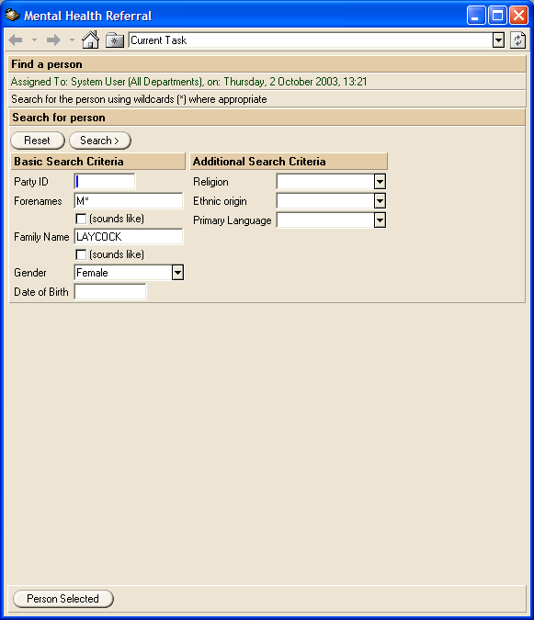

and to help you select ‘the right person’ -

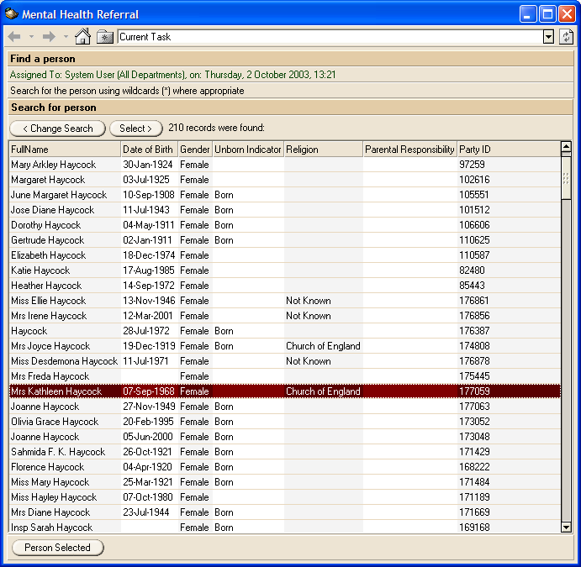

A key part of our outstanding data modelling work is designing the way we pull information in from different application databases and match up ‘the right person’ across these databases. We then also need to decide which system is the ‘default’ for populating static information like date of birth on screen headers.

When you have selected the ‘right person’ from the choice screen you are shown the ‘front page’ of the health record, giving personal details.

High up the screen there are tabs that indicate the other type of information available.

‘Protocol’ offers sophisticated control over the information displayed. If you do not want certain types of users to see, say, the service user NHS Number or ethnicity, you can get your System Administrator to blank it out, as in the example below.

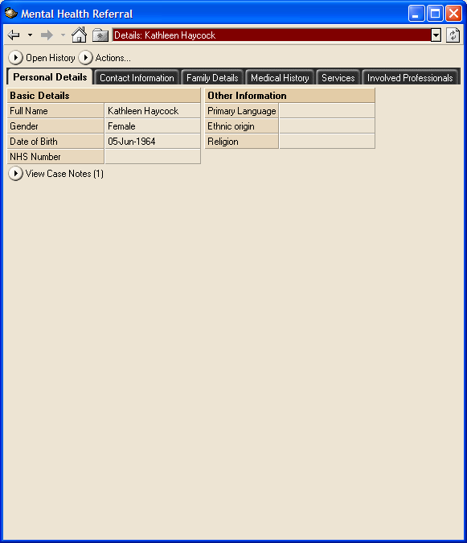

The application will benefit from a screen showing Medical Episodes and Treatments. This is a basis for the design. If core systems read allow, we can link free format notes to each row.

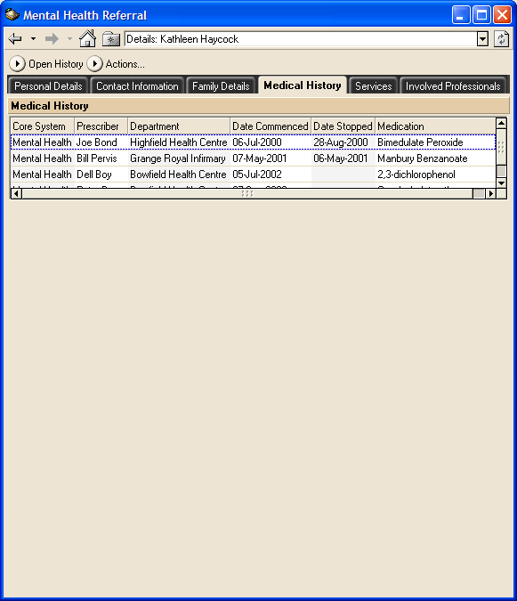

Services offered and attended are a vital part of the integrated history record. Here is some of the information we envisage displaying.

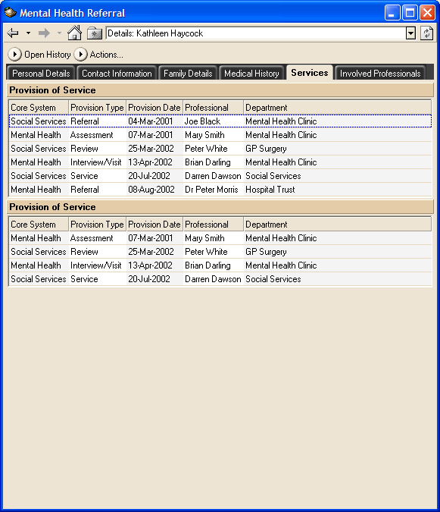

The application can offer and filter lists of people and their details. One possibility is a list of Involved Professionals. Others concern the service user, carers and family members.

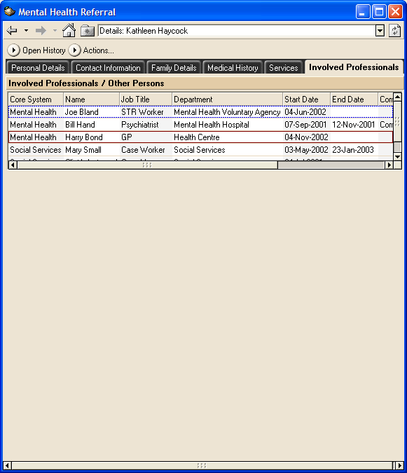

Protocol Workflow features – messaging, form processing

As well as provide a read-only record that slots neatly into and enhances any working procedure Protocol can support business processes, especially workflow oriented processes. It can send a link to the information behind the record alongside the message. For example -

Practitioners can use Protocol’s workflow and messaging features to send a Referral message to other authorities (or to pick one up from other system users). You can send colleagues in any agency or authority a message accompanied by a link into the service user’s record as long as they too are registered system users.

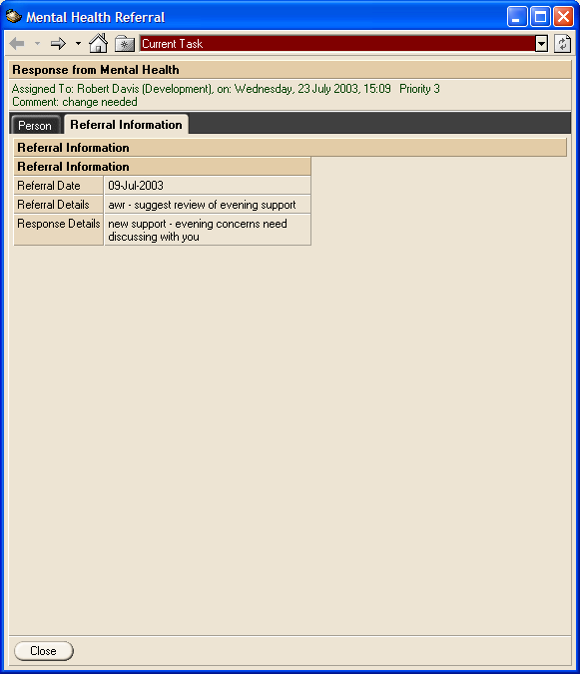

Every Protocol system user has a ‘Work tray’ that holds an index of the electronic documents – referrals, messages, assessments – assigned to him.

The tray for Mental Health application users would resemble the following:

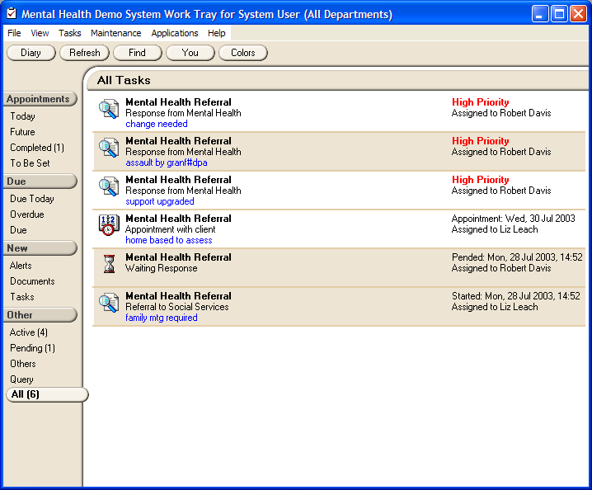

Double clicking the icon opens the record. The record holds a link to the vIMHR.

Note how different icons represent different types of contact, the left hand menu bar allows swift filtering of past, current, new and urgent contacts, and also note the highlighting via summary notes (in blue) and indicators (priority in bold red).

Imagine double clicking one of the the icons and opening up a fully completed electronic form covering multi-agency information.

If you have to fill the details in Protocol offers features for automatically completing the form headers, based on the designated core application’s service user master file. It then saves and passes them on to any number of involved professionals in any agency or authority who are registered on the system.

Using Messaging and the vIMHR together

Windows functionality and a Protocol ‘pop-up’ option menu will allow you to move between options quickly, compare a form you’re completing with details on the vIMHR or look at a record as you make referrals.

This setup complements current and should open up new working methods e.g. two users, subject to security, may view the same record while talking on the phone, pass information to and from work trays.

Approaches can be piloted but any adopted for the future will clearly need formalising.

Accessing Protocol from other applications

We need to link the vIMHR to other systems so we can retrieve information to populate the screens.

We also want to be able to call Protocol from, say, the screens CMHTs use in CareFirst. This will be done via a hotkey or radio button. The hotkey will take the details (based round id number(s)) of the person whose details you are looking at and go through the logon and ‘right person’ search automatically and then present you with the person’s vIMHR and a menu of ‘messaging’ functions you can perform. We need to resolve whether this link is required and how users want it to work. It has to be financed from outside of FAME’s budget.

Appendix 3 – Mental Health Use Case information

No. | Use Case Title | Level | Summary | Conc | Dep | Link | CPA form
IR01 | Provide mental health services | Sum | Madeley (and Bridgnorth) CMHT receives a referral from one of many different sources. A team member takes the initial referral. At a weekly meeting senior members of the team allocate it to a care co-ordinator. The care co-ordinator assesses the potential service user, sets up a written care plan. If an external care package is required, the case is considered by the purchasing panel. If agreed, the care co-ordinator commissions care services from in-house or from a service provider who has a service level agreement with CMHT. The care co-ordinator reviews the service user at regular intervals and amends services as needed |  | VR02 | VR02
IR02 | Refer person to CMHT | User | A professional or an individual refers the service user to CMHT for an assessment of their needs/advice, treatment and/or care. |  | VR02 | - | 1
IR16 | Redirect a contact to another professional | User | The team manager decides this service user’s case is not best supported by his team and makes an immediate referral to another professional |  | IR02 | IR02
IR03 | Accept referral | User | A team member takes the referral via electronic means, the phone or letter. H/she may contact the referrer for additional information. |  | IR02 | IR02 | 2
IR04 | Allocate referral to care co-ordinator | User | The team manager allocates the case to the appropriate member who becomes the care co-ordinator. One of the team enters contact details, if applicable, into the core client record system, (eg CareFirst) by and starts up/retrieves from storage a paper file. |  | IR03
IR05 | Conduct Needs Assessment | User | The identified care co-ordinator will make arrangements with the service user to carry out a needs assessment using the agreed assessment tool The care co-ordinator prints off Forms 3 and 4 and visits the service user at home or arranges for the person to come to the CMHT office | IR06 |  |  | 3, 4
IR15 | Conduct Specialist Assessment | User | The identified care co-ordinator refers the service user to a specialist team for assessment. The assessment is carried out using a special tool. |  | IR02
IR14 | Conduct Carers Assessment | User | The care co-ordinator with the carer, decides whether a Care Plan is required for the carer in their own right and fills in Form 12 |  | IR05 |  | 12
IR06 | Conduct Risk Assessment | User | The care co-ordinator carries out a risk assessment using the agreed (CPA) tool and fills in Form 19.1 or 19.3 if applicable. | IR05 | IR05 first |  | 19.1,  19.3,
IR07 | Set up a Care Plan | User | The care co-ordinator evaluates the information in the assessment and using their professional judgement, agrees with the service user, a care plan. |  | IR05 | IR05 | 5
IR13 | Set up a Carers Plan | User | The care co-ordinator evaluates the information in the assessment and agrees, with the carer, a care plan |  | IR14 | IR14 | 13
IR08 | Provide Service/Care for a service user | User | The care co-ordinator commissions service delivery from an accredited source. The care co-ordinator sends the completed Care Plan to the service provider together with any other relevant information supplied by the original referrer. The care co-ordinator agrees with the provider the cost of the service, start dates and the proposed service plan. A declaration of resources is completed. The service provider or care co-ordinator contacts the service user and sets up dates and venues for the activities. The service provider sends the authority an invoice for payment for services. |  | IR05 | IR07
IR17 | Update service user’s personal details | User | If a service user passes on key changes of personal details the team member records them on their core System.
IR09 | Review care plan | User | The care co-ordinator monitors and reviews the needs of the service user, then fills in forms 7 or 7a and arranges new services |  | IR08 |  | 7
IR10 | Discharge service user | User | A professional discharges the service user; the care co-ordinator fills in form 9 and makes any necessary arrangements for follow up (GP etc). |  | IR09 |  | 9

Use Case Diagram – vIMHR including Mental Health Processes (viewed at high level)

provide integrated info about a service user
view the vIMHR
identify the service user

- view personal info
- view CPA summary

send messages re service user
read core systems
(SS, GP, PCT)
send different types of message
audit read of the vIMHR

create reports
The Mental Health related Use Cases

These Use Cases reflect current Mental Health processes.

To aid understanding of where current paper procedures fit in we have added an extra column on the right of the Use Case matrix above which cross-references Shropshire and Telford and Wrekin paper forms to Use Cases.

IR01  provide mental health services for a service user

Scope: |  | FAME project IMHR systems
Level: |  | Summary
Summary: |  | A CMHT receives a request to provide services. The team manager allocates a care coordinator to the case. The coordinator makes an assessment of services needed, sets up a Care Plan, negotiates a care package and reviews the service user’s progress against the care plan until he can be discharged
Primary Actor: |  | professional responsible for the service user’s care
Other Actors: |  | Service user; CMHT manager
Preconditions: |  | none
Trigger: |  | request to provide services from another authority
Linking use case:
Concurrency
Success Guarantee: |  | The manager allocates a care coordinator and their care plan is put into action; this leads to treatment and/or attendance at events and eventual discharge
Minimal Guarantee: |  | The request is allocated to someone in the manager’s team or redirected
Frequency: |  | Maximum of 5 times a day by 2 managers during the pilot
Basic Course of Events
1  2  3  4.  5  6  7  8  9 | Someone sends the CMHT a referral request (can make use of VR22 above).  The manager takes the referral and makes a decision regarding the appropriateness of the referral.  At a weekly meeting senior members of the team allocate it to a care co-ordinator.  The care co-ordinator assesses the potential service user, sets up a written care plan.  If a care package needing external services is required as part of the plan, the care is considered by the purchasing panel.  If agreed, the care co-ordinator commissions care services from an in-house service or from a service provider who has a service level agreement with CMHT.  The coordinator assesses the main carer’s service needs and arranges services  The care co-ordinator reviews the service user at regular intervals and amends services as needed  The care co-ordinator closes the case following a review that indicates services are no longer required.
Alternative paths
2a  6a  7a | The team manager redirects the request to another professional  If the care coordinator cannot get funding for the package he reassesses the care plan and package. If all services are internal go straight to 7.  There may be no carer or the carer refuses an assessment. If so, the coordinator proceeds with the service user’s requirements only.
Exceptions
Business rules and non-functional requirements
Procedures must comply with the Mental Health Act and Community Care Act
All staff in a CMHT must use the CPA process
A service user must be assessed within agreed timescales
Owner |  | Shropshire Project Manager
Iteration Dates and person(s) completing iterations:
1 | 22 October 2003 |  | AWR
2 | 03 December 2003 |  | AWR
3 | 04 December 2003
4

IR02 Specification of Client Requirements

Scope: |  | FAME project IMHR systems
Level: |  | User goal
Summary: |  | An individual makes a call or sends a letter or fax requesting the CMHT takes on responsibility for the service user’s mental health care programme
Primary Actor: |  | professional responsible for the service user’s care
Other Actors: |  | Service user; CMHT manager
Preconditions: |  | Service user seen by other professional  The service user’s ref number has been identified via VR02
Trigger: |  | Contact from individual
Linking use case: |  | IR05, IR15, IR06, IR08, IR07, IR09, IR11, VR01
Concurrency
Success Guarantee: |  | The team receives the contact, makes a decision regarding the appropriateness of the referral
Minimal Guarantee: |  | The team receives the contact, makes a decision regarding the appropriateness of the referral
Frequency:
Basic Course of Events
1  2 | The individual requests the CMHT takes on responsibility for the service user’s mental health care programme  The CMHT fills in the designated CPA form (form 1)
Alternative paths
Exceptions
Business rules and non-functional requirements
All reads of the vIMHR must be auditable.
Owner |  | Shropshire Project Manager
Iteration Dates and person(s) completing iterations:
1 | 22 October 2003 |  | AWR
2 | 02 December 2003 |  | AWR
3 | 04 December 2003
4

IR03 accept a referral to provide services for a service user
Scope: |  | FAME project IMHR systems
Level: |  | User goal
Summary: |  | The CMHT manager decides to take on the service user’s care programme and makes an initial assessment of priority
Primary Actor: |  | CMHT manager
Other Actors: |  | professional responsible for the service user’s care
Preconditions: |  | IR02 is complete
Trigger: |  | IR02  Review of Referral request (IR02)
Linking use case: |  | IR02
Concurrency
Success Guarantee: |  | The CMHT manager decides to take on the service user’s care programme and makes an initial assessment of priority
Minimal Guarantee: |  | The CMHT manager reviews the detail and either takes it on or redirects
Frequency:
Basic Course of Events
1  2  3  4 | The team member takes the referral over the phone or via a letter/fax.  The team manager makes a decision regarding the appropriateness of the referral. H/She may contact the referrer for additional information.  The Team Manager signs all referrals and gives a priority to the case.  The paperwork is prepared for the weekly Allocation Meeting
Alternative paths
2a  4a | The Manager re-directs the referral direct to another professional agency.  In urgent cases the manager may allocate a care coordinator immediately
Exceptions
Business rules and non-functional requirements
Owner |  | Shropshire Project Manager
Iteration Dates and person(s) completing iterations:
1 | 21 October 2003 |  | AWR
2 | 03 December 2003
3 | 04 December 2003 |  | AWR
4

IR04 Specification of Client Requirements

Scope: |  | FAME project IMHR systems
Level: |  | User goal
Summary: |  | At a weekly team meeting the team assess the service request and decide on a care coordinator
Primary Actor: |  | CMHT manager
Other Actors: |  | Service user; CMH team; care coordinator
Preconditions:
Trigger: |  | IR03
Linking use case: |  | IR03
Concurrency
Success Guarantee: |  | the team allocates a care coordinator
Minimal Guarantee: |  | the team allocates a care coordinator
Frequency:
Basic Course of Events
1  2  3  4. | The CMH team considers the case  The team allocates the case to the appropriate member who becomes the care co-ordinator.  The team fills in allocation paperwork.  One of the team enters the contact details into the core system, if applicable,  (eg Care First) and makes up or retrieves from storage a paper file.
Alternative paths
2a  4a | In urgent cases the team manager will assign a care coordinator when accepting the case (IR03)  if it is not the service user’s first contact much info will already be on the database
Exceptions
Business rules and non-functional requirements
Service user must be assessed within agreed timescales
Owner |  | Shropshire Project Manager
Iteration Dates and person(s) completing iterations:
1 | 21 October 2003 |  | AWR
2 | 03 December 2003 |  | AWR
3 | 04 December 2003
4

IR05 Specification of Client Requirements
Scope: |  | FAME project IMHR systems
Level: |  | User goal
Summary: |  | Care coordinator conducts assessments to enable decisions on a care plan
Primary Actor: |  | Care coordinator
Other Actors: |  | Service user
Preconditions: |  | IR04 is complete
Trigger: |  | IR04, IR09
Linking use case: |  | IR04
Concurrency |  | IR06
Success Guarantee: |  | Coordinator sees service user and completes both care and risk assessments
Minimal Guarantee: |  | The care co-ordinator attends the appointment to carry out an assessment
Frequency:
Basic Course of Events
1  2  3  4.  5  6  7.  8. | The identified care co-ordinator familiarises himself with the service user’s medical record  The care co-ordinator arranges for a visit to the service user home or an appointment at the CMHT office.  The care co-ordinator carries out a care assessment using the agreed (CPA). assessment tool and requests consent for professionals to view details  The coordinator carries out a risk assessment.  The coordinator records restrictions on Protocol  The coordinator looks at the outcome of the assessments  The coordinator decides whether enhanced or standard CPA is required  The team member keys relevant information into their core system
Alternative paths
2a | The service user refuses the assessment or does not attend the appointment. Care coordinator records lack of attendance (IR12) or refusal and comments on problems, then seeks to arrange another meeting.
Exceptions
Business rules and non-functional requirements
Service user must be assessed within agreed timescales
Owner |  | Shropshire Project Manager
Iteration Dates and person(s) completing iterations:
1 | 21 October 2003 |  | AWR
2 | 03 December 2003 |  | AWR
3 | 04 December 2003
4

IR06 Specification of Client Requirements
Scope: |  | FAME project IMHR systems
Level: |  | User goal
Summary: |  | A care co-ordinator carries out a risk assessment using the agreed CPA tool
Primary Actor: |  | Care coordinator
Other Actors: |  | Service user
Preconditions: |  | IR04
Trigger: |  | IR04, IR09
Linking use case: |  | IR04
Concurrency |  | IR05
Success Guarantee: |  | The care co-ordinator carries out a risk assessment using the agreed tool
Minimal Guarantee: |  | The care co-ordinator attends the appointment to carry out an assessment
Frequency:
Basic Course of Events
1  2  3 | The care co-ordinator familiarises himself with the service user’s medical record  The coordinator carries out a risk assessment using the agreed CPA tool and fills in form 19.1 or 19.3, if applicable  The team member keys information from form 19 into the core system
Alternative paths
2a | The service user refuses to undertake the risk assessment. The care coordinator records lack of attendance (IR12) and seeks to arrange another meeting.
Exceptions
Business rules and non-functional requirements
Service user must be assessed within agreed timescales
All staff in CMHT must use the agreed CPA processes
Owner |  | Shropshire Project Manager
Iteration Dates and person(s) completing iterations:
1 | 21 October 2003 |  | AWR
2 | 04 December 2003 |  | AWR
3 | 04 December 2003 |  | AWR
4

IR07 set up Specification of Client Requirements
Scope: |  | FAME project IMHR systems
Level: |  | User goal
Summary: |  | The care co-ordinator evaluates the information in the assessment and using their professional judgement, agrees with the service user, a care plan.
Primary Actor: |  | Care coordinator
Other Actors: |  | Service user
Preconditions: |  | Service user must have had an assessment
Trigger: |  | Assessment, unaffordable care package (IR08)
Linking use case: |  | IR05, IR08
Concurrency
Success Guarantee: |  | The care co-ordinator meets with the service user and agrees a care plan.
Minimal Guarantee: |  | The care co-ordinator meets with the service user and offers a care plan.
Frequency:
Basic Course of Events
1  2  3  4.  5 | The care co-ordinator evaluates the information in the assessments  He reviews the needs identified, matches services available and records unmet needs  He proposes a care plan to the service user, recording details on CPA Form 5.  He discusses, amends and finally agrees a care plan with the service user, recording final details and agreement on Form 5  The team member keys information into the core system
Alternative paths
4a | If the parties cannot agree a care plan the coordinator attempts to negotiate changes to the care plan or agrees to record areas of disagreement
Exceptions
Business rules and non-functional requirements
All staff in CMHT must use the CPA process
Owner |  | Shropshire Project Manager
Iteration Dates and person(s) completing iterations:
1 | 21 October 2003 |  | AWR
2 | 03 December 2003 |  | AWR
3 | 04 December 2003 |  | AWR
4

IR16 Specification of Client Requirements

Scope: |  | FAME project IMHR systems
Level: |  | User goal
Summary: |  | The team manager decides this service user’s case is not best supported by his team and makes an immediate referral to another professional
Primary Actor: |  | team manager
Other Actors: |  | Service user, Care coordinator
Preconditions: |  | Receipt of a referral request
Trigger: |  | IR02
Linking use case: |  | IR02
Concurrency
Success Guarantee: |  | The team manager makes a referral to another professional
Minimal Guarantee: |  | The team manager makes a referral to another professional
Frequency:
Basic Course of Events
1  2 | The team manager reviews the received request. He decides this service user’s case is not best supported by his team  She / he makes a referral to another professional
Alternative paths
Exceptions
Business rules and non-functional requirements
Owner |  | Shropshire Project Manager
Iteration Dates and person(s) completing iterations:
1 | 21 October 2003 |  | AWR
2 | 02 December 2003
3 | 04 December 2003 |  | AWR
4

IR15 Specification of Client Requirements
Scope: |  | FAME project IMHR systems
Level: |  | User goal
Summary: |  | The Care coordinator requests specialist assessment or treatment but maintains overall responsibility for the service user’s care plan
Primary Actor: |  | Care coordinator
Other Actors: |  | Service user; professional specialist
Preconditions: |  | IR05, IR06 complete
Trigger: |  | IR06
Linking use case: |  | IR02, IR05, IR06
Concurrency
Success Guarantee: |  | The service user receives the specialist assessment or treatment requested
Minimal Guarantee: |  | The Care coordinator logs that his request has been assessed but rejected
Frequency:
Basic Course of Events
1  2  3 | The Care coordinator reviews specialist needs identified from the assessment  The care co-ordinator refers the service user to a specialist team for assessment. The assessment is carried out using a special tool or specialist equipment and results are returned to the care co-ordinator.  The details or outcomes are entered on to the core system
Alternative paths
2a | If the service is refused or not affordable the coordinator records actions and reasons
Exceptions
Business rules and non-functional requirements
All reads of the vIMHR must be auditable.
Owner |  | Shropshire Project Manager
Iteration Dates and person(s) completing iterations:
1 | 21 October 2003 |  | AWR
2 | 03 December 2003 |  | AWR
3 | 04 December 2003
4

IR14 Specification of Client Requirements

Scope: |  | FAME project IMHR systems
Level: |  | User goal
Summary: |  | The care co-ordinator carries out a carers assessment
Primary Actor: |  | Care coordinator
Other Actors: |  | Service user; carer
Preconditions: |  | Service user has been assessed (IR05), carer identified
Trigger: |  | IR05, IR06?
Linking use case:
Concurrency
Success Guarantee:
Minimal Guarantee:
Frequency:
Basic Course of Events
1  2  3  4. | The Care coordinator arranges an appointment with the carer.  The Care coordinator assesses needs.  The Care coordinator fills in CPA form 12  The care co-ordinator with the carer, decides whether a Care Plan is required for the carer in their own right
Alternative paths
1a  4a | If the carer does not attend the coordinator records the fact and arranges another visit  If the carer does not require a care plan the coordinator records the fact.
Exceptions
Business rules and non-functional requirements
Owner |  | Shropshire Project Manager
Iteration Dates and person(s) completing iterations:
1 | 1 October 2003 |  | AWR
2 | 03 December 2003 |  | AWR
3 | 04 December 2003
4

IR08 Specification of Client Requirements

Scope: |  | FAME project IMHR systems
Level: |  | User goal
Summary: |  | The care co-ordinator commissions service delivery from an accredited source at an agreed price
Primary Actor: |  | Care Co-ordinator
Other Actors: |  | Service user, Visiting Officer
Preconditions: |  | IR07 complete, service user has agreed care plan
Trigger: |  | service user has agreed care plan
Linking use case: |  | IR07
Concurrency
Success Guarantee: |  | The care co-ordinator arranges service delivery of a range of services on agreed dates at an agreed price
Minimal Guarantee: |  | The care co-ordinator attempts to arrange service delivery and reassesses the needs and cost
Frequency:
Basic Course of Events
1  2  3  4.  5  6  7  8  9 | The Care coordinator finalises the service plan.  If there are funding implications the care co-ordinator agrees a care package with the Purchasing Panel  The Care coordinator commissions service delivery from an accredited source.  The care co-ordinator sends the completed care plan to the service provider  The care co-ordinator agrees with the provider the cost of the service, start dates and the proposed service plan.  The team member keys some care plan information into the core system  A declaration of resources is completed  The service provider or care co-ordinator contacts the service user and sets up dates and venues for the activities.  The service provider sends an invoice for payment for services
Alternative paths
2a  3a | If the cost cannot be agreed the care coordinator looks at the care plan again (IR07)  If the service is unavailable the care coordinator looks at the care plan again
Exceptions
Business rules and non-functional requirements
All staff in CMHT must use the agreed CPA process
Services must be provided by the agreed provider to the service level agreement put in place
Owner |  | Shropshire Project Manager
Iteration Dates and person(s) completing iterations:
1 | 22 October 2003 |  | AWR
2 | 03 December 2003 |  | AWR
3 | 04 December 2003
4

IR13 Specification of Client Requirements

Scope: |  | FAME project IMHR systems
Level: |  | User goal
Summary: |  | The care co-ordinator evaluates the information in the carer assessment and using their professional judgement, agree with the carer, a care plan
Primary Actor: |  | Care coordinator
Other Actors: |  | Main carer; Service user
Preconditions: |  | Coordinator has conducted a carer’s assessment
Trigger: |  | .  Agreement of carer’s assessment
Linking use case: |  | IR14
Concurrency
Success Guarantee: |  | The coordinator successfully sets up services to assist the carer
Minimal Guarantee: |  | The coordinator attempts to set up services and reassesses the plan if unsuccessful
Frequency:
Basic Course of Events
1  2  3  4.  5 | The care co-ordinator evaluates the information in the carer assessment form  The care co-ordinator contacts the service provider to agree services for the carer - funding should be obtained via local protocols.  The Care coordinator negotiates dates and prices with the service provider  The Care coordinator fills in the carer’s care plan and conveys details to the carer  The team member keys information into the core system
Alternative paths
Exceptions
Business rules and non-functional requirements
All reads of the vIMHR must be auditable.
Owner |  | Shropshire Project Manager
Iteration Dates and person(s) completing iterations:
1 | 1 October 2003 |  | AWR
2 | 02 December 2003 |  | AWR
3 | 04 December 2003 |  | AWR
4

IR09 Specification of Client Requirements

Scope: |  | FAME project IMHR systems
Level: |  | User goal
Summary: |  | The care co-ordinator monitors and reviews the needs of the service user
Primary Actor: |  | The Care coordinator responsible for the service user’s care
Other Actors: |  | Service user; professionals
Preconditions: |  | Care plan set. Timeframe for review has been reached
Trigger: |  | Event of note; Timeframe for review has been reached
Linking use case: |  | IR07, IR08
Concurrency
Success Guarantee: |  | The care coordinator looks at the care plan again with the service user. They agree changes (if any)
Minimal Guarantee: |  | The care coordinator looks at the care plan again with the service user.
Frequency:
Basic Course of Events
1  2  3  4.  5.  6. | An event or review date triggers a need to review.  The care co-ordinator arranges to meet the service user, any other involved parties and carer, if appropriate, for a review  The care co-ordinator monitors and reviews the needs of the service user.  the care coordinator and the service user agree any changes to the care plan  the care coordinator fills in CPA review update forms 7 or 7a, with special emphasis on care plan, crisis plan and signs of relapse  The team member keys relevant information into the core system
Alternative paths
2a  4a | The care co-ordinator logs non attendance  Other parties and carer may not be present  The care co-ordinator reassesses the care plan if agreement is not reached
Exceptions
Business rules and non-functional requirements
Service user needs must be reviewed within 12 months
All staff in CMHT must use agreed CPA process
Owner |  | Shropshire Project Manager
Iteration Dates and person(s) completing iterations:
1 | 21 October 2003 |  | AWR
2 | 02 December 2003
3 | 04 December 2003 |  | AWR
4

IR10 Specification of Client Requirements

Scope: |  | FAME project IMHR systems
Level: |  | User goal
Summary: |  | The professionals responsible for the service user’s care agree with the service user that he does not need care plans and reviews any more. They agree to discharge him.
Primary Actor: |  | Care co-ordinator
Other Actors: |  | Service user; professionals; consultant
Preconditions: |  | Care plan well established. review completed
Trigger: |  | Successful review
Linking use case: |  | IR09
Concurrency
Success Guarantee: |  | The care co-ordinator and the Service user agree on discharge
Minimal Guarantee:
Frequency:
Basic Course of Events
1  2  3  4  5 | The professionals involved in the service user’s care review his progress.  The care co-ordinator and other professionals discuss discharge with the service user  All parties agree on discharge date and ongoing care (IR07)  The team member enters discharge details on the core system  The team member sends information to the service user’s GP and other bodies
Alternative paths
Exceptions
Business rules and non-functional requirements
All reads of the vIMHR must be auditable.
Owner |  | Shropshire Project Manager
Iteration Dates and person(s) completing iterations:
1 | 1 October 2003 |  | AWR
2 | 02 December 2003
3 | 04 December 2003 |  | AWR
4

