Document Purpose

This document was produced by the FAME Programme to provide guidance and practical examples to all Local Authorities/Partner Agencies for an implementation of Multi-Agency working. All documents are the property of FAME National Project, and to access these documents you have agreed to the terms and conditions set out in the accessing of these products from the FAME website.

For a further description of this document please see the Product Definition below stating exactly what the product is. For more in depth explanation and guidance please see the FAME "How to Implement and Sustain a Multi-Agency Environment".

Care Plans

When a write up for a Review Meeting is done a care plan is automatically created for the child.

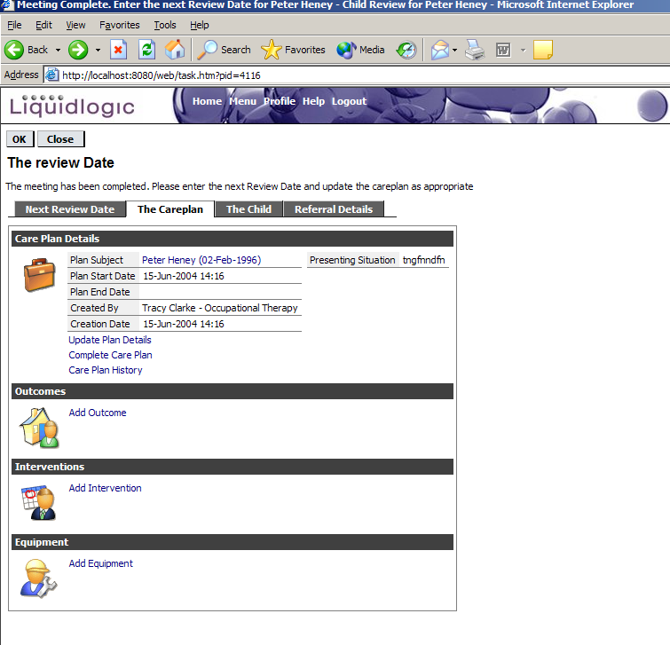

Updating Plan Details

- Click the Update Plan hyperlink.

- Update the ‘Plan Start Date’ and/or ‘Presenting Situation’.

- Click Update.

Adding an Outcome

- Click the ‘Add Outcome’ hyperlink.

- Enter the relevant outcome details.

- Click ‘Create’.

Updating/Deleting an Outcome

- Select an existing outcome. If you wish to delete the outcome go to step 2, to update it go to step 3.

- To delete the outcome click the ‘Delete this plan Outcome’.

Click ‘OK’ to confirm you wish to delete this outcome.

- To update the outcome click the ‘Update’ hyperlink.

- Update the outcome as necessary.

- Click ‘Update’.

Adding an Intervention

- Click the ‘Add Intervention’ hyperlink.

- Enter the relevant intervention details.

- Click ‘Create’

Updating/Deleting an Intervention

- Select an existing intervention. If you wish to delete the intervention go to step 2, to update it go to step 3.

- To delete the intervention click the ‘Delete Intervention’.

Click ‘OK’ to confirm you wish to delete this intervention.

- To update the intervention click the ‘Update’ hyperlink.

- Update the intervention as necessary.

- Click ‘Update’.

Adding Equipment

- Click the ‘Add Equipment’ hyperlink.

- Enter the relevant equipment details.

- Click ‘Create’

Updating/Deleting Equipment

- Select an existing intervention. If you wish to delete the intervention go to step 2, to update it go to step 3.

- To delete the intervention click the ‘Delete this Plan Equipment’.

Click ‘OK’ to confirm you wish to delete this equipment.

- To update the equipment click the ‘Update’ hyperlink.

- Update the equipment as necessary.

- Click ‘Update’.

Child Review and Meetings

When the warning date for a child review is reached a task will appear on your home page, ‘Review Date for XXXX XXXXX is approaching’.

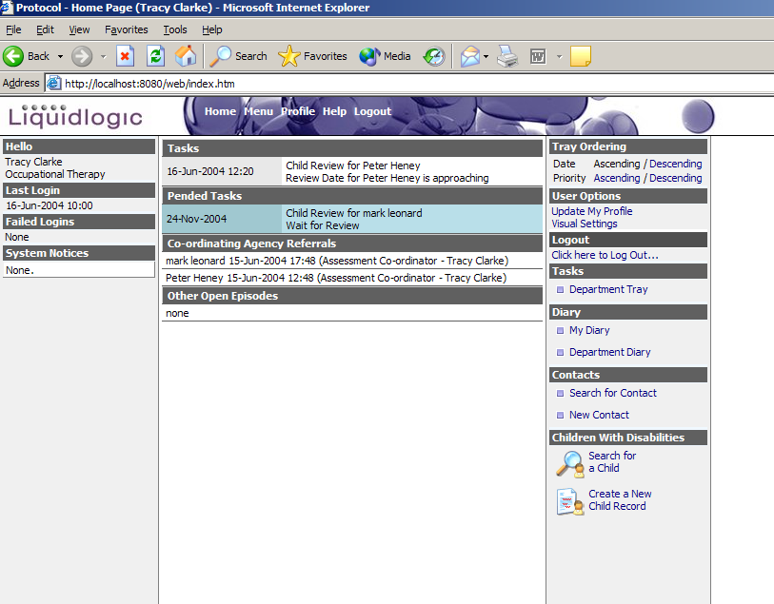

- Click the task to open it.

- Click ‘Create a Meeting’.

- The role of meeting organiser defaults to yourself, but you can appoint another user to this role. Click ‘OK – Create a Meeting’.

- Enter the details of the new meeting. It is advised that you add the meeting attendees first, see Adding Meeting Attendees below. Then complete the meeting details (see step 5 below) and finally send invites to the attendees (see step 7 below).

- Go to the ‘Meeting Details’ tab and complete the relevant fields. The date and time for the meeting can be set from the ‘Set From Calendar’ hyperlink, this will display the calendars of the meeting attendees.

Choose a relevant date, and start and end time for the meeting.
- Click ‘Confirm’.

- Invite the meeting attendees, see Inviting Meeting Attendees below.

- Click ‘Meeting Finalised’.

- Click ‘OK’ to confirm all attendees have been invited to the meeting.

- Click ‘OK – Meeting Finalised’.

- Click ‘Close’.

The meeting appears as an appointment on your home page, ‘Meeting is setup and pending’.

When attendees accept your invitation a task appears on your home page confirming ‘Meeting Confirmations Received’.

- Open the task and review Attendees to view who has accepted.

- Click ‘Confirm’ when done and the meeting appears as an appointment on your home page.

When the meeting date is reached the appointment becomes a task on your home page. To enter details of the meeting outcome see Meeting Write-Up below.

Adding Meeting Attendees

- Go to the ‘Attendees’ tab and click ‘Add Attendee’.

- Choose the type of attendee from the relevant category by clicking the hyperlink.

- Select the relevant person from the chosen category and click ‘Select’. This process can be repeated as many times as necessary.

- Once all the attendees have been selected go to step 5 of Child Review and Meetings.

Inviting Meeting Attendees

- Go to the ‘Attendees’ tab and select an attendee that has not been invited to the meeting.

- Click ‘Send Invitation’.

- Select the relevant communication method and complete the necessary details.

- If the person has been invited via an ‘Internal Workflow Process’ the attendees list will update when they accept or decline to attend.

- If the person has been invited via a phone call or a letter you are able to state if the attendee has accepted or declined.

- Once all the attendees have been invited go to step 8 of Child Review and Meetings.

Meeting Write-Up

- Open the task.

- Click ‘Write-Up’.

- Type the outcome of the meeting into the text box. Click ‘Complete’

- Select the next review and warning dates.

- Update the Care Plan, see Quick Ref Guide to Care Plans.

- Click ‘OK’.

Child Review and Meetings

When the warning date for a child review is reached a task will appear on your home page, ‘Review Date for XXXX XXXXX is approaching’.

- Click the task to open it.

- Click ‘Create a Meeting’.

- The role of meeting organiser defaults to yourself, but you can appoint another user to this role. Click ‘OK – Create a Meeting’.

- Enter the details of the new meeting. It is advised that you add the meeting attendees first, see Adding Meeting Attendees below. Then complete the meeting details (see step 5 below) and finally send invites to the attendees (see step 7 below).

- Go to the ‘Meeting Details’ tab and complete the relevant fields. The date and time for the meeting can be set from the ‘Set From Calendar’ hyperlink, this will display the calendars of the meeting attendees.

Choose a relevant date, and start and end time for the meeting.
- Click ‘Confirm’.

- Invite the meeting attendees, see Inviting Meeting Attendees below.

- Click ‘Meeting Finalised’.

- Click ‘OK’ to confirm all attendees have been invited to the meeting.

- Click ‘OK – Meeting Finalised’.

- Click ‘Close’.

The meeting appears as an appointment on your home page, ‘Meeting is setup and pending’.

When attendees accept your invitation a task appears on your home page confirming ‘Meeting Confirmations Received’.

- Open the task and review Attendees to view who has accepted.

- Click ‘Confirm’ when done and the meeting appears as an appointment on your home page.

When the meeting date is reached the appointment becomes a task on your home page. To enter details of the meeting outcome see Meeting Write-Up below.

Adding Meeting Attendees

- Go to the ‘Attendees’ tab and click ‘Add Attendee’.

- Choose the type of attendee from the relevant category by clicking the hyperlink.

- Select the relevant person from the chosen category and click ‘Select’. This process can be repeated as many times as necessary.

- Once all the attendees have been selected go to step 5 of Child Review and Meetings.

Inviting Meeting Attendees

- Go to the ‘Attendees’ tab and select an attendee that has not been invited to the meeting.

- Click ‘Send Invitation’.

- Select the relevant communication method and complete the necessary details.

- If the person has been invited via an ‘Internal Workflow Process’ the attendees list will update when they accept or decline to attend.

- If the person has been invited via a phone call or a letter you are able to state if the attendee has accepted or declined.

- Once all the attendees have been invited go to step 8 of Child Review and Meetings.

Meeting Write-Up

- Open the task.

- Click ‘Write-Up’.

- Type the outcome of the meeting into the text box. Click ‘Complete’

- Select the next review and warning dates.

- Update the Care Plan, see Quick Ref Guide to Care Plans.

- Click ‘OK’.

Dealing with a Referral

When a referral is assigned to a user’s tray it appears as a task on the home page.

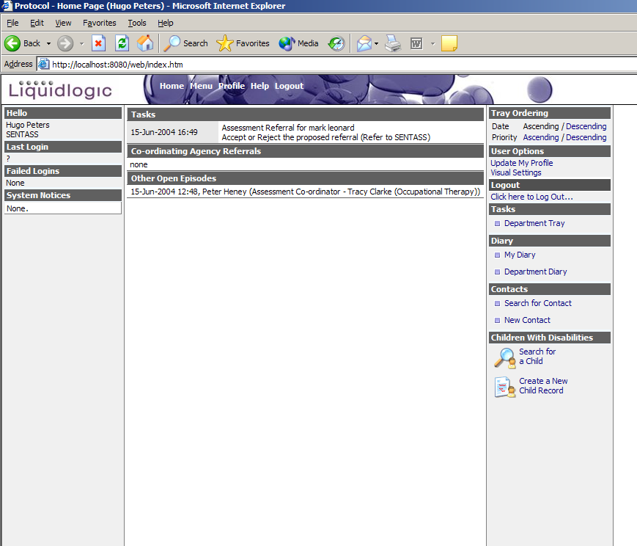

Open the task by clicking it and full details of the referral are displayed.

The full details of the child and the referral form can be viewed so as a decision can be made to reject or accept a referral.

Rejecting a Referral

If you choose to reject a referral click ‘Reject Referral’ and type your reason why in the text box.

The reasons you detail for rejecting the referral are sent back to the person that completed the referral form.

Accepting a Referral

1. If you choose to accept the referral click ‘Accept Referral’ and a screen similar to the following is displayed.

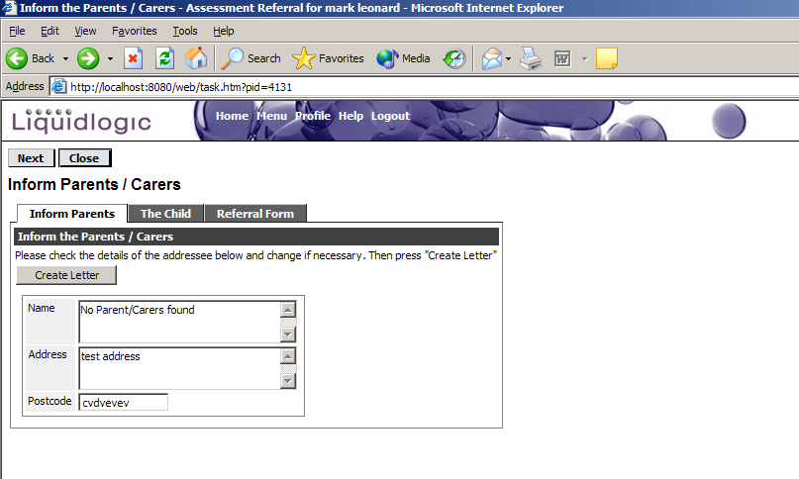

2. If you wish to inform the parents that a referral has been accepted you can produce a letter for them at this point. To produce the letter click ‘Create Letter’. If you don’t wish to inform the parents via letter please go to step 6.

3. The text of the letter to be sent to the parent/s is displayed, which can be added to if need be. Once you are satisfied with the detail of the letter click ‘Print Document’ and a print window is displayed allowing you to choose the relevant printer you wish to print to.

- Click ‘Print’.

- If the letter did not print correctly click ‘Back’ and you will be returned to step 3. This means you can choose another printer if necessary.

If the letter did print correctly click ‘Archive Document’ and a message is displayed informing you the letter has been archived and requesting that you click ‘Next’.

- If you do not wish to inform the parents click ‘Next’.

Assessment Co-ordinator

Regardless of whether you chose to produce a letter for the parents or not a screen similar to the following is displayed.

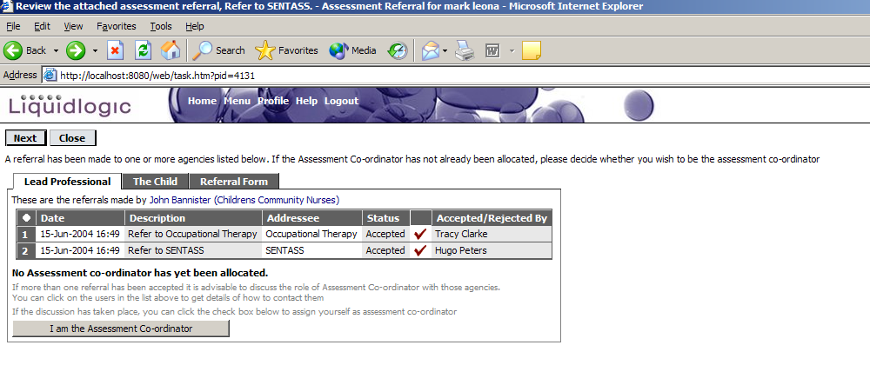

This screen details the other people who have received a referral and that no assessment co-ordinator has yet been allocated. If you wish to be the assessment co-ordinator go to step 2 below, if you don’t wish to be the assessment co-ordinator go to step 1.

- Click ‘Next’, and then click ‘Close’. A pended task appears on your home page waiting for the assessment co-ordinator to be allocated.

- Click ‘I am the Assessment Co-ordinator’, it will confirm that you are the assessment co-ordinator. Click ‘Next’.

- Provide the review date for the child and select the relevant warning date too, either manually or via one of the selectable options. Click ‘Next’.

- The option to start a multi agency assessment is now given. Please refer to the Quick Reference Guide on Multi Agency Assessments.

Logging in

To be able to access the application you will need to know your user id, password and responses to one of 3 pre-defined security questions.

From Internet Explorer
To Log in via the Internet Explorer

- Double click the icon located on your desktop and a window similar to the one below will be displayed (what is displayed is dependant upon how your system has been set-up)

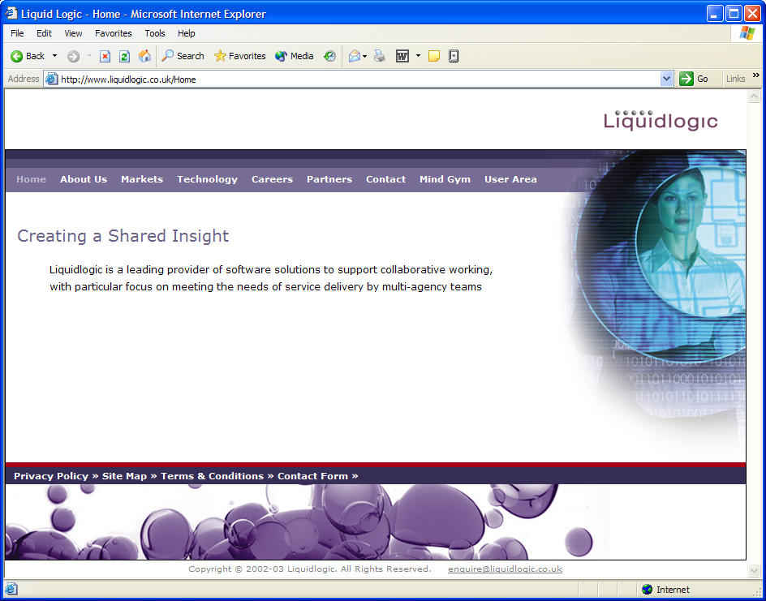

- Then, enter the following text (URL) in the Address field

https:\\nccfame.newcastle.gov.uk\web\login.htm - this is the live system

The play system is as follows:

http:\\nccfame.newcastle.gov.uk\web\login.htm

- You will be prompted with the following message

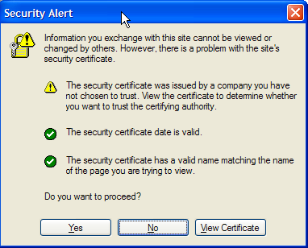

- Select ‘Yes’ to continue, the next screen that will be displayed will be the Liquidlogic Log in as below

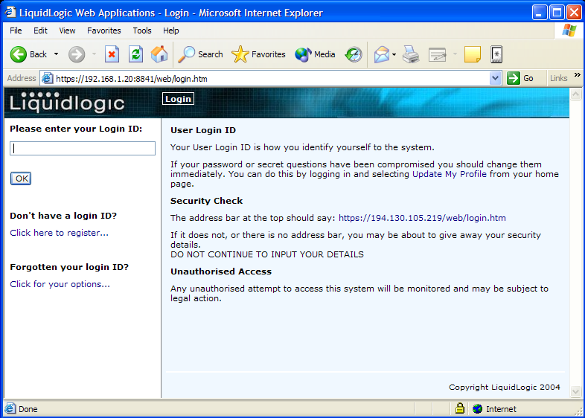

Logging In

Stage 1
Enter your User Id in the field provided and click OK

Stage 2
You will then be prompted to enter selected characters from your password (as below)

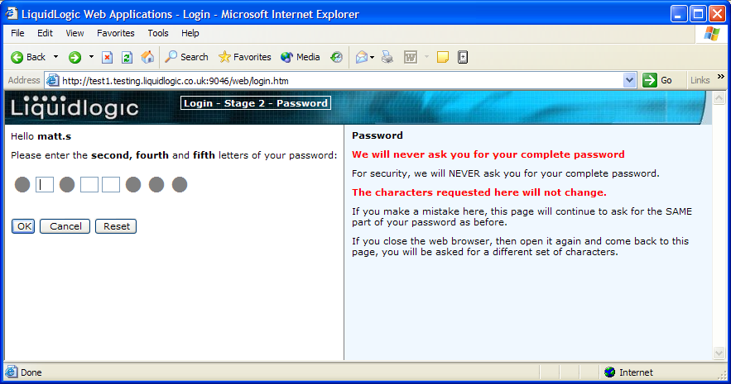

Enter the relevant characters and click OK to continue.

If you have entered your password incorrectly, a message will be displayed (as below) requiring you to input your password again

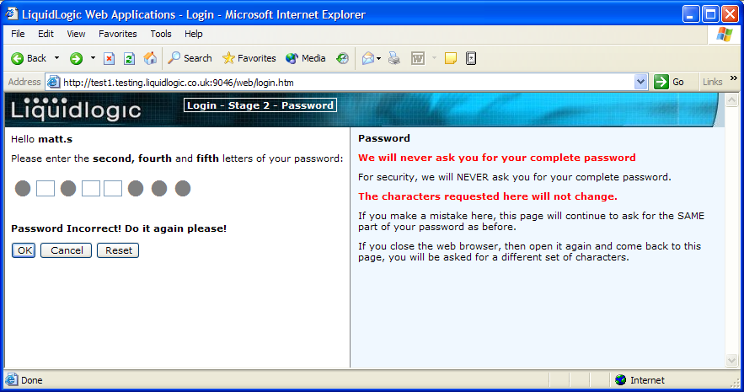

You will have a number of attempts (definable locally) to log in before being locked out of the system. If you get locked out, you will need to contact your Systems Administrator to be released before attempting again.

Stage 3
Next you will be asked at random one of your security questions (see example below)

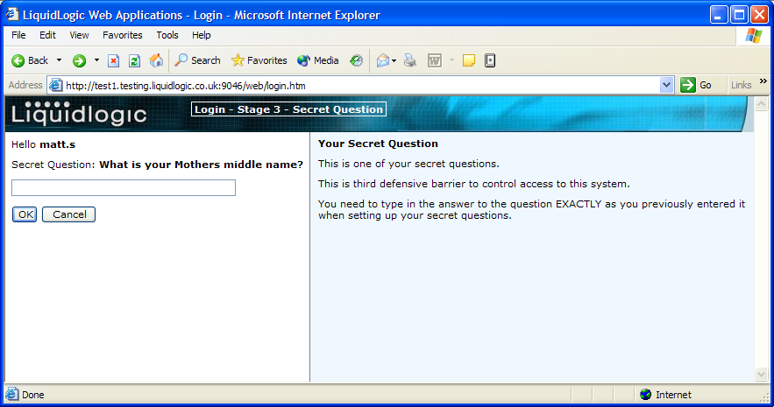

Input the response to the security question and then click OK to continue – this will open your work area within the application (see example below)

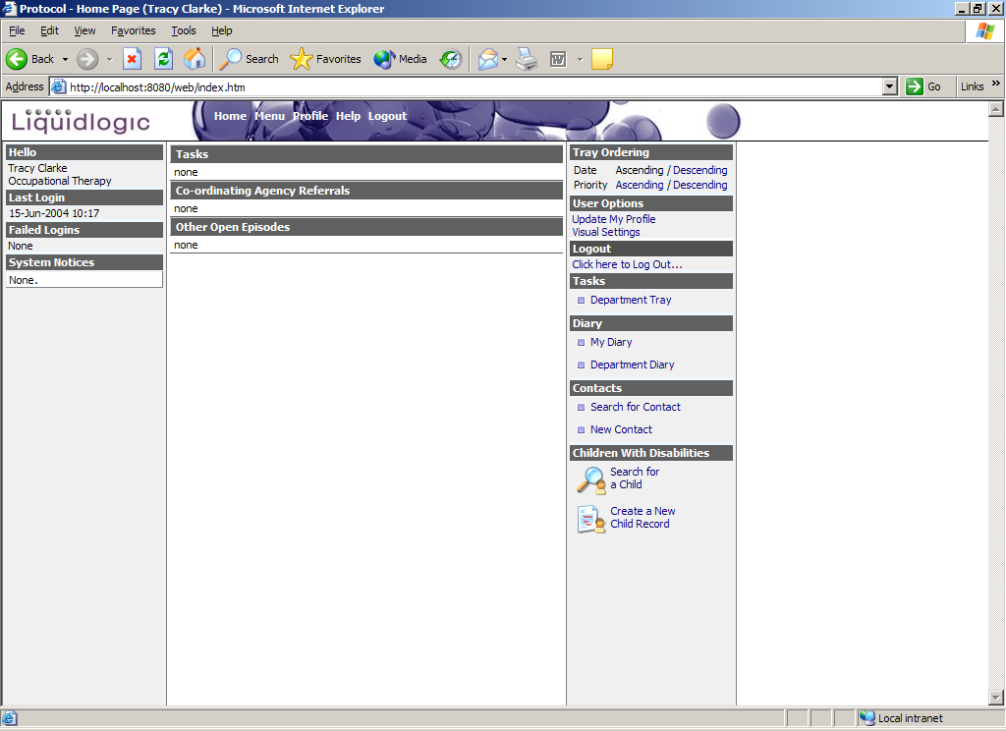

N.B. Full details on using the other options available from the Log In window i.e. Registering as a new user & Forgotten Id’s can be found in the full Reference Guide.

Multi-Agency Assessment

The assessment co-ordinator is the person who starts the multi agency assessment.

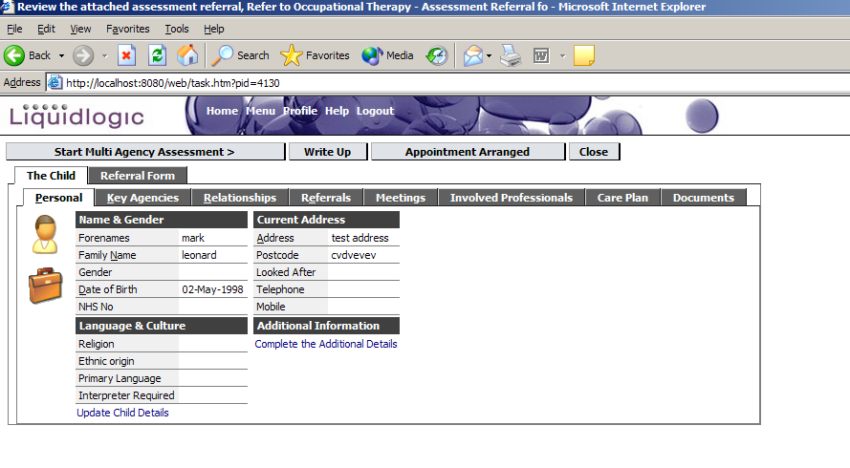

- To start the multi agency assessment click ‘Start Multi Agency Assessment’.

- Complete the relevant sections of the multi agency assessment on the ‘Joint Health, Social Care and Educational Assessment’ tab. If you wish to delegate any sections of the form please see Delegating Sections of the Form below. Also see Dealing with Delegated Sections of the Form below.

If you just wish to save your answers at any point without moving onto the next stage in the process click ‘Save Answers’. The task can then be closed and it appears as a task on your home page.

- Once you have completed the referral form click ‘Finalise Assessment’. This will also save your answers and move you onto the next stage in the process.

- If you have delegated the any parts of the assessment and they have not yet been completed you are not able to complete the assessment. If you click ‘Close’ the assessment will appear as a pended task on your home page ‘Waiting on completion of assessment sections’.

Once any delegated sections have been completed, the assessment will appear as a task on your home page ‘Review the Completed Assessment’. Open this task and move to step 5.

- If you have not delegated any sections of the assessment or once the delegated sections have been completed click ‘Complete Process’.

- Click ‘OK’ to confirm you wish to complete the assessment.

- Add your completion comments in the text box (these are mandatory) and click ‘OK – Write Up’.

Delegating Sections of the Form

- If you want to delegate any parts of the assessment to another agency click the ‘Delegate’ tab.

- Choose the relevant section to delegate on the left hand side of the screen and click ‘Add New Assessor’.

- Choose the person to refer to from the department hierarchy and input the ‘Due Date’ if wanted. Click ‘Confirm New Delegate’. The Assessment Section Delegation will now show the relevant section has been delegated to this person. This process can be repeated as many times as necessary.

Dealing with Delegated Sections of the Form

- The Delegated assessment section appears as a task on your home page. Open the task, you can view the assessment and see the sections that have been completed so far. The section/s delegated to you has a green square at the right hand end.
- Complete the section/s delegated to you.

If you just wish to save your answers at any point without moving onto the next stage in the process click ‘Save Answers’. The task can then be closed and it appears as a task on your home page.

- Once you have completed the referral form click ‘Finalise my Assessment Sections’, this will also save your answers.

- Click ‘OK’ to confirm you have completed the delegated section/s of the form.

- Type in any completion comments you want to make and click ‘OK – Finalise my Assessment Sections’.

Referrals and Episodes

When you are sent a referral and you accept it appears under the ‘Other Open Episode’ section on your home page if you are not the assessment co-ordinator.

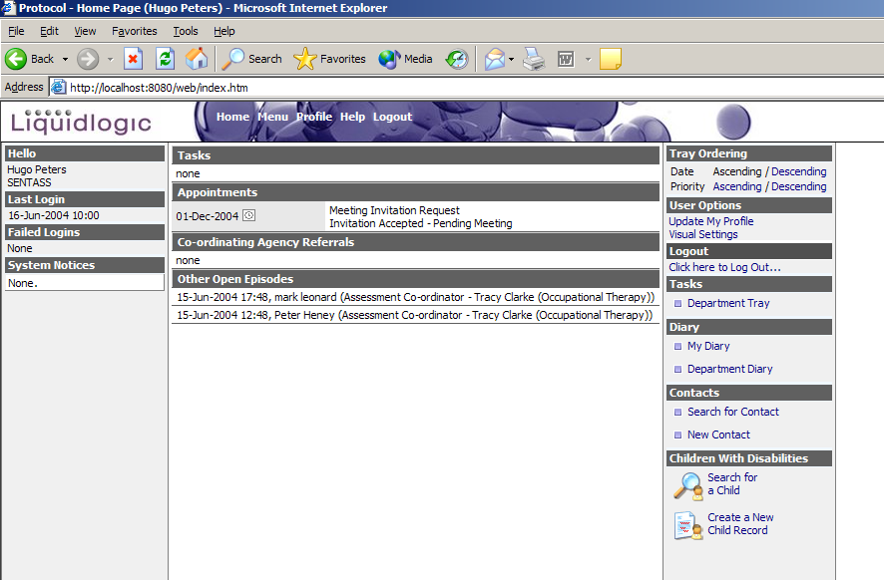

If you are the assessment co-ordinator it appears under the ‘Co-ordinating Agency Referrals’ section on your home page.

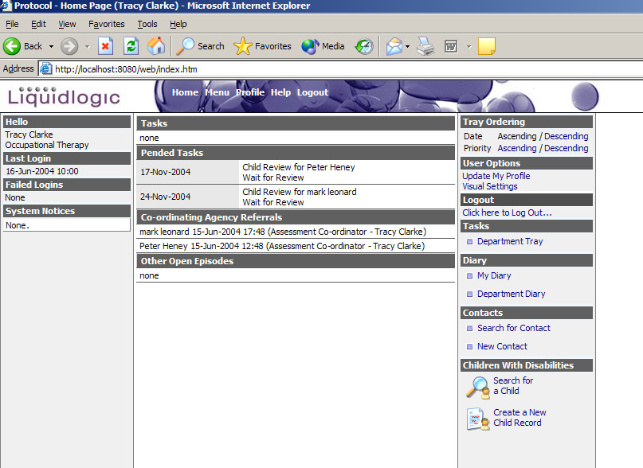

When you open one of these tasks the details of the referral are displayed.

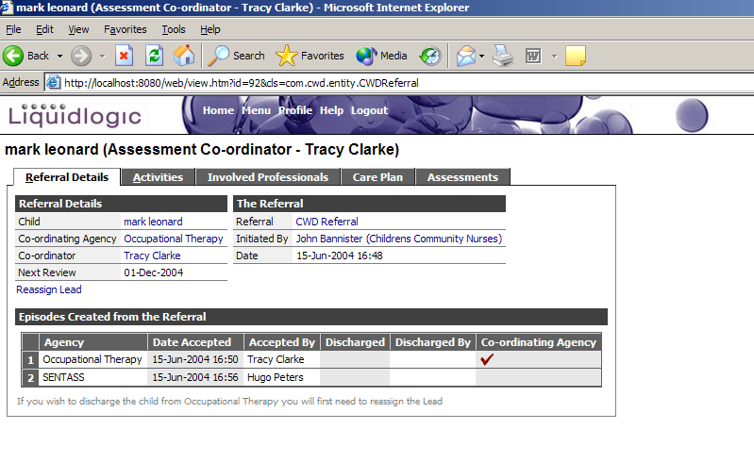
The information contained on each tab is explained below.

Referral Details

This tab contains hyperlinks to the child’s record (see Quick Reference Guide to Updating Child Record), the person that created the referral record (their contact details), the assessment co-ordinator (their contact details), the referral form and the episodes created from the referral form (see Episode Details below).

Activities

This tab contains the details of any activities carried out by all agencies involved with a referral.

To add an activity:

- Click ‘Add an Activity’.

- Input the details of the activity.

- Click ‘Create’.

To update an existing activity:

- Select an existing activity.

- Click ‘Update Activity’.

- Update the activity as necessary.

- Click Update.

Involved Professionals

This tab contains details of all professionals currently involved with a child or professionals that have been involved with an open referral.

To add professional:

- Click the ‘Add a Professional’ hyperlink.

2. Click ‘OK’ to confirm that you wish to add an involvement against the referral.

If there is currently no open referral it will ask you to confirm that the involved professional is against the child and not a referral.

3. Input the details of the involvement and the user’s details.

- Click ‘Create’.

Care Plan

This tab contains details of any current or completed care plans.

The exact details of a completed Child Care Plan can be viewed by selecting it.

The exact details of a current care plan can be viewed by selecting it. There can be only one current care plan.

For details of updating a care plan please refer to the Quick Reference Guide Care Plans.

Assessments

This tab contains details of any multi agency assessments for this referral and any specialist assessments performed by the professionals involved in the referral.

To view details of any type of assessment on this tab select it and the exact details of the assessment are displayed.

New multi agency assessments can be started from this tab. Please refer to the Quick Reference Guide Multi Agency Assessment for further details.

Episode Details

When you open a referral the following page is displayed.

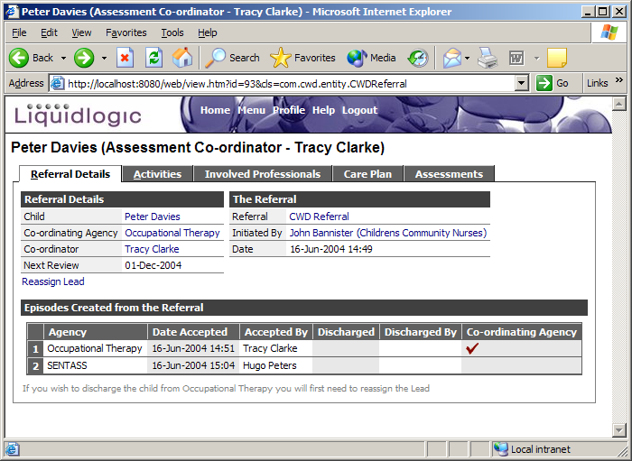

There are 2 episodes for this referral, one for Occupational Therapy and one for SENTASS, in other words two referrals were made from the original referral form.

If you select one of these episodes, in this case Occupational Therapy’s, the following screen is displayed.

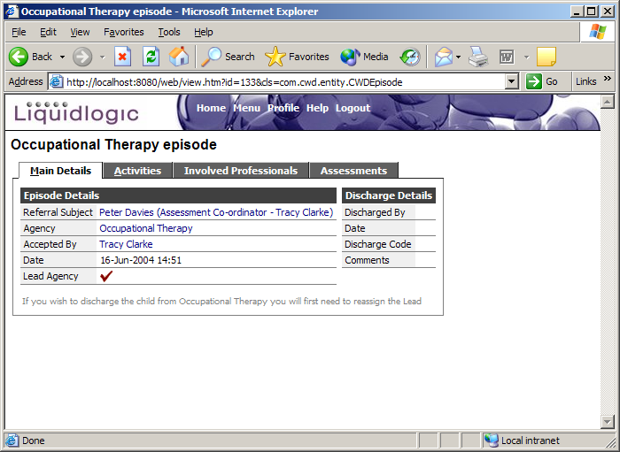

The information displayed on each tab is explained below.

Main Details

This tab contains hyperlinks to the child’s record (see Quick Reference Guide to Updating Child Record), the person that created the referral record (their contact details) and their department.

Activities

This tab contains the details of any activities carried out by one agency involved with a referral, i.e. all activities carried by Occupational Therapy workers for example. Only workers from this one department can add activities to this episode.

Please see Activities under Referrals above for details of how to add to this tab.

Involved Professionals

This tab contains details of all professionals from this agency currently involved with a child or professionals from this agency that have been involved with this open referral.

Please see Involved Professional under Referrals above for details of how to add to this tab.

Assessments

This tab contains details of any specialist assessments done for an agency, i.e. if this it an Occupation Therapy episode you will only see specialist Occupational Therapy assessments detailed, and not multi agency assessments, they are detailed on the assessments tab for the referral.

For details of how to view or create a specialist assessment please see Assessments under Referrals above.

Search for a Service User

Guidelines for Searching

Within the Search screen there are a number of different search fields that can be used. You do not have to input data into every field, invariably, less is best however; search results will differ depending upon how data is entered into the search fields.

The fields that are available to you are shown below and suggestions on searching are also included within these Guidance Notes.

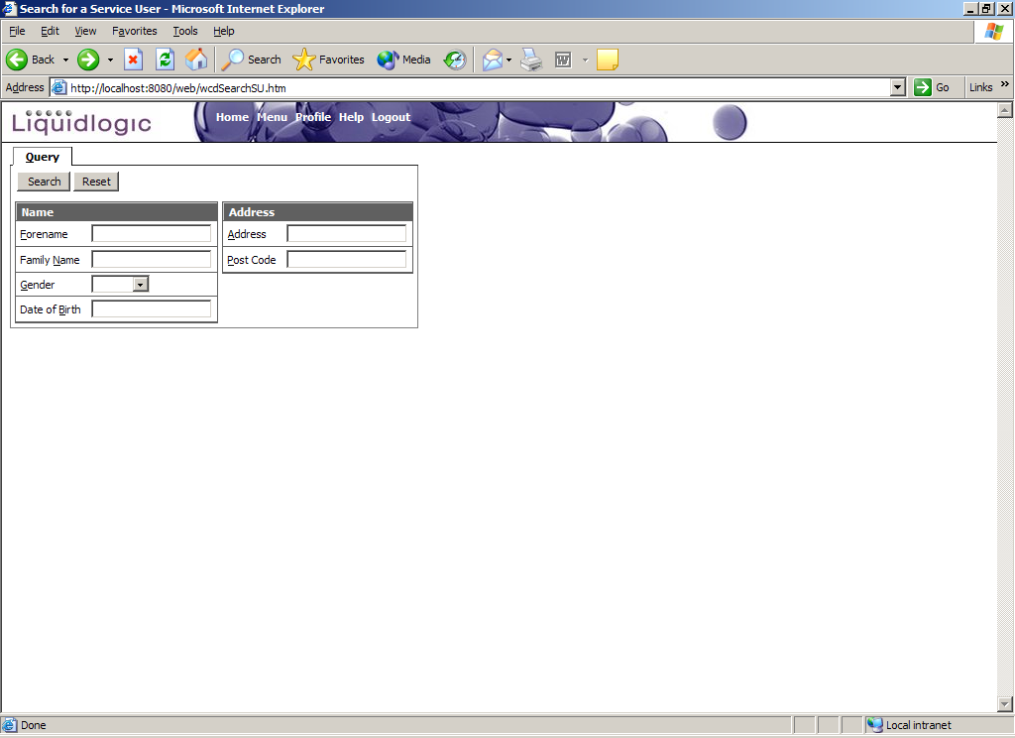

Entering exact information can sometimes result in no records being found. This is normally due to a number of factors:-

- Differences in spelling
- Differences in the data being supplied for the field and what’s been input into the database originally – with the most common problem being encountered with the Forename (as earlier example)
- Incorrect information held in original record i.e. wrong date of birth.
- Data held in different formats

Therefore, it is recommended that ‘wildcards’ always be used to improve the success of a search.

Wildcards

A ‘wildcard’ is a character (asterisk *) that is used to represent a character or series of characters. It can be added to the beginning, end or in the middle of data being entered into the search field.

Examples

- Searching for a Service User whose surname is Brendan – this could have been entered into the database as Brendan, Brenden, Brendon, etc.,

To make searching for this person easier, you could enter the first 5 characters of the surname followed by the * into the Family Name field e.g.

Family Name = Brend*

Clicking on Search will then find you all records in the database for those people whose surnames begin with Brend. You would then use the data presented to match the person you are looking for.

- Searching for a Service User whose surname is Daniel Smith – this is a very common surname and entering just the surname in the search criteria will present you with a very large list of results. Narrow this down by providing information in other fields available i.e. Forename

Enter the whole Surname in the Family Name field and then enter the Forename followed by the * into the Forename field e.g.

Family Name = Smith
Forename = Daniel*

Clicking on Search will then find you all records in the database for those people whose surnames are Smith but only if their first names start with Daniel

- Searching for a Service User whose address is Flat 4, 29 Green Lane – the address search will look on the first line of the address (generally the Street Name) therefore it is easier to narrow down the search by preceding the data entered into the address field with the * e.g.

Select the option to carry out an extended query and then
Address = *Green Lane

Clicking on Search will then find all records for Service Users that live on Green Lane. If this is used along with data entered for Surname, the resulting list will be shorter.

Performing a Search

- Enter what information you have into the fields provided
- Click on the ‘Search >’ button
- The system will query the information available and provide you with either a list of options or an exact record from the Protocol and any additional databases.

Example - List of options

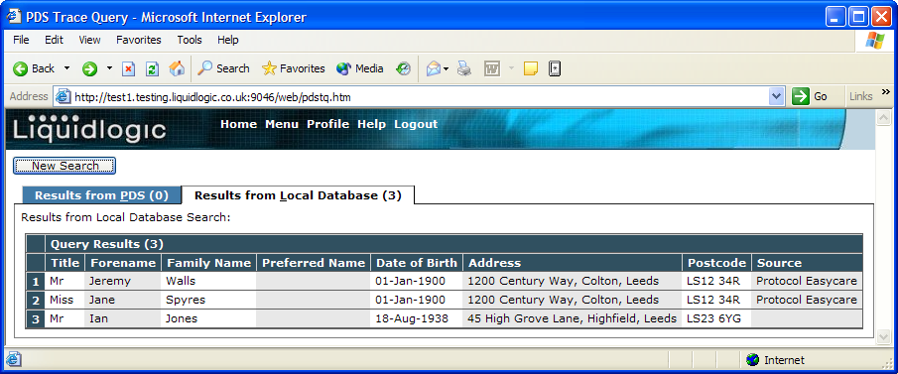

- If presented with a list of results (as above), click on the required entry to select that record.
- If the search did not return the expected results, click on the ‘’ button to perform another search and follow the previous instructions.
- If your search found the required record and you have selected their details, you will be presented with a window displaying the Service Users details (as below)
- If the required entry is not listed, you will need to amend the search criteria.
- Click on the ‘Back’  button to take you back to the search screen, amend the original data entered and search again.

Example - Exact match

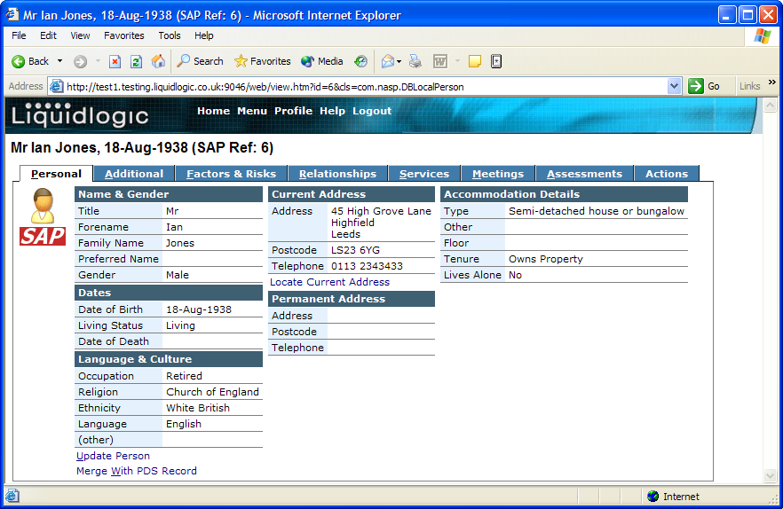

- If the search has produced and exact match, you will then be presented with a window displaying the Service Users details (as above)
- If the record is not correct, you will need to amend the search.
- Click on the ‘Back’ button to take you back to the search screen, amend the original data entered and search again.

Problem

A common problem encountered by New users is that searching doesn’t appear to find the right people even though they are in the database. This is generally due to the fact that wildcards are not being used at all during a search.

Problems tend to arise around when using Service Users forenames and occasionally addresses. This is caused because of inconsistencies with how the data has originally been entered (example below on variations of a forename)

- Just the first name i.e. Avril
- The first name and the second name i.e. Avril Dawn
- The first name and any number of middle names i.e. Avril Dawn Jane
- The first name and initials of any middle name i.e. Avril D J

It is important when searching, that a WILDCARD (*) be placed at the end of the data entered in the forename field i.e. Avril* - this will ensure that the application will search for every possible entry in the system. Without the wildcard, (in the example above) only those records with just Avril in the forename field would be found.

New Person

If your search has been unsuccessful, you will need to add the Service User in order to record the assessment. Please see “Create a New Service User Reference Guide”.

IMPORTANT – if you have received an electronic referral (review case) work task from another user / agency, this persons details will already be on the system. In these circumstances, you should NEVER add a new user to the system. If you are having trouble locating the Service User, redefine your search using the guidance notes above.

Updating a Child’s Record

There are 8 tabs of information on a child’s record. To update the details of a record you need to search and select the relevant record (see Quick Reference Guide on Searching for a Child)

Once you have selected a child a screen similar to the one below is displayed:

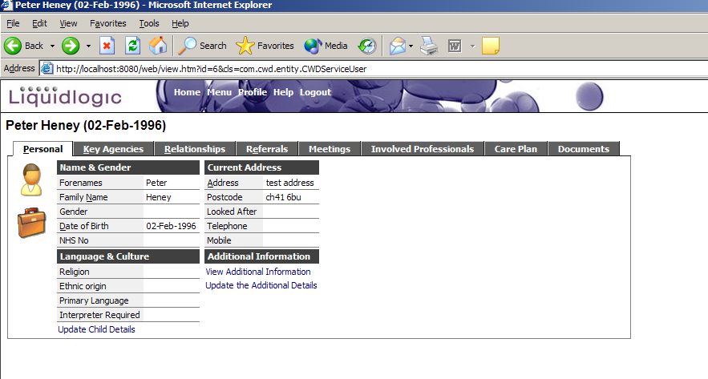

The tabs of information are described below in turn:

Personal

This tab displays details of the child’s name and gender, language and culture and current address. To update any of these details click the ‘Update Child Details’ hyperlink beneath the ‘Language and Culture’ section. The screen displayed is similar to the screen displayed when creating a new child record (see Quick Reference Guide Creating a New Child).

There is also a section titled Additional Information that, on the example above, contains a hyperlink allowing you to complete ‘additional details’. This allows you to enter further details regarding the child.

Completing the Additional Details

Click the ‘Complete Additional Details’ hyperlink and a screen similar to the following is displayed:

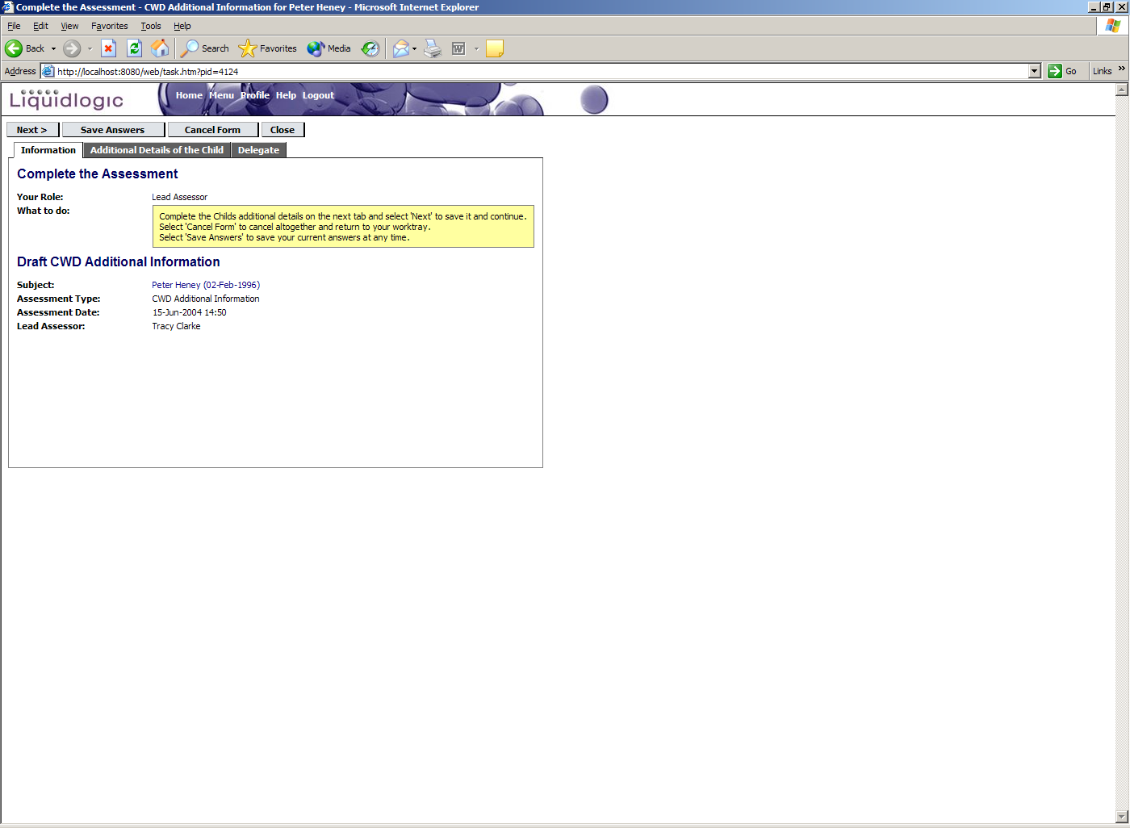

Complete the relevant parts of the ‘Additional Details of the Child’ tab and click ‘Next’.

If you wish to save your answers so far and return to complete them at a later point click ‘Save Answers’ and click ‘Close’. A task will appear in the tasks area of your home page that you can ad further details to.

To complete additional details click ‘Complete Process’.

Once the ‘Additional Details’ for a child have been completed you have the ability to view or update them from the Personal tab.

Key Agencies

This tab displays details of any key agencies involved with a child. In the example below there is one key agency already set up.

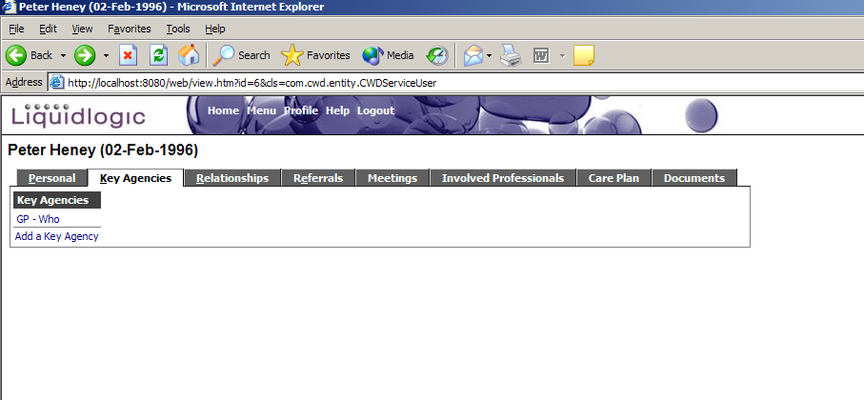

To view details of this key agency click the ‘GP – Who’ hyperlink. The relevant details of the key agency are displayed together with two hyperlinks that allow you to update or delete the key agency involvement.

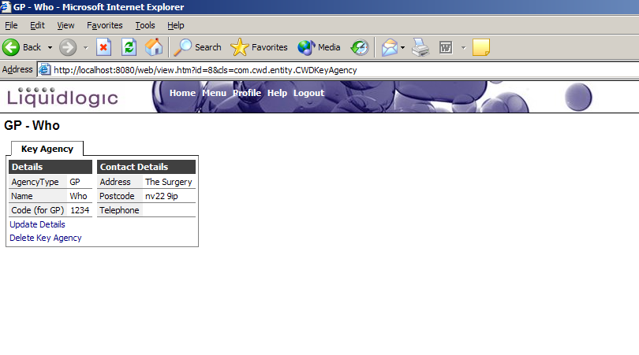

To add details of a key agency click the ‘Add a Key Agency’ hyperlink and a screen similar to the one below is displayed:

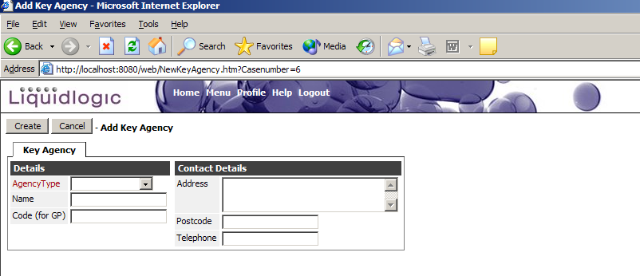

Complete the details of the key agency and click Create.

Relationships

This tab contains details of relationships a child has to other people, e.g. parents/carers.

In the example below one relationship has already been set up.

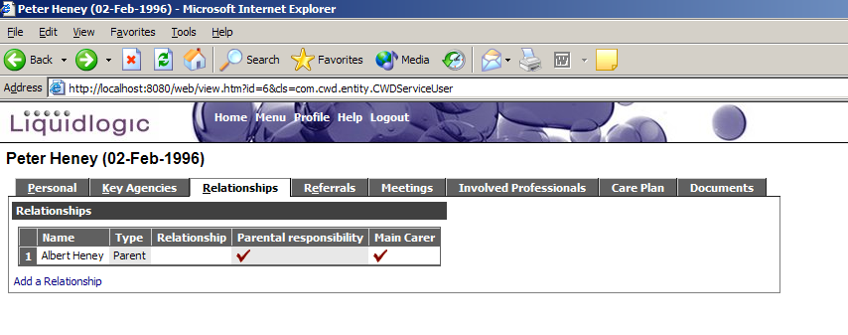

If you select the relationship two hyperlinks allowing you to update or delete the relationship are displayed.

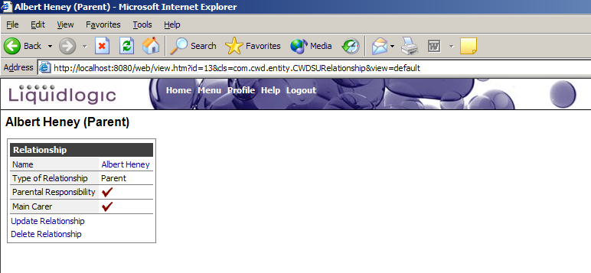

To add details of a new relationship click the ‘Add a Relationship’ hyperlink and a screen similar to the following is displayed.

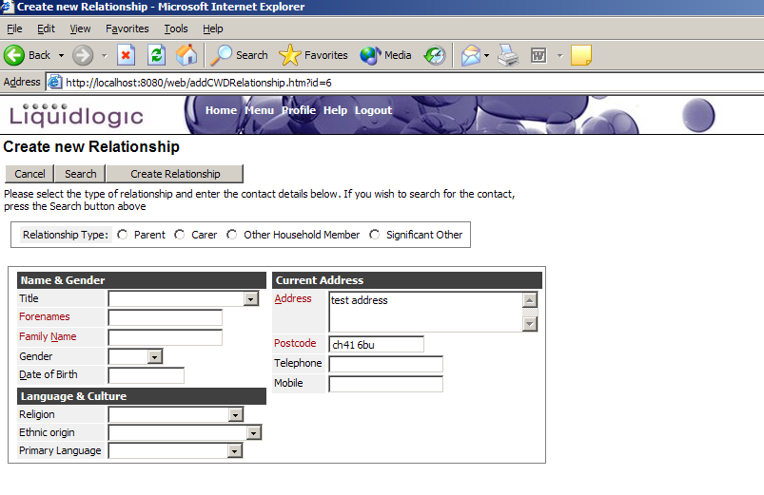

Complete the relevant details and click ‘Create Relationship’.

Referrals

This tab contains details of all referrals that have been made. In the example blow there is one currently open referral.

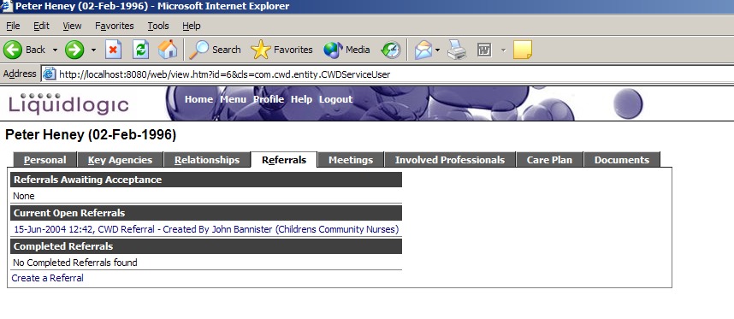

If you select the open referral the full details are displayed.

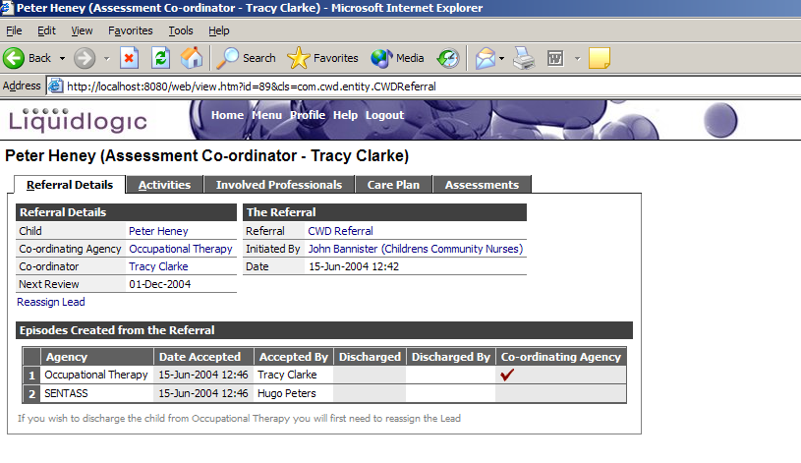

Further details of referrals are contained in the Quick Reference Guide to Referral and Episode Details.

To create a new referral click the ‘Create a Referral’ hyperlink. Further details of how to do this are contained in the Quick Reference Guide to Creating a Referral.

Meetings

This tab contains details of any meetings held regarding the child. In the example below there is one completed meeting.

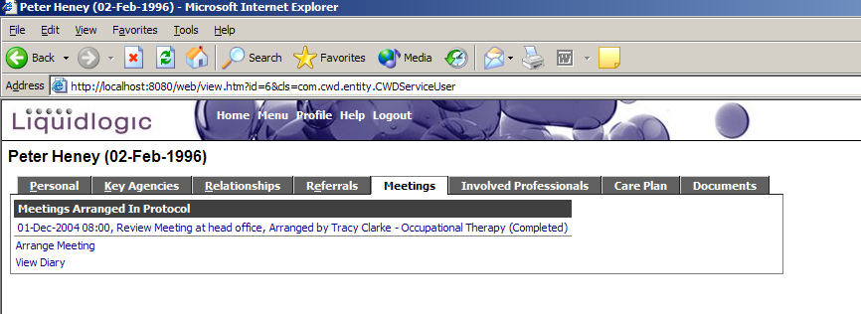

If you select this completed meeting full details are displayed.

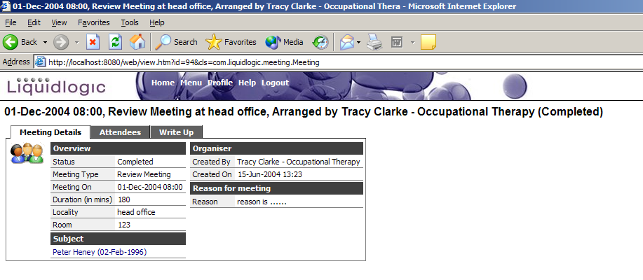

Further details of how to arrange a meeting are contained in the Quick Reference Guide Dealing with a Referral.

Involved Professionals

This tab contains details of any professionals currently involved with a child. In the example below there are three professionals involved.

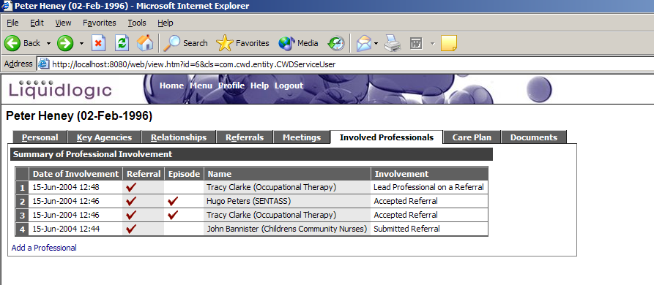

If you select one of the involvements you can view the relevant referral or episode (see Quick Reference Guide to Referrals and Episodes).

Care Plans

This tab contains details of any ongoing and completed care plans for a child. In the example below there are two completed and one current care plan.

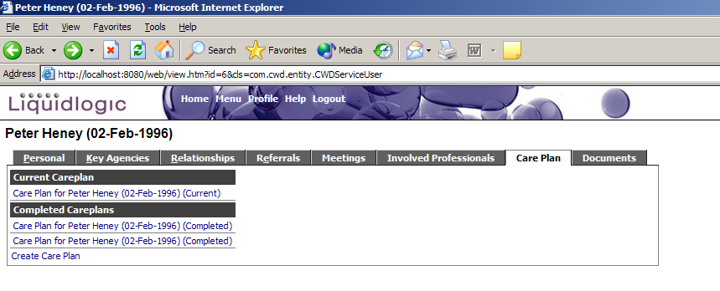
Select a completed care plan to view further details of the outcomes, interventions and equipment used.

Further information regarding current care plans is given in the Quick Reference Guide to Meetings.

Documents

This tab contains details of any documents produced or attached to a child’s record. In the example below there is one attached document, a CWD referral acceptance letter.

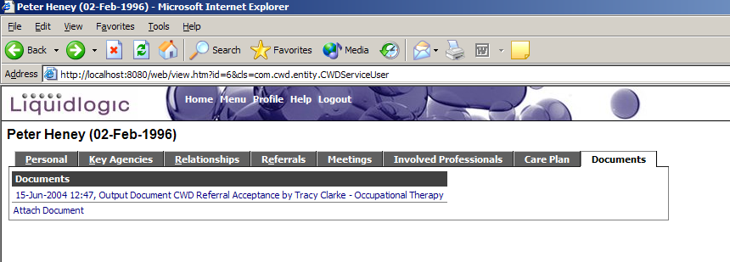

If you select the acceptance letter further details of the acceptance letter are displayed together with a hyperlink to view the actual letter sent.

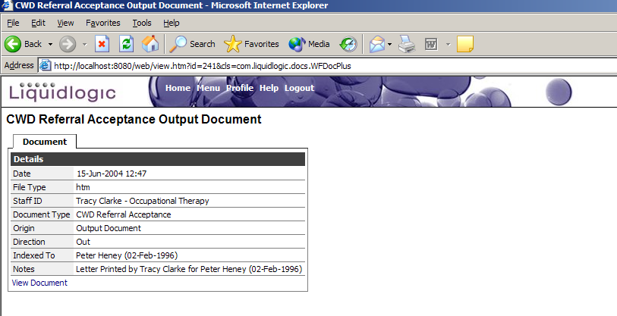

To attach a new document to a child’s record click the ‘Attach Document’ hyperlink and a screen similar to the following is displayed.

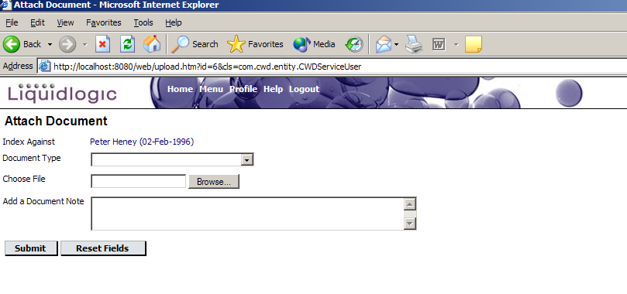

Complete the relevant details of the letter and click submit. The details of the new document will be recorded on the Documents tab.

Updating Profile

The ‘Update My Profile’ option allows you to view and update your personal details on the SAP system. It is possible to update name, contact, password, security question and any additional information at any time whilst using the system. A lot of this information will remain the same, but it is possible to update these details at any time when required; for example, if your telephone extension number changes or you wish to update your password. Alongside each section there is a Help section which contains text to explain what information is required and how it should be entered.

From your work tray select ‘Update my Profile’ and you will see the screen below.

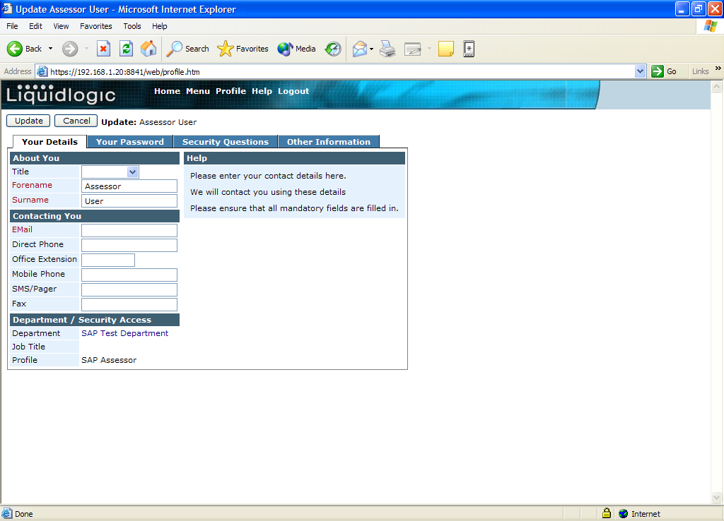

Your Details

This tab contains your basic details e.g. Title, Forename, Surname, Direct Phone number, Office extension etc.

Enter your details into then click on update, this will take you back to the work tray.

Once you have updated the details you can either move on to another tab, or click update to save your changes.

Your Password

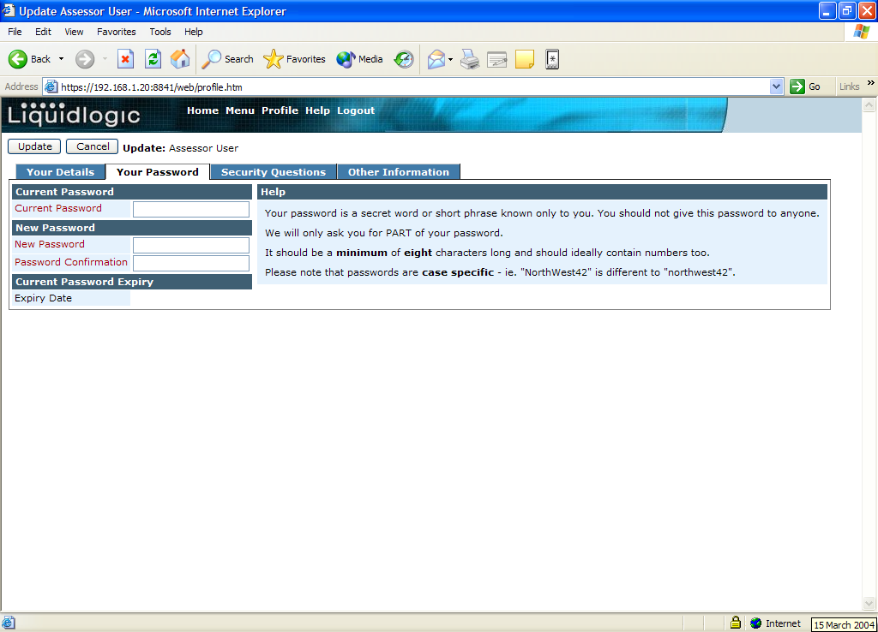

From here you are able to change your password.

Enter your existing password in the “Current Password” filed, then enter your new password in the “New Password” and “Password Confirmation”.

Your password must be at least 8 characters long and contain at least 2 numbers (e.g. Winter04)

Once you have updated the details you can either move on to another tab, or click update to save your changes.

Security Questions

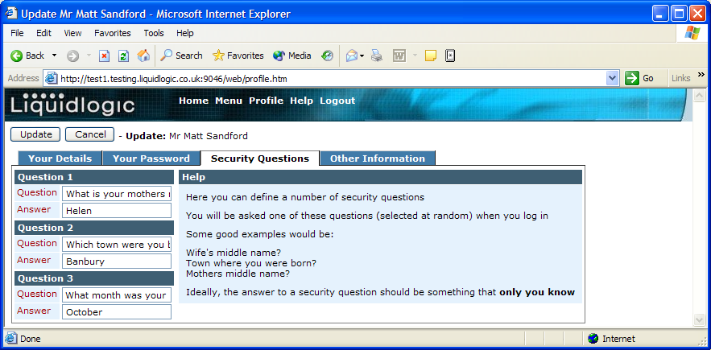

From here you are able to change your unique questions and answers that are part of your log in process. (eg Mothers Maiden name)

Once you have updated the details you can either move on to another tab, or click update to save your changes – if you are only updating your secret questions, you will be asked to confirm your password, to do this, click on the Your Password tab and enter your ‘Current Password’. You do not have to create a new password.
Other Information

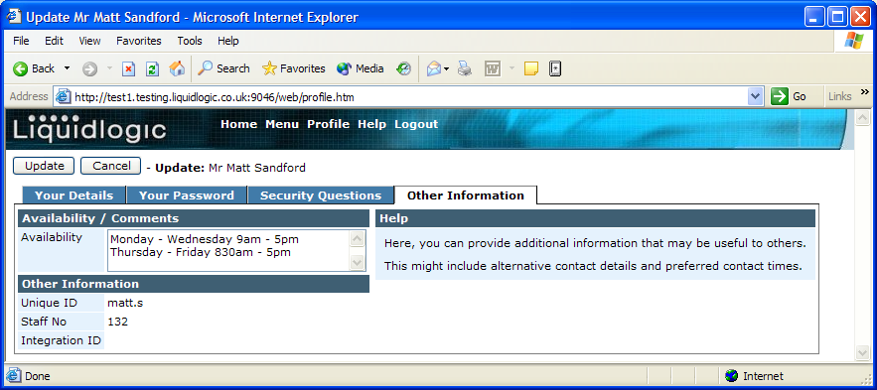

This is a free text box allowing you to enter any additional information that you feel may be useful for other users to know about your details. This could include alternative contact details, contact times or your availability (ie on emergency duty this current week).

Once you have updated the details you can either move on to another tab, or click update to save your changes.

Creating a Referral Form

- To complete a referral form click the ‘Create Referral’ hyperlink on the Referrals tab of a child’s record. The following is displayed.

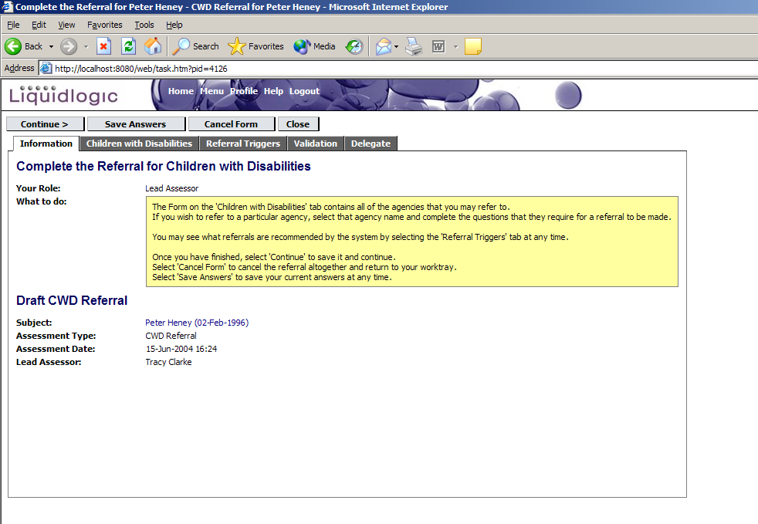
2. Complete the relevant sections of the referral form contained on the ‘Children with Disabilities’ tab.

If you just wish to save your answers at any point without moving onto the next stage in the process click ‘Save Answers’. The task can then be closed and it appears as a task on your home page.

3. Once you have completed the referral form click ‘Continue’. This will also save your answers and move you onto the next stage in the process.

4. To make referrals to the relevant agencies click ‘Make Referrals’ and then confirm this is what you want to do by clicking ‘Ok’ to message that is displayed.

5. Select the ‘Take Actions’ tab and the referral paths that have been triggered are displayed as mandatory actions. To make these referrals click ‘Initiate All’ and provide a reason for the referral.

Click ‘Refer’ and the referrals will be made.

Once this is done the referrals made are displayed under the History of Actions Taken section.

6. To complete the referral form click ‘Complete Process’ and then click ‘Ok’ to confirm this is what you want to do. Provide any relevant completion comments for you referral form and click ‘OK – Complete Process’.

