Document Purpose
This document was produced by the FAME Programme to provide guidance and practical examples to all Local Authorities/Partner Agencies for an implementation of Multi-Agency working. All documents are the property of FAME National Project, and to access these documents you have agreed to the terms and conditions set out in the accessing of these products from the FAME website.
For a further description of this document please see the Product Definition below stating exactly what the product is. For more in depth explanation and guidance please see the FAME "How to Implement and Sustain a Multi-Agency Environment".

Technical Solution:
the technical hardware, software and architecture including interfacing with other suppliers’ products and the relationship for the integration specification.

Table of Contents
1 Overview 1
2 Service Directory Load Interface 1
2.1 Overview 1
2.2 Data Load Process 1
2.3 Service Data Import XML Specification 2
2.3.1 ServiceDirectory XML Document Format 2
2.3.2 ServiceDirectoryResponse XML Document Format 3
2.4 Import Data Fields 4
3 Service Directory Retrieval Interface 7
3.1 Overview 7
3.2 Usage Scenarios 7
3.2.1 Overview 7
3.2.2 Keyword Search Usage 7
3.2.3 Hierarchical Search Usage 8
3.3 Filtered Search Interface Specification 8
3.3.1 Overview 8
3.3.2 Syntax 8
3.3.3 FilteredSearchRequest Document 9
3.3.4 FilteredSearchResponse Document 9
3.3.5 Response Codes 11
3.3.6 Web Service Parameters 12
3.4 List Categories Interface Specification 12
3.4.1 Overview 12
3.4.2 Syntax 12
3.4.3 Response Codes 13
3.4.4 Web Service Parameters 13
4 Category Data Format Specification 14
4.1 Overview 14
4.2 Import Data Format Specification 14
5 Spatial Data Format Specification 15
5.1 Overview 15
5.2 Geography Hierarchy Definition 16
5.3 Geographic Area Import Data Format Specification 16
5.4 Postcode Area Import Data Format Specification 17
Appendices 19
A Web Service Schema 19
B Import Schema 19
C Sample Geography Definition 19

Overview
The CIBER IRT Service Directory application provides facilities for recording and accessing information about services in a structured way, with a particular emphasis on providing a filtered search mechanism for use within the context of IRT (Identification Referral and Tracking, also known as Information Sharing and Assessment).
This document presents the Service Directory interface specification covering:
- How to load service information into the Service Directory – see section 2
- How to retrieve information from the Service Directory – see section 3
- The data load format of the category information – see section 4
- The data load format of the spatial data – see section 5
- Service Directory Load Interface

Overview
The Service Directory uses 3 types of information:
- Information on services supplied by service providers
- Service categories – the Local Government Category List (LGCL)
- Geographic mapping information
The Service Directory load interface is concerned only with the service information. This interface is provided to allow regular automatic loading of service information from one or more data feeds, allowing data providers to maintain the service information electronically from existing data sources. Loading of service categories and geographic mapping information will both be one-off tasks undertaken as part of configuration of the system - no facility is included for regular automatic loading of these data sets.

Data Load Process
Source data is presented to the Service Directory as an XML file structured as described in section 2.3. The data file must be placed in a designated file directory:
- For Lewisham, this directory will be on Lewisham’s BizTalk server
- For external agencies supplying information, this directory will be on the IRT BizTalk server. A script can be supplied to automate the upload of the extract file to this directory via the Internet.
A data file must contain the entire service information for a particular source system – there is no facility to supply only updated information. The data file is automatically processed by the Service Directory, replacing all existing information from the specified source system. Service data from other source systems is not affected. A “source system” is any separate data source that can supply data in the specified format. The designation of source systems does not affect retrieval of service information, only how service data is maintained.
On completion of the data load, the source file is deleted and a status file is produced in an output directory.

Service Data Import XML Specification
The Service Directory import format is formally described by the ServiceDirectoryImport XML schema presented in Appendix B. There are 2 messages involved:
- ServiceDirectory – this is the input message format
- ServiceDirectoryResponse – this is the format of the response message to the import

ServiceDirectory XML Document Format
The corresponding XML for a data import is structured as follows:
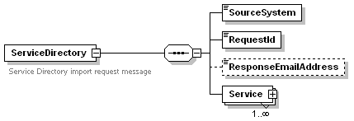
The definition of the fields is:
Field | Type | Mandatory | Description
ServiceDirectory | Complex | Yes | Encloses all the other elements
SourceSystem | String, 1-20 characters | Yes | Unique identifier for the source of the data. This is used to identify which service directory records are to be replaced by the new records contained within this document.
RequestId | String | Yes | A unique request identifier – used to correlate with the response message.
ResponseEmailAddress | String | No | The email address where the response message is sent to. Only required for non-Lewisham data sources. Responses to Lewisham messages will be written back to a file on Lewisham’s BizTalk server.
Service | Complex | Yes | 1 or service records, see section 2.4.
The corresponding XML should look as follows:
<ServiceDirectory>
<SourceSystem>name of source system</SourceSystem>
<RequestId>unique identifier for this request</RequestId>
<ResponseEmailAddress>name@somewhere.com</ResponseEmailAddress>
<Service>
<Name>name of service</Name>
<Description>description of service</Description>
and so on as per the list of data fields as specified in section 2.4
</Service>
<Service>
next service
</Service>
<ServiceDirectory>
A <SourceSystem> tag must be the first data item, identifying the data source. The value must be a unique identifier that will not change since it is used to identify existing data that is to be replaced.
Following <RequestId> comes one or more <Service> tags, with each <Service> tag wrapping the data fields for a service definition. The data field tags must appear in the order as documented in 2.4.

ServiceDirectoryResponse XML Document Format
The ServiceDirectoryResponse XML document is returned by the IRT system:
- for requests sent from Lewisham BizTalk, the response will be sent back to Lewisham BizTalk where it will be written out as a file
- for non-Lewisham requests, the response will be sent back to the supplied email address
The purpose of the document is to confirm that the request has been processed and report any errors detected. The format of the response document is:
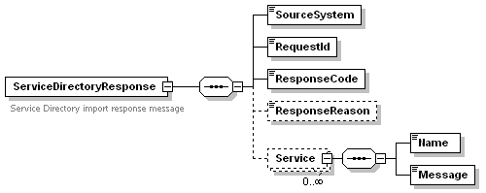
The meaning of each element is:
Field | Type | Description
ServiceDirectoryResponse | Complex | Encloses all the other elements
SourceSystem | String | The source system name as supplied on the ServiceDirectory message
RequestId | String | The unique request identifier as supplied on the ServiceDirectory message
ResponseCode | String | A numeric value, with “0” (zero) meaning the request was processed without error
ResponseReason | String | An optional string used to report back error messages
Service | Complex | Used to report back an error with a service record. Occurs zero or more times as required.
Service/Name | String | The name of a service record in error
Service/Message | String | The error detected with the service record
The “Service” structure is used to report any errors encountered with a service definition record. If an error is encountered the record is still loaded into the system but it may not be selectable by the user due to the error reported.

Import Data Fields
The following table lists the fields used to describe a service.
- Data fields must appear in the order specified using an XML tag as specified by the “XML Element Name” column.
- The “MI” column specifies which fields are mandatory for data import– services without this information will be rejected during importation.
- Mandatory fields from a business perspective, i.e. those fields that must be present for a correctly defined service, are to be defined separately by Lewisham
- The data format for all fields is string except for MinimumAge and MaximumAge which require numeric values.
- The MaxLen column shows the maximum length of information that is accepted by that field. On importation of data, fields exceeding the specified length will be truncated from the right.
XML Element Name | Description | MI | MaxLen
Name | Name of service provider or service offered | Y | 100
Description | Description of service | Y | 2000
LGCLCategory | The LGCL (LAWS) category for this service – only 1 value. Restricted to LGCL terms as contained in version 1.03 of the LGCL. See http://www.esd-toolkit.org/laws/ for a complete list. | Y | 100
NeedLevel | A numeric value from 1-4 denoting the level of need this service is targeted at. A value of 1 denotes a universal service and 4 a very specialised service. The following terms can be equated with the numeric values:  1 = Universal, 2 = Vulnerable, 3 = Looked After or Complex, 4 = Acute | Y | 1
ServiceArea | Geographic area served. The name must match one of the names of geographic areas defined to the Service Directory. This is the value used to perform geographic filtering of services, not the Address1-5 or PostCode fields. | Y | 100
MinimumAge | Minimum age of clients served – a numeric value, default is 0. | N | 3
MaximumAge | Maximum age of clients served – a numeric value, default is 199. | N | 3
Address1 | Address line 1 of service access point | N | 250
Address2 | Address line 2 of service access point | N | 100
Address3 | Address line 3 of service access point | N | 100
Address4 | Address line 4 of service access point | N | 100
Address5 | Address line 5 of service access point | N | 100
PostCode | Postcode of service access point | N | 8
Telephone | One or more telephone numbers | N | 100
Fax | One or more fax numbers | N | 100
Minicom | Minicom number | N | 100
Email | One email address | N | 250
URL | URL Web address for obtaining more information on this service | N | 250
OpeningTimes | Opening date and times, to be used only when OpeningHoursMonday – Sunday are not used. | N | 100
OpeningHoursMonday | time in string format, e.g. 9.30am – 6.30pm | N | 50
OpeningHoursTuesday | time in string format, e.g. 9.30am – 6.30pm | N | 50
OpeningHoursWednesday | time in string format, e.g. 9.30am – 6.30pm | N | 50
OpeningHoursThursday | time in string format, e.g. 9.30am – 6.30pm | N | 50
OpeningHoursFriday | time in string format, e.g. 9.30am – 6.30pm | N | 50
OpeningHoursSaturday | time in string format, e.g. 9.30am – 6.30pm | N | 50
OpeningHoursSunday | time in string format, e.g. 9.30am – 6.30pm | N | 50
OutOfHoursContact | Information on how/who to contact out of normal hours | N | 100
ReferralProcedure | How to make a referral or who to contact, e.g. contact Social Services | N | 250
ReferralInformation | Information required to make a referral. | N | 250
ReferralChannels | List of channels for referring: Telephone, Letter, Fax, Email | N | 100
EligibilityCriteria | Who is eligible for this service | N | 100
EligibilityRestrictions | E.g. capacity, funding required, etc | N | 250
ElectronicReferralMethod | Electronic referral method, if any. One of: Email, eForm | N | 10
ElectronicReferralAddress | Email address or eForm URL | N | 250
Language | Languages other than English which are supported | N | 250
PublicTransport | Information on public transport access | N | 500
CarParking | Car parking available? Blue badge parking available? | N | 100
BuildingAccessibility | Wheel chair access? Access without stairs? | N | 100

Service Directory Retrieval Interface

Overview
The Service Directory provides two application interfaces for retrieving information on services. These facilities are provided to applications as web service interfaces, the input and output data being passed as XML documents.
The primary interface is the “Filtered Search” API which provides a variety of ways of conducting a search on the service information. The “List Categories” API is a supporting interface that provides applications access to the hierarchical category tree maintained by the Service Directory, facilitating the construction of a hierarchical search user interface into the Service Directory.

Usage Scenarios

Overview
The retrieval interfaces have been designed to allow search user interfaces to be constructed in a variety of ways by simply altering the parameters to the API calls. Search mechanisms that are supported are:
- Restricted to public services (Need Level = 1)
- Category keyword search
- Hierarchical navigation by category structure
- Geographical search
This section supplies suggestions on how to use the Service Directory interfaces to support the construction of a keyword search or a hierarchical search.

Keyword Search Usage
In this scenario the user is prompted to enter a search term, that is, the type of service they require. The user interface could also allow the following to be selected:
- Need Level – For professionals, this would most likely be presented as a drop down list equating to the values 1-4. For public access this value should be preset to “1” to ensure only public services are returned.
- Age – the child’s age, 0-19 years.
- Location – the geographic location where the service is required, used to prioritise the order of results. This could be a drop-down list of geographic areas, free text field or a postcode field.
The Service Directory will respond with a list of services that exactly match the service category term or a direct equivalent. Services are ordered by geographic location if a location value has been entered, with the closest match appearing first.
The Service Directory will also return a list of sub-categories that contain similar but more specific services. These categories should be presented to the user as an auto-link to perform a search using the specified search term, allowing the user to drill-down to more specific services.
If the service category term is not found, then the Service Directory will not return any service information, but will return a list of potential service categories. The user interface should display these to the user as an auto-link to perform a direct search on that term.

Hierarchical Search Usage
A hierarchical search interface can be constructed by using a combination of the ListCategories and FilteredSearch API methods, as follows:
- Call the ListCategories method with ParentCategory omitted – Service Directory will respond with a top level list of service categories
- Present to the user a drop-down list of service categories
- When the user selects a category from the list, call the FilteredSearch method with that category value
- For public access, NeedLevel should be set to 1
- Optionally allow the user to enter Age and Location values
- Service Directory will respond with:
- A list of services that match the supplied category name
- A list of sub-categories to allow the user to refine their search
- A bread-crumb trail of the category hierarchy can be constructed by displaying the values of CategoryLevel1 – 6 as a directed search link, allowing the user to navigate back up the hierarchy

Filtered Search Interface Specification

Overview
The FilteredSearch web service call allows an application to retrieve service information filtered by any of 4 criteria:
- The “Need Level” of the child
- The service category
- The child’s age
- A location, either a location name or postcode
The Service Directory will return all the details on services that exactly match the filter criteria. If a category search is being performed (a service category keyword is supplied), the Service Directory will also return summary information about sub-categories that have services matching the other filter criteria.

Syntax
The Filtered Search API has the following syntax:
FilteredSearchResponse FilteredSearch( FilteredSearchRequest )
where:
- FilteredSearchRequest is an XML document containing the search criteria
- FilteredSearch is the Service Directory web-service method to be invoked. See section 3.3.5.
- FilteredSearchResponse is the returned XML document containing the results of the search
The XML document formats are formally described by an XML schema presented in Appendix A.

FilteredSearchRequest Document
The FilteredSearchRequest XML document is required input to the FilteredSearch API method. The request format is defined by the following XML schema:
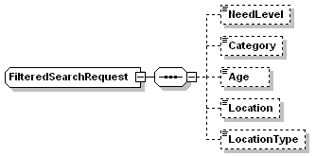
- NeedLevel - optional, the service Need Level
- Category – optional, the LGCL category term or synonym to locate
- Age – optional, the child’s age, a numeric value 0-199
- Location – either a location name or postcode
- LocationType – specifies the type of location passed. Must be “LocationName” or “PostCode”.

FilteredSearchResponse Document
The FilteredSearchResponse XML document is returned by the Service Directory from a call to FilteredSearch. The XML document is described by the following XML schema:
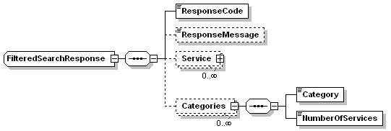
- ResponseCode – a numeric code to indicate the type of response, “0” being a non-error response
- ResponseMessage – used to pass back error messages
- Service – zero or more services that exactly match the search criteria. A “Service” contains all the data fields for a service (see section 2.4 for definition), plus the category hierarchy for each service.
- Categories – zero or more categories related to the search criteria. Only returned if a category is supplied on input.
The format of the “Service” information is shown in Figure 1. The elements of a “Service” are similar to those in the import definition (see section 2.4) plus the following fields:
Element Name | Description
ServiceDirectoryId | A unique numeric value allocated to the service
SourceSystem | The name of the source system where the service information was obtained from
Category | The LGCL category
CreationDate | The date this information was created within the Service Directory
CategoryLevel1 | The name of the level 1 category in which this service is classified
CategoryLevel2 | The name of the level 2 category in which this service is classified
CategoryLevel3 | The name of the level 3 category in which this service is classified
CategoryLevel4 | The name of the level 4 category in which this service is classified
CategoryLevel5 | The name of the level 5 category in which this service is classified
CategoryLevel6 | The name of the level 6 category in which this service is classified

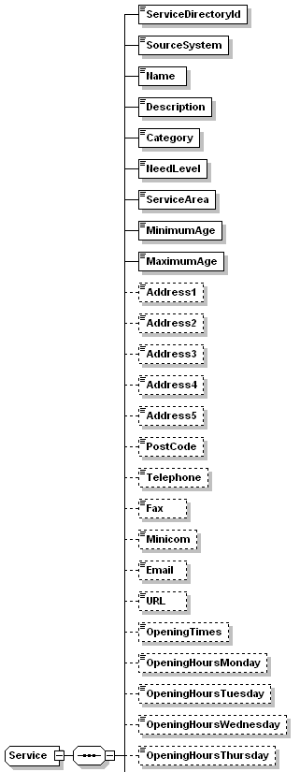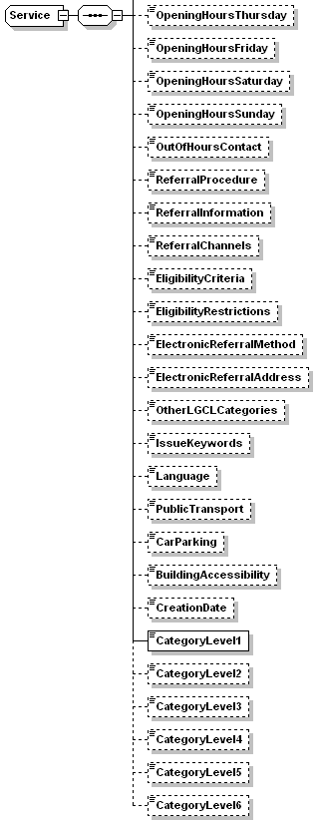
Figure 1 Service Fields

Response Codes
The following response code values are defined:
Code | Description
0 | Search completed successfully using the search terms
2 | Category term not found but potential alternative categories have been found, returned in the “Categories” element.
3 | Category term not found
4 | Location value not found

Web Service Parameters
The FilteredSearch web service is invoked using these parameters:
- SOAP Address: http://<servername>/ServiceDirectory/ServiceDirectory.asmx
- SOAPAction: http://www.ciber-uk.com/servicedirectory/FilteredSearch
- Style=document, use=literal
A WSDL for the method is available at http://<servername>/ServiceDirectory/ServiceDirectory.asmx?WSDL.

List Categories Interface Specification

Overview
The List Categories interface provides access to the list of LGCL categories with services defined. The interface is provided to allow applications to construct a hierarchical navigation user interfaced based on the category tree.

Syntax
The format of the request is:
ListCategoriesResponse ListCategories( string ParentCategory )
- ParentCategory – optional, the LGCL category to return the sub-categories for. If omitted, Service Directory returns the top level LGCL categories.
- ListCategories – the web service method to invoke
- ListCategoriesResponse – an XML document containing the list of categories
The format of the ListCategoriesResponse XML document is specified by the following schema:
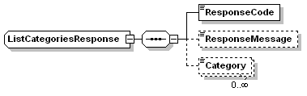
- ResponseCode – a numeric code to indicate the type of response
- ResponseMessage – used to pass back error messages
- Category – zero or more category names. If no ParentCategory was supplied, then this list will be the top level category names, otherwise it will be the names of any sub-categories.
The XML document formats are formally described by an XML schema presented in Appendix A.

Response Codes
The following response code values are defined:
Code | Description
0 | Search completed successfully using the search terms
3 | Category term not found

Web Service Parameters
The ListCategories web service is invoked using these parameters:
- SOAP Address: http://<servername>/ServiceDirectory/ServiceDirectory.asmx
- SOAPAction: http://www.ciber-uk.com/servicedirectory/ListCategories
- Style=document, use=literal
A WSDL for the method is available at http://<servername>/ServiceDirectory/ServiceDirectory.asmx?WSDL.

Category Data Format Specification

Overview
All services within the Service Directory belong to a category. These categories are organised into a hierarchical tree up to 6 levels deep. Each category can also have one or more synonyms defined. The category structure has been designed to allow the Local Government Category List (LGCL) to be used as the source of this information.
This section documents the import data load format of the category information to enable the category data to be loaded into the Service Directory category table.
The loading of this data will be a one-off task as part of configuration of the system - no facility is included for regular automatic loading of this data.

Import Data Format Specification
The category data file must be formatted as follows:
- field names in row 1
- comma delimited format - each field delimited by a comma except the last field
- string values enclosed within double quotes
- all fields must be present – empty fields must include the delimiter
Each row must contain the following fields in the order specified in the table:
Field name | Type | Max Len / Values | Mandatory | Description
id | Integer | 5 digits | Yes | Unique identifier of this category or synonym
name | String | 100 | Yes | Category or synonym name. Must be a unique value.
synonym | Boolean | 0 or 1 | Yes | 0 = category; 1 = synonym
hierarchy_level | Integer | 1 – 6 | Yes | 1 = top of the hierarchy, 6 = lowest level
parentid | Integer | 5 digits | Conditional | The id of the category above this category. Required if Level > 1 and not a synonym.
parentname | String | 100 | Conditional | Name of the parent category. Required if parentid present.
baseid | Integer | 5 digits | Conditional | The id of the category for which this record is a synonym. Required if synonym=1.
basename | String | 100 | Conditional | Name of the base category. Required if baseid present.
level1 | String | 100 | Yes | Name of the category at level-1 within this branch of the hierarchy
level2 | String | 100 | Conditional | Name of the category at level-2, if any, within this branch of the hierarchy
level3 | String | 100 | Conditional | Name of the category at level-3, if any, within this branch of the hierarchy
level4 | String | 100 | Conditional | Name of the category at level-4, if any, within this branch of the hierarchy
level5 | String | 100 | Conditional | Name of the category at level-5, if any, within this branch of the hierarchy
level6 | String | 100 | Conditional | Name of the category at level-6, if any, within this branch of the hierarchy
Sample data rows:
id,name,synonym,hierarchy_level,parentid,parentname,baseid,basename,level1,level2,level3,level4,level5,level6
1,"Business",0,1,,"",,"","Business","","","","",""
5,"Business finance",0,2,1,"Business",,"","Business","Business finance","","","",""
1684,"Real estate",1,2,,"",15,"Business property","Business","Business property","","","",""
Explanation of sample data:
- Item “1” is a level 1 category
- Item “5” is a level 2 category whose parent is item “1”
- Item “1684” is a synonym for item “5”

Spatial Data Format Specification

Overview
This section documents the import data load format of the geographic information to enable the spatial data to be loaded into the Service Directory spatial tables. Two spatial data sets are required:
- Geographic area hierarchy – specifies the names of the geographic areas and the hierarchical relationship between areas
- Postcode to area map – specifies the postcodes contained within the lowest level of the geography hierarchy
The Service Directory uses the spatial data in two ways:
- to allow a service area to be defined for each service – the service area must match one of the defined geographic names
- to allow filtering and ranking of Service Directory searches by location, either by geographic name or by postcode
The loading of this data will be a one-off task as part of configuration of the system - no facility is included for regular automatic loading of this data.

Geography Hierarchy Definition
The Service Directory geographic hierarchy requires the supply of spatial data with the following characteristics:
- area names must be unique
- areas are related to each other in a strict hierarchy tree
- the top level of the hierarchy (level 1) may contain more than one area
- areas must not spatially overlap, that is a level 2 area can only exist within one level 1 area
- the number of hierarchy levels is user defined
- postcodes can only map onto one area and that area should be at the lowest level of the hierarchy
- synonyms can be defined to allow alternate spellings of geographic areas – this allows villages for example to be associated with a ward or parish
- synonyms are not directly defined by a collection of postcodes or sub-areas – this is inferred through reference to the base geographic area
For the Lewisham IRT Service Directory, the following geographical hierarchy will be used:
Level | Geographic area | Example
1 | Greater London | London
2 | London Boroughs | Lewisham
3 | PCT sub-areas | Neighbourhood 1
4 | Ward | New Cross
A sample geography using this hierarchy is provided in Appendix C. Changes to this data structure will affect the interface definition as described within this document.

Geographic Area Import Data Format Specification
The geographic import data file must be formatted as follows:
- field names in row 1
- comma delimited format - each field delimited by a comma except the last field
- string values enclosed within double quotes
- all fields must be present – empty fields must include the delimiter
- must obey the rules defined in section 5.2
Each row must contain the following fields in the order specified in the table:
Field name | Type | Max Len / Values | Mandatory | Description
id | Integer | 5 digits | Yes | Unique identifier of this geographic area
areaname | String | 100 | Yes | Unique geographic name of this area
hierarchy_level | Integer | 1 digit | Yes | 1 = top of the hierarchy, 2 = next level down, etc.
Synonym | Boolean | 0 or 1 | Yes | 0 = area; 1 = synonym for area
Parentid | Integer | 5 digits | Conditional | The “id” value of the area containing this area. Required if hierarchy_level > 1 and synonym=0.
Baseid | Integer | 5 digits | Conditional | The “id” value for which this area name is a synonym of. Required if synonym=1.
Sample data import file:
id,areaname,hierarchy_level,synonym,parentid,baseid
1,London,1,0,,
2,Lewisham,2,0,1,
3,Neighbourhood 1,3,0,2,
4,Catford South,4,0,3,
5,Catford,4,1,,4
Explanation of sample data:
- Item “1” is the top of the spatial hierarchy
- Item “4” is a level 4 area, contained within area id “3”
- Item “5” is a synonym for level 4 area id “4”

Postcode Area Import Data Format Specification
The postcode-to-area data file must be formatted as follows:
- field names in row 1
- comma delimited format - each field delimited by a comma except the last field
- string values enclosed within double quotes
- all fields must be present – empty fields must include the delimiter
- each row specifies a single, fully specified postcode
- a postcode can only occur once
- the geographic area names must match those specified in the geography import
Each row must contain the following fields in the order specified in the table:
Field name | Type | Max Len / Values | Mandatory | Description
id | Integer | 5 digits | Yes | Unique identifier of this postcode
areaname | String | 100 | Yes | The name of the geographic area in which this postcode occurs. Must specify an area at the bottom level of the spatial hierarchy.
postcode | String | 8 | Yes | The postcode value, including a space between the 2 parts of the postcode. Must be a unique value.
Sample data import file:
id,areaname,postcode
1,Catford South,SE6 7NQ
2,Catford South,SE6 7NR

Appendices
- Web Service Schema
The “webservicetypes.xsd” file contains the web service schemas for the web service APIs as defined in section 3.
- Import Schema
This XML schema defines the structure of an XML data feed for the Service Directory. The schema is contained within the attached “import.xsd” file.
- Sample Geography Definition
The following table supplies a sample geographic hierarchy for the Lewisham Service Directory:
Level | Name | Parent
1 | London | n/a
2 | Lewisham | London
3 | Neighbourhood 1 | Lewisham
3 | Neighbourhood 2 | Lewisham
3 | Neighbourhood 3 | Lewisham
3 | Neighbourhood 4 | Lewisham
4 | Telegraph Hill | Neighbourhood 1
4 | Brockley | Neighbourhood 1
4 | New Cross | Neighbourhood 1
4 | Evelyn | Neighbourhood 1
4 | Blackheath | Neighbourhood 2
4 | Ladywell | Neighbourhood 2
4 | Lewisham Central | Neighbourhood 2
4 | Lee Green | Neighbourhood 2
4 | Downham | Neighbourhood 3
4 | Whitefoot | Neighbourhood 3
4 | Rushey Green | Neighbourhood 3
4 | Catford South | Neighbourhood 3
4 | Grove Park | Neighbourhood 3
4 | Bellingham | Neighbourhood 4
4 | Sydenham | Neighbourhood 4
4 | Forest Hill | Neighbourhood 4
4 | Perry Vale | Neighbourhood 4
4 | Crofton Park | Neighbourhood 4

