Document Purpose

This document was produced by the FAME Programme to provide guidance and practical examples to all Local Authorities/Partner Agencies for an implementation of Multi-Agency working. All documents are the property of FAME National Project, and to access these documents you have agreed to the terms and conditions set out in the accessing of these products from the FAME website.

For a further description of this document please see the Product Definition below stating exactly what the product is. For more in depth explanation and guidance please see the FAME "How to Implement and Sustain a Multi-Agency Environment".

Technical Solution:
the technical hardware, software and architecture including interfacing with other suppliers’ products and the relationship for the integration specification.

Table of Contents
1 Overview 5
2 Batch Data IRT Integration 5
2.1 Overview 5
2.2 Data Upload Process 5
2.2.1 Integration Process for Lewisham Back Office Systems 5
2.2.2 Integration Process for non-Lewisham Back Office Systems 5
2.3 Data Extract File Specification 5
2.3.1 System Names 5
2.3.2 Child Record Fields 5
2.3.3 Party Record Fields 5
3 Real Time IRT Integration 5
3.1 Overview 5
3.2 Back Office Interface Requirements 5
3.3 Query Child Interface 5
3.3.1 Overview 5
3.3.2 Messaging Protocol 5
3.3.3 Request Document Format (QueryChildRequest) 5
3.3.4 Response Document Format (QueryChildResponse) 5
3.4 Search Child Request Specification 5
3.4.1 Overview 5
3.4.2 Request Document Format (SearchChildRequest) 5
3.4.3 Response Document Format (SearchChildResponse) 5
3.5 Retrieve Child Request Specification 5
3.5.1 Overview 5
3.5.2 Request Document Format (RetrieveChildRequest) 5
3.5.3 Response Document Format (RetrieveChildResponse) 5
Appendices 5
A Real Time Interface XML Schema 5

Overview
This document presents the integration specification between the IRT system and the IRT feeder systems – the back office applications that supply the source IRT data. This document refers only to the communications between the IRT integration components and the back office systems. Information on the internal communications between the CIBER IRT integration components and the Liquidlogic Protocol application are specified in the IRT CIBER to Protocol Integration Specification document, reference 12250563-001.
This specification document includes the standard data format used to upload information into the IRT application, along with the interface mechanisms for the back office systems.
The integration of the back-office systems is possible in two ways:
A batch upload of a data via the IRT integration component
A real-time query from IRT, via the IRT integration component, into the back-office application
The IRT integration components are based on Microsoft BizTalk and thus all of the back-office integrations involve an interface with BizTalk. The nature of these interfaces is specified within this document.

Batch Data IRT Integration

Overview
The IRT data upload process works as follows:
A data extract script is run against the back office database system to extract information on children to create a data-extract file in a format specified within this document
The data-extract file is moved to a directory for upload to IRT
The CIBER integration application will automatically pick up the data extract file, convert the data into XML format and send the data to the IRT application
The IRT application will update its copy of the back-office’s system data
If errors are encountered, message(s) will be sent back to the source provider documenting which records could not be processed
The frequency of the data-upload can be varied to suite each system, but it is recommended that the upload is performed out of normal IRT usage hours to minimise impact on IRT users.

Data Upload Process
The data upload process will differ for Lewisham and non-Lewisham systems because Lewisham will be using their own BizTalk server as part of the integration process.
A diagrammatic view of the process for both types of systems is shown below.
The diagram distinguishes the components into 3 categories:
Supplied by Liquidlogic and CIBER
Supplied by Lewisham or external agency
Supporting system software

Integration Process for Lewisham Back Office Systems
The IRT system will utilise Lewisham’s BizTalk server to transport the data extract file to the IRT system.
A data extract script is run against the back office database system to extract information on children to create a data-extract file in the IRT specified format
- The creation and running of this script is the responsibility of Lewisham
The data-extract file is moved to a directory for upload to IRT
- This directory will be a directory accessible to Lewisham’s BizTalk server
- Placing the extract file in the required directory is Lewisham’s responsibility
Data extract file is sent to IRT for processing
- A CIBER supplied BizTalk application, installed on Lewisham’s BizTalk server, will process the extract file, sending it to the IRT server
- CIBER integration components, running on the IRT BizTalk server, process the batch upload, converting it into the format required by the IRT application and then sending it on to IRT
If any errors are encountered during the processing of the data upload by the CIBER IRT integration component, one or more XML messages are sent back to Lewisham and written out to a different directory
- The subsequent processing of these messages is the responsibility of Lewisham

Integration Process for non-Lewisham Back Office Systems
For non-Lewisham systems (an “Agency”) a different process is required to facilitate the uploading of the data extracts to the IRT integration server. Two methods are provided:
Using a data upload script, provided by CIBER, that transmits the data over an internet connection to the IRT server for subsequent processing
- The customisation and running of the script is the Agency’s responsibility
- The transmission is performed using HTTPS / SSL for security and will require authentication of the sender with a userid/password
Creating the data-extract file on a transportable medium (e.g. CD), which is then manually transported and copied onto a specified directory on the IRT integration server
The process for running the batch data extract for agencies is:
A data extract script is run against the back office database system to extract information on children to create a data-extract file
- The creation and running of this script is the responsibility of the Agency
- The data extract file must be produced using the IRT data extract format
The data-extract file is sent to IRT for processing, either manually or electronically as described above
The uploaded data is processed and sent to the IRT application
- CIBER integration components, running on the IRT BizTalk server, process the uploaded data, converting it into the format required by the IRT application and then sending it on to IRT
If any errors are encountered, an XML document describing the records in error is sent as an email message to a designated email-address for the source system
- The email will not contain any child information, only the child’s reference number on the source system

Data Extract File Specification
The data to be uploaded must be extracted as a flat file using the following format:
System:<systemname>
Batch:<batchid>
Child:<child-field1>|<child-field2>|…
Party:<party-field1>|<party-field2>|…
The file must be uniquely named in the format <systemname><date-time>.txt
- e.g. sch2004-07-02T130912.txt
The “System:” record must be the 1st record in the file
- <systemname> is the name of the source system, e.g. “SCH”. See section 2.3.1 for recognised names
The “Batch:” record must be the 2nd record in the file.
- Specify a unique value to identify this batch upload
- This value is used in response messages to correlate any errors with the original load
One or more “Child:” + “Party:” lines follows, with the “Party:” record containing details on the parties involved with the preceding child
Each field within a “Child:” or “Party:” record is delimited by a vertical bar “|”
- Fields must occur in the order as specified in sections 2.3.2 and 2.3.3
- Each field must be followed by a vertical bar “|”
- Empty or “missing” fields must still include the vertical bar delimiter
- Fields must not contain any ASCII control characters (e.g. Form Feed)
The “Party:” record is optional – if there is no party information for a child (or any children within the source system), this line can be omitted
Each record must be terminated with a carriage-return + line-feed combination (0x0D + 0x0A in hexadecimal notation)
Fields that exceed the specified length will cause the batch upload to be rejected
If mandatory fields do not have a value, the batch upload will be rejected

An example extract file:
System:SCH
Batch:20040712
Child:487|John|||Doe|||||||||19 Main Street|||Lewisham|London|SE6 8GY|Home|…|
Party:School|Napier School|81 Neal Street|||Lewisham|London|SE5 1SR|Telephone|0208 654 3219|
Child:981|Susan|Jane||Ward|||||||||Flat 2B|72 Borough Road||Lewisham|London|SE6 8GY|…|
Party:GP|George Sale|Catford Surgery|9 High Road||Lewisham|London|SE5 2HY|Fax|0208 987 6543|

System Names
The following system name values must be used:
Source System | System Name
Social Care and Health (SWIFT) | SCH
Education | Education
Youth Offending Team | YOT
Connexions | Connexions
Housing | Housing
Police | Police

Child Record Fields
Each “Child:” record line consists of the fields shown in the following table. If a source system does not have a value for a field then an empty field must be used, ie. “||”. The element names used in the table are for cross-reference purposes to the IRT upload XML schema. Fields must be in the order as listed in the table, separated by a vertical bar “|”.
Element | Mandatory | Type | Max Len | Field Notes
Systemid | Yes | String | 15 | The unique identifier of the child record used in the source system
Forename1 | No | String | 50 | 0-3 forenames can be recorded
Forename2 | No | String | 50 | 0-3 forenames can be recorded
Forename3 | No | String | 50 | 0-3 forenames can be recorded
Surname | Yes | String | 50
Alias1.Forename1 | No | String | 50 | 0-3 forenames can be recorded
Alias1.Forename2 | No | String | 50 | 0-3 forenames can be recorded
Alias1.Forename3 | No | String | 50 | 0-3 forenames can be recorded
Alias1.Surname | No | String | 50 | Not mandatory for alias
Alias2.Forename1 | No | String | 50 | 0-3 forenames can be recorded
Alias2.Forename2 | No | String | 50 | 0-3 forenames can be recorded
Alias2.Forename3 | No | String | 50 | 0-3 forenames can be recorded
Alias2.Surname | No | String | 50 | Not mandatory for alias
Address1.Line1 | Yes | String | 250 | May contain multiple parts of an address if source system does not split into constituent parts
Address1.Line2 | No | String | 100 | Typically street name
Address1.Line3 | No | String | 100 | Typically locality
Address1.Line4 | No | String | 100 | Typically town
Address1.Line5 | No | String | 100 | Typically administrative Area
Address1.Postcode | No | String | 8
Address1.Type | No | String | 50 | Type of address, e.g. home, as defined in source system
Address2.Line1 | Yes, If data is present for this address | String | 250 | May contain multiple parts of an address if source system does not split into constituent parts
Address2.Line2 | No | String | 100 | Typically street name
Address2.Line3 | No | String | 100 | Typically locality
Address2.Line4 | No | String | 100 | Typically town
Address2.Line5 | No | String | 100 | Typically administrative Area
Address2.Postcode | No | String | 8
Address2.Type | No | String | 50 | Type of address, e.g. home, as defined in source system
Address3.Line1 | Yes, If data is present for this address | String | 250 | May contain multiple parts of an address if source system does not split into constituent parts
Address3.Line2 | No | String | 100 | Typically street name
Address3.Line3 | No | String | 100 | Typically locality
Address3.Line4 | No | String | 100 | Typically town
Address3.Line5 | No | String | 100 | Typically administrative Area
Address3.Postcode | No | String | 8
Address3.Type | No | String | 50 | Type of address, e.g. home, as defined in source system
BirthDate | No | Date | 10 | yyyy-mm-dd format
EstimatedBirthDate | No | Date | 10 | yyyy-mm-dd format
Gender | Yes | Integer | 1 | Restricted to eGIF values: 0=Not Known, 1=Male, 2=Female, 9=Not Specified
OtherIdentifier1.Identifer | No | String | 15 | The unique identifier value
OtherIdentifier1.Type | No | String | 20 | Description of the type of identifier, e.g. NHS Number
OtherIdentifier2.Identifer | No | String | 15 | The unique identifier value
OtherIdentifier2.Type | No | String | 20 | Description of the type of identifier, e.g. NHS Number
CurrentProfessional.Type | Yes, if Current Professional data is present | String | 50 | Type of Party – School, GP, Principal Carer, etc. Free text.
CurrentProfessional.Name | Yes, if Current Professional data is present | String | 100 | The name of the party.
CurrentProfessional.Address.Line1 | Yes, If data is present for this address | String | 250 | May contain multiple parts of an address if source system does not split into constituent parts
CurrentProfessional.Address.Line2 | No | String | 100 | Typically street name
CurrentProfessional.Address.Line3 | No | String | 100 | Typically locality
CurrentProfessional.Address.Line4 | No | String | 100 | Typically town
CurrentProfessional.Address.Line5 | No | String | 100 | Typically administrative Area
CurrentProfessional.Postcode | No | String | 8
CurrentProfessional.Contact1.Type | No | String | 20 | Type of contact information, i.e. Telephone, Email, Fax, Mobile
CurrentProfessional.Contact1.Details | Yes, if a Type is present for this contact | String | 100 | The contact details
CurrentProfessional.Contact2.Type | No | String | 20 | Type of contact information, i.e. Telephone, Email, Fax, Mobile
CurrentProfessional.Contact2.Details | Yes, if a Type is present for this contact | String | 100 | The contact details
CurrentProfessional.Contact3.Type | No | String | 20 | Type of contact information, i.e. Telephone, Email, Fax, Mobile
CurrentProfessional.Contact3.Details | Yes, if a Type is present for this contact | String | 100 | The contact details

Party Record Fields
A single “Party:” record optionally follows each “Child:” record, allowing involved party information to be uploaded. A party can be a School, GP, Principal Carer or other professional. The Party record contains the fields shown in the following table. Fields must be in the order as listed in the table, separated by a vertical bar “|”.
Element | Mandatory | Type | Max Len | Field Notes
Party1.Type | Yes, if data is present for this Party | String | 50 | Type of Party – School, GP, Principal Carer, etc. Free text.
Party1.Name | Yes, if data is present for this Party | String | 100 | The name of the party.
Party1.Address.Line1 | Yes, If data is present for this address | String | 250 | May contain multiple parts of an address if source system does not split into constituent parts
Party1.Address.Line2 | No | String | 100 | Typically street name
Party1.Address.Line3 | No | String | 100 | Typically locality
Party1.Address.Line4 | No | String | 100 | Typically town
Party1.Address.Line5 | No | String | 100 | Typically administrative Area
Party1.Postcode | No | String | 8
Party1.Contact1.Type | No | String | 20 | Type of contact information, i.e. Telephone, Email, Fax, Mobile
Party1.Contact1.Details | Yes, if a Type is present for this contact | String | 100 | The contact details
Party1.Contact2.Type | No | String | 20 | Type of contact information, i.e. Telephone, Email, Fax, Mobile
Party1.Contact2.Details | Yes, if a Type is present for this contact | String | 100 | The contact details
Party1.Contact3.Type | No | String | 20 | Type of contact information, i.e. Telephone, Email, Fax, Mobile
Party1.Contact3.Details | Yes, if a Type is present for this contact | String | 100 | The contact details
Party2.Type | Yes, if data is present for this Party | String | 50 | Type of Party – School, GP, Principal Carer, etc. Free text.
Party2.Name | Yes, if data is present for this Party | String | 100 | The name of the party.
Party2.Address.Line1 | Yes, If data is present for this address | String | 250 | May contain multiple parts of an address if source system does not split into constituent parts
Party2.Address.Line2 | No | String | 100 | Typically street name
Party2.Address.Line3 | No | String | 100 | Typically locality
Party2.Address.Line4 | No | String | 100 | Typically town
Party2.Address.Line5 | No | String | 100 | Typically administrative Area
Party2.Postcode | No | String | 8
Party2.Contact1.Type | No | String | 20 | Type of contact information, i.e. Telephone, Email, Fax, Mobile
Party2.Contact1.Details | Yes, if a Type is present for this contact | String | 100 | The contact details
Party2.Contact2.Type | No | String | 20 | Type of contact information, i.e. Telephone, Email, Fax, Mobile
Party2.Contact2.Details | Yes, if a Type is present for this contact | String | 100 | The contact details
Party2.Contact3.Type | No | String | 20 | Type of contact information, i.e. Telephone, Email, Fax, Mobile
Party2.Contact3.Details | Yes, if a Type is present for this contact | String | 100 | The contact details
Party3.Type | Yes, if data is present for this Party | String | 50 | Type of Party – School, GP, Principal Carer, etc. Free text.
Party3.Name | Yes, if data is present for this Party | String | 100 | The name of the party.
Party3.Address.Line1 | Yes, If data is present for this address | String | 250 | May contain multiple parts of an address if source system does not split into constituent parts
Party3.Address.Line2 | No | String | 100 | Typically street name
Party3.Address.Line3 | No | String | 100 | Typically locality
Party3.Address.Line4 | No | String | 100 | Typically town
Party3.Address.Line5 | No | String | 100 | Typically administrative Area
Party3.Postcode | No | String | 8
Party3.Contact1.Type | No | String | 20 | Type of contact information, i.e. Telephone, Email, Fax, Mobile
Party3.Contact1.Details | Yes, if a Type is present for this contact | String | 100 | The contact details
Party3.Contact2.Type | No | String | 20 | Type of contact information, i.e. Telephone, Email, Fax, Mobile
Party3.Contact2.Details | Yes, if a Type is present for this contact | String | 100 | The contact details
Party3.Contact3.Type | No | String | 20 | Type of contact information, i.e. Telephone, Email, Fax, Mobile
Party3.Contact3.Details | Yes, if a Type is present for this contact | String | 100 | The contact details
Party4.Type | Yes, if data is present for this Party | String | 50 | Type of Party – School, GP, Principal Carer, etc. Free text.
Party4.Name | Yes, if data is present for this Party | String | 100 | The name of the party.
Party4.Address.Line1 | Yes, If data is present for this address | String | 250 | May contain multiple parts of an address if source system does not split into constituent parts
Party4.Address.Line2 | No | String | 100 | Typically street name
Party4.Address.Line3 | No | String | 100 | Typically locality
Party4.Address.Line4 | No | String | 100 | Typically town
Party4.Address.Line5 | No | String | 100 | Typically administrative Area
Party4.Postcode | No | String | 8
Party4.Contact1.Type | No | String | 20 | Type of contact information, i.e. Telephone, Email, Fax, Mobile
Party4.Contact1.Details | Yes, if a Type is present for this contact | String | 100 | The contact details
Party4.Contact2.Type | No | String | 20 | Type of contact information, i.e. Telephone, Email, Fax, Mobile
Party4.Contact2.Details | Yes, if a Type is present for this contact | String | 100 | The contact details
Party4.Contact3.Type | No | String | 20 | Type of contact information, i.e. Telephone, Email, Fax, Mobile
Party4.Contact3.Details | Yes, if a Type is present for this contact | String | 100 | The contact details
Party5.Type | Yes, if data is present for this Party | String | 50 | Type of Party – School, GP, Principal Carer, etc. Free text.
Party5.Name | Yes, if data is present for this Party | String | 100 | The name of the party.
Party5.Address.Line1 | Yes, If data is present for this address | String | 250 | May contain multiple parts of an address if source system does not split into constituent parts
Party5.Address.Line2 | No | String | 100 | Typically street name
Party5.Address.Line3 | No | String | 100 | Typically locality
Party5.Address.Line4 | No | String | 100 | Typically town
Party5.Address.Line5 | No | String | 100 | Typically administrative Area
Party5.Postcode | No | String | 8
Party5.Contact1.Type | No | String | 20 | Type of contact information, i.e. Telephone, Email, Fax, Mobile
Party5.Contact1.Details | Yes, if a Type is present for this contact | String | 100 | The contact details
Party5.Contact2.Type | No | String | 20 | Type of contact information, i.e. Telephone, Email, Fax, Mobile
Party5.Contact2.Details | Yes, if a Type is present for this contact | String | 100 | The contact details
Party5.Contact3.Type | No | String | 20 | Type of contact information, i.e. Telephone, Email, Fax, Mobile
Party5.Contact3.Details | Yes, if a Type is present for this contact | String | 100 | The contact details

Real Time IRT Integration

Overview
The IRT real time interface provides a search and retrieval mechanism to allow back-office data sources to be interrogated in real time by the IRT application. A single interface (“Query Child”) is used with two message variants, one for searching (Search Child) and one for direct retrieval of detail information (Retrieve Child). The interface is implemented as a request/response message pair with the data being passed as XML documents.
The search query passes one or more search criteria and expects zero or more matching child personal detail records to be returned (one record per child). The retrieve child query specifies the unique record id of a child for which demographic details and relationship information is to be returned. In both cases, the data to be returned for a child is exactly the same as that used in the batch interfaces.
To integrate a back-office system with the IRT Real Time interface requires the provision by the back office system of an API interface that is callable from the IRT application. The specification of this interface is provided in section 3.2.

Back Office Interface Requirements
To enable a back office system to be integrated with the IRT real time interface, the back office system must provide an interface with the following characteristics:
Back office interface that can accept the IRT Search and Retrieve request XML documents and return the required response XML documents:
- The standard format of these documents is specified in sections 3.3 & 3.5 and electronically as an XML schema (see Appendix A)
- The XML documents can be transformed by IRT to/from back-office formats if required
The back office interface is responsible for performing the search and for assembling the information on the child into a single XML document containing the fields as specified in this document
The interface must be callable using one of the following methods:
- A web service defined using WSDL version 1.1 and SOAP 1.1
- A HTTP/HTTPS interface that accepts and returns XML documents
- A BizTalk orchestration that accepts and returns XML documents
The interface must respond synchronously in a timely manner:
- The IRT calls are issued in response to IRT application user requests, so a quick response is required to ensure the IRT user interface remains responsive
For applications that do not provide callable interfaces as specified above, it may be possible to use the features of the back-office database software to provide a suitable interface.

Query Child Interface

Overview
The Query Child interface allows a search or retrieval request to be issued to a back office system. The IRT application will specify the following common parameters:
The name of the source system to be queried
The type of query to be performed – Search or Retrieve
A unique request identifier
This information is followed by the specific search or retrieve parameters as appropriate.

Messaging Protocol
The IRT Real Time interface invokes the back office application by sending a “QueryChildRequest” XML document to the back office interface. See section 3.3.3 for the standard format of this document.
The back office application must return a QueryChildResponse XML document containing the results of the search or retrieval request. See section 3.3.4 for the format of this document.

Request Document Format (QueryChildRequest)
A Query Child request is specified by a QueryChildRequest XML document described by the QueryChildRequest XML schema, shown diagrammatically below.
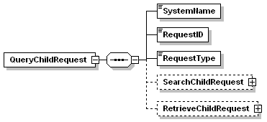
The definition of the common fields is provided in the following table:
Element | Mand-atory | Type | Max Len | Description
SystemName | Yes | String | 20 | The unique identifier of the source system. See 2.3.1 for defined values.
RequestID | Yes | String | 50 | A unique identifier for this search request. This value must be returned in the response document to aid correlation of the messages.
RequestType | Yes | Enumeration | - | The type of query to be performed - restricted to “RetrieveChild” and “SearchChild”.
SearchChildRequest | Yes for Search Child | Complex | - | The detailed parameters for the Search query – see section 3.4
RetrieveChildRequest | Yes for Retrieve Child | Complex | - | The detailed parameters for the Retrieve query – see section 3.5 for details

Response Document Format (QueryChildResponse)
The back-office Query Child interface must return a QueryChildResponse XML document formatted as shown in the following diagram:
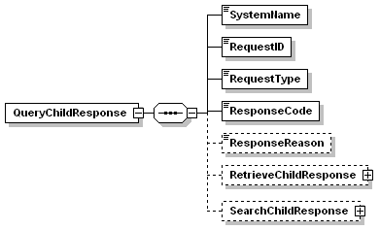
The definition of the common fields in the QueryChildResponse is provided in the following table:
Element | Mand-atory | Type | Max Len | Description
SystemName | Yes | String | 20 | The unique identifier of the source system. See 2.3.1 for defined values. This value must be the same as passed on the QueryChildRequest.
RequestID | Yes | String | 50 | The unique identifier of this search request as passed in the QueryChildRequest document.
RequestType | Yes | Enumeration | - | The type of query performed - restricted to “RetrieveChild” and “SearchChild”.
ResponseCode | Yes | String | - | A numeric value that indicates the success of the request, with “0” meaning success.
ResponseReason | No | String | - | The response textual message, if any.
RetrieveChildResponse | No | Complex | - | Present for a RetrieveChild query if a child record was found. See section 3.5 for details.
SearchChildResponse | No | Complex | - | Present for a SearchChild query if one or more child records were found. See section 3.4.

Search Child Request Specification

Overview
The Search Child interface allows IRT users issue a search request to a back office system, using a number of search criteria. The back office system returns zero or more records that match the search parameters. The search criteria consists of one or more of the following data items:
Search Item | Description | Wildcard
Forename | Searches any of the child’s forenames, including aliases | Yes
Surname | Searches the child’s surname, including aliases | Yes
Date Of Birth | Searches for a child with this date of birth | No
Age | Searches for a child with this age in years | No
Gender | Searches for a child with this gender | No
Address1 – Address5 | Searches for a child at this address. Each address line is mapped onto the corresponding address line of the source system. | Yes
PostCode | Searches for a child at this postcode | No
Notes:
The use of the search parameters is dependent on the capabilities of the specific back office system – some systems may not support some of the criteria, in which case they should be ignored by that back office system
Additional parameters are passed to control the search process
Items that support wildcard searches (Wildcard = Yes), allow partial matching by using the following wildcard characters within the data value:
Wildcard Character | Matches
% | Any string of zero or more characters
_ (underscore) | Any single character
Wildcard characters can appear anywhere within the search string, where supported

Request Document Format (SearchChildRequest)
A QueryChildRequest XML document is sent by IRT to the back office application to initiate a search for a child with RequestType set to “SearchChild”. The search parameters are contained in the SearchChildRequest structure within the QueryChildRequest message. The SearchChildRequest XML schema is shown diagrammatically below.
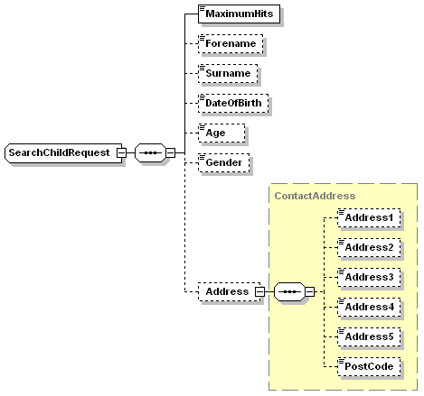
Field definitions:
Element | Mand-atory | Type | Max Len | Description
SearchChildRequest | Yes | Complex | - | Encloses the other search parameters
MaximumHits | Yes | Integer | - | Maximum number of child records to be returned.
Forename | No | String | 50 | Child’s forename search filter. The back office system should also search alias forenames.
Surname | No | String | 50 | Child’s surname search filter. The back office system should also search alias forenames.
DateOfBirth | No | Date |  | Birth date search filter, in “yyyy-mm-dd” format
Age | No | Integer |  | Child’s age search filter, in years
Gender | No | Integer | 1 | Sex filter, using eGIF format: 0, 1, 2, 9
Address1 | No | String | 250 | Address line 1 search filter
Address2 | No | String | 100 | Address line 2 search filter
Address3 | No | String | 100 | Address line 3 search filter
Address4 | No | String | 100 | Address line 4 search filter
Address5 | No | String | 100 | Address line 5 search filter
PostCode | No | String | 8 | Postcode search filter

Response Document Format (SearchChildResponse)
The back office system must return a QueryChildResponse XML document as specified in section 3.3.4. Search results are returned in the SearchChildResponse structure – if no matching records are found, then this structure is omitted. The search results are the demographic information on each child that matches the search criteria. The standard format of the SearchChildResponse XML structure is shown in the following diagram:

The format of the “ChildSummary” element is shown below. Note that the data definitions are exactly the same as for the batch interface as described in section 2.3.2.
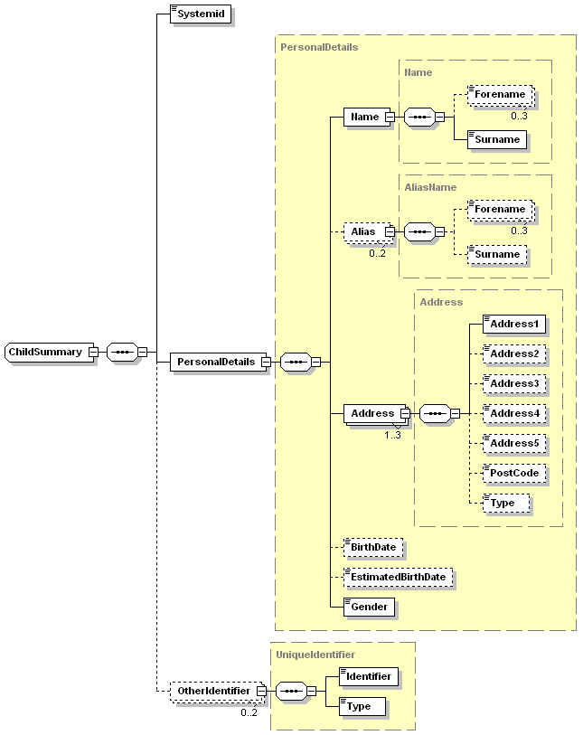
Definition of the SearchChildResponse fields is provided in the following table:
Element | Mand-atory | Type | Max Len | Description
SearchChildResponse | No | Complex | - | Encloses the ChildSummary records if they are present
ChildSummary | No | Complex | - | Zero or more summary child records matching the search criteria.
Systemid | Yes | String | 15 | Unique id of the child record on the source system
PersonalDetails | Yes | Complex | - | The child’s personal details.
Name | Yes | Complex | -
Forename | No | String | 50 | 0-3 child forenames
Surname | Yes | String | 50 | Child’s surname
Alias | No | Complex | - | 0 - 2 occurrences to record alternative names
Alias/Forename | No | String | 50 | 0-3 forenames
Alias/Surname | No | String | 50 | Not mandatory for alias
Address | Yes | Address | - | Max 3 occurrences
Address/Address1 | Yes | String | 250 | May contain multiple parts of an address if source system does not split into constituent parts
Address/Address2 | No | String | 100 | Typically street name
Address/Address3 | No | String | 100 | Typically locality
Address/Address4 | No | String | 100 | Typically town
Address/Address5 | No | String | 100 | Typically administrative Area
Address/PostCode | No | String | 8
Address/Type | No | String | 50 | Type of address, e.g. home, as defined in source system
BirthDate | No | Date | - | In “yyyy-mm-dd” format.
EstimatedBirthDate | No | Date | - | In “yyyy-mm-dd” format.
Gender | Yes | Integer | - | Restricted to eGIF values: 0, 1, 2, 9
OtherIdentifier | No | Complex | - | 0-2 other unique identifiers for this child. Used to record other unique identifiers, such as NHS number.
OtherIdentifier/Identifer | Yes | String | 15 | The unique identifier value
OtherIdentifier/Type | Yes | String | 20 | The type of identifier, e.g. NHS Number

Retrieve Child Request Specification

Overview
The Retrieve Child interface requests a detailed child record to be retrieved from a back office system given the system’s unique identifier of that child record. The data to be returned is the same as that used in the batch data load interface, that is the child’s demographic information plus details of involved parties. Only one child record is returned for each request.

Request Document Format (RetrieveChildRequest)
A retrieve child request is specified with a QueryChildRequest XML document with RequestType set to “RetreiveChild”and the RetrieveChildRequest parameters set. The retrieval parameters are described by the RetrieveChildRequest XML schema, shown diagrammatically below.

Definition of the fields is provided in the following table:
Element | Mand-atory | Type | Max Len | Description
RetrieveChildRequest | Yes | Complex | - | Encloses the retrieve parameters
Systemid | Yes | String | 15 | The unique id of the child record on the source system

Response Document Format (RetrieveChildResponse)
A QueryChildResponse XML document must be returned by the back office application as specified in section 3.3.4. If a child record is found it must be enclosed within the RetrieveChildResponse structure, formatted as shown in the following diagram:
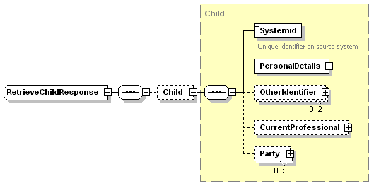
The definition of the RetrieveChildResponse fields is provided in the following table:
Element | Mand-atory | Type | Max Len | Description
RetrieveChildResponse | No | Complex | - | Encloses the Child record
Child | No | Complex | - | The detailed child record.
Systemid | Yes | String | 15 | Unique id of the child record on the source system
PersonalDetails | Yes | Complex | - | The child’s personal details. See section 3.4.3 for details.
OtherIdentifier | No | Complex | - | 0-2 other unique identifiers for this child. See section 3.4.3 for details.
CurrentProfessional | No | Party | - | Contact information about the current person involved with the child in the source system. The sub-elements are the same as for Party below.
Party | No | Party | - | Used to record contact information for Parent, School, GP, Principal carer, etc. 0-5 occurrences allowed.
Party/Type | Yes | String | 50 | Type of Party – Parent, School, GP, Principal Carer, etc. Free text.
Party/Name | Yes | String | 100 | The name of the party.
Party/Address | No | ContactAddress | - | Party’s address, formatted as shown below.
Party/Address/Address1 | Yes | String | 250 | May contain multiple parts of an address if source system does not split into constituent parts
Party/Address/Address2 | No | String | 100 | Typically street name
Party/Address/Address3 | No | String | 100 | Typically locality
Party/Address/Address4 | No | String | 100 | Typically town
Party/Address/Address5 | No | String | 100 | Typically administrative Area
Party/Address/PostCode | No | String | 8 | Post code
Party/Contact | No | ContactDetails | - | Used to record up to 3 contact details, as shown below.
Party/Contact/Type | Yes | String | 20 | Type of contact information, i.e. Telephone, Email, Fax, Mobile
Party/Contact/Details | Yes | String | 100 | The contact details

Appendices
- Real Time Interface XML Schema
The XML schemas for the IRT Real Time interfaces is attached below as a schema file:

